[](http://www.hpe.com)HPE Reference Configuration for Docker Containers as a Service on HPE Synergy Composable Infrastructure

**Deployment Guide**

Contents

Executive Summary 5

Solution overview 5

New in this release 5

Solution configuration 6

High availability 8

Sizing considerations 9

Disaster Recovery 12

Security 13

Solution components 13

Hardware 13

Software 14

Application software 15

Preparing the environment 16

Verify prerequisites 16

Enable vSphere High Availability (HA) 17

Install vSphere Docker Volume Service driver on all ESXi hosts 17

Create the Ansible node on Fedora 17

Create the Red Hat Linux template 18

Configuring the solution components 19

Ansible configuration 19

Editing the inventory 20

Inventory group variables 22

Overriding group variables 24

VMware configuration 24

Networking configuration 25

Environment configuration 25

Docker configuration 26

Orchestrator configuration 26

Kubernetes configuration 27

Protecting sensitive information 28

Overview of the playbooks 29

Core components 29

Optional components 29

Backup and restore playbooks 29

Convenience playbooks 30

Convenience scripts 30

Deploying the core components 30

Provisioning RHEL VMs 30

Provisioning load balancers for UCP and DTR 30

Installing Docker UCP and DTR on RHEL VMs 32

Deploying RHEL workers 32

Post deployment 33

Installing kubectl 33

Installing the client bundle 34

Installing Helm 34

Post-deploy validation 36

UCP metrics in Prometheus 42

Configuring storage 44

Using HPE 3PAR when deploying NFS provisioner for Kubernetes 44

Using NFS VM when deploying NFS provisioner for Kubernetes 52

Validating the NFS provisioner using WordPress and MySQL 54

Deploying Windows workers 61

Create the Windows Template 61

Playbooks for adding Windows workers 62

Windows configuration 63

Windows operating system and Docker EE 65

Deploying bare metal workers 65

Introduction to bare metal workers 65

Playbooks and configuration 65

OS Deployment Plan Custom Attributes 67

RHEL Golden Images 71

Windows Golden Images 75

OS Deployment Plans 78

OneView Server Profile Templates 79

Deploying Sysdig monitoring 79

Monitoring with Sysdig 79

Playbooks for installing Sysdig on RHEL 80

Sysdig configuration 80

Registering for Sysdig trial 81

Deploying Sysdig monitoring on Kubernetes 84

Deploying Sysdig monitoring on Docker Swarm 84

Deploying Splunk 85

Monitoring with Splunk 85

Playbooks for installing Splunk 87

Splunk configuration 87

Accessing Splunk UI 90

Redeploying Splunk demo 92

Deploying Prometheus and Grafana on Kubernetes 93

Monitoring Kubernetes with Prometheus and Grafana 93

Playbooks for installing Prometheus and Grafana on Kubernetes 93

Prometheus UI 95

Node Exporter 97

cAdvisor 98

Grafana UI 98

Deploying Prometheus and Grafana on Docker swarm 101

Monitoring with Prometheus and Grafana 101

Playbooks for installing Prometheus and Grafana on Docker swarm 102

Prometheus and Grafana configuration 102

Accessing Grafana UI 102

Backup and restore 104

Backup and restore UCP and DTR 104

Backup and restore Docker persistent volumes 112

Integrate UCP and DTR backup with HPE RMC and HPE StoreOnce 115

Solution lifecycle management 116

HPE Synergy 116

vSphere Docker Volume Service Plug-in 116

Red Hat Enterprise Linux operating system 117

Docker EE Environment 118

Monitoring Tools 118

Summary 118

Appendix A: Software Licenses 119

Appendix B: Using customer supplied certificates for UCP and DTR 119

Generating and testing certificates 119

Verify your certificates 122

Appendix C: Enabling SSL between the universal forwarders and the Splunk indexers using your certificates 122

Limitations 122

Prerequisites 123

Before you deploy 123

Hybrid environment Linux / Windows 124

Appendix D: How to check that certs were deployed correctly 125

Resources and additional links 127

# Executive Summary

HPE Reference Configuration for Docker Containers as a Service on HPE Synergy Composable Infrastructure is a complete solution from Hewlett Packard Enterprise that includes all the hardware, software, professional services, and support you need to deploy a Containers-as-a-Service (CaaS) platform, allowing you to get up and running quickly and efficiently. The solution takes the HPE Synergy infrastructure and combines it with Docker’s enterprise-grade container platform, popular open source tools, along with deployment and advisory services from HPE Pointnext.

HPE Enterprise Containers as a Service with Docker EE is ideal for customers migrating legacy applications to containers, transitioning to a container DevOps development model or needing a hybrid environment to support container and non-containerized applications on a common VM platform. This Reference Configuration provides a solution for IT operations, addressing the need for a production-ready environment that is easy to deploy and manage.

This release supports Kubernetes 1.11 via Docker Enterprise Edition (EE) 2.1, which is the only platform that manages and secures applications on Kubernetes in multi-Linux, multi-OS and multi-cloud customer environments. This document describes the best practices for deploying and operating HPE Enterprise Containers as a Service with Docker Enterprise Edition (EE). It shows how to automate the provisioning of the environment using a set of Ansible playbooks. It also outlines a set of manual steps to harden, secure and audit the overall status of the system.

Target Audience: This document is primarily aimed at technical individuals working in the operations side of the software pipeline, such as infrastructure architects, system administrators and infrastructure engineers, but anybody with an interest in automating the provisioning of virtual servers and containers may find this document useful.

Assumptions: The present document assumes a minimum understanding in concepts such as virtualization and containerization and also some knowledge around Linux®, Microsoft Windows® and VMware® technologies.

# Solution overview

The HPE Reference Configuration for Docker Containers as a Service on HPE Synergy Composable Infrastructure consists of a set of Ansible playbooks that run on top of a VMware virtualization platform on HPE Synergy and HPE 3PAR storage hardware. The solution allows you to configure a flexible OS environment (with both RHEL and Windows workers) providing built-in high availability (HA), container monitoring and security, and backup and restore functionality. This solution assumes that you have already set up your HPE Synergy hardware, that you have installed your VMware virtualization platform and have configured HPE 3PAR for storage.

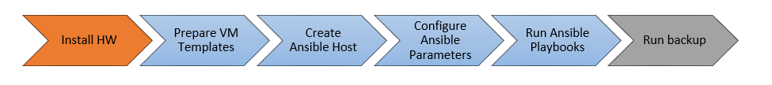

Figure 1. Solution overview

Figure 1 provides an overview of the steps used to deploy the solution. Deploying your hardware and HPE Synergy is specific to your environment and is not covered here. This document shows you how to:

* Prepare the VM templates
* Create the Ansible host
* Configure the Ansible parameters

Run the Ansible playbooks

Once you are up and running, you should regularly back up the system using the scripts provided as part of this solution.

## New in this release

Version 2.1 of the solution provides support for Kubernetes 1.11 via Docker EE 2.1. It is recommended that you set the DTR version to 2.6.4 (released 2019-03-28) to avoid a known issue when restoring DTR after backup. New features in this release include:

Bare metal deployment for Linux and Windows

Features taken from the most recent release of HPE Express Containers on HPE SimpliVity include:

* Prometheus/Grafana on Kubernetes: The playbooks now set up a full monitoring stack for the deployed Kubernetes infrastructure using Prometheus Operator. They install kube-state-metrics and node-exporter components, as well as supporting Kubelet and Apiserver metrics. Sample dashboards for Grafana are installed to help you monitor your Kubernetes infrastructure.
* Docker UCP metrics for Kubernetes: A separate, standalone Prometheus/Grafana deployment is provided to support visualization of UCP metrics. This will be integrated into the full stack deployment in a future release.
* Sysdig for Kubernetes: The Sysdig deployment has been updated to use Kubernetes 1.11 RBAC and config maps for sensitive data.
* NFS Provisioner for Kubernetes: The NFS Provisioner has been updated to use Kubernetes 1.11 RBAC.
* WordPress and MySQL using NFS Provisioner: Playbooks are provided to validate the NFS Provisioner, featuring a WordPress and MySQL deployment with persistent storage.
* kubectl: A convenience playbook is provided to download and install kubectl.
* Client bundle: A convenience playbook is available to download and configure the client bundle from UCP.
* Helm charts: Playbooks for downloading, installing and configuring Helm are provided, with the use of sample charts for validation purposes.

For more details on what is new in this release, see the release notes at <https://hewlettpackard.github.io/Docker-Synergy/rel-notes/new-features-syn.html>.

## Solution configuration

The Ansible playbooks are available to download at <https://github.com/HewlettPackard/Docker-Synergy>. By default, the playbooks are configured as shown in Figure 2 to set up a 3 node environment. This is the minimal starter configuration recommended by HPE and Docker for production.

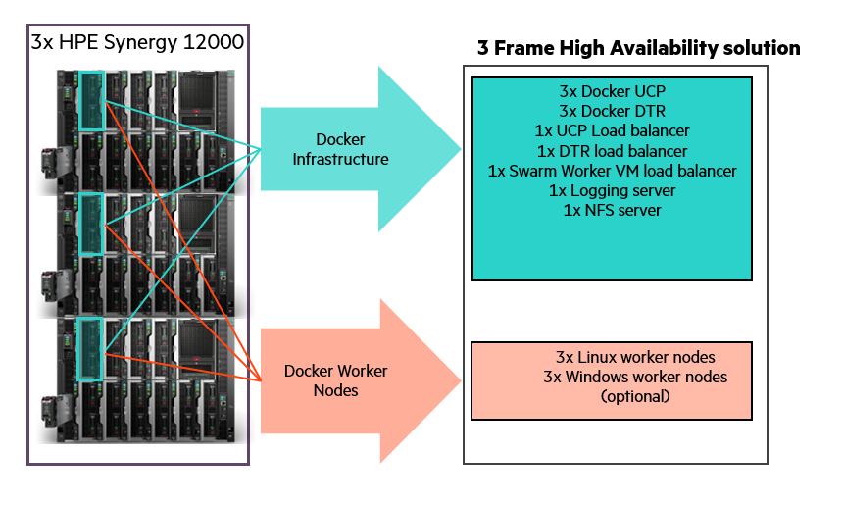

Figure 2. Three node HPE Synergy Configuration

The playbooks can also be used for larger container environments, for example, with a 3 frame, 6 node HPE Synergy system, as shown in Figure 3 with 2 nodes in each frame.



Figure 3. Six node HPE Synergy Configuration

### Linux-only VM configuration

* 3 Docker Universal Control Plane (UCP) VM nodes for HA and cluster management
* 3 Docker Trusted Registry (DTR) VM nodes for HA of the container registry

The Docker UCP and DTR nodes are spread across 3 physical nodes, with one on each physical node. An odd number of manager nodes is recommended to avoid split-brain issues. It is possible to restrict the deployment to 1 UCP and 1 DTR, or to expand to more than 3, but the recommended minimum for an enterprise production deployment is 3 UCPs and 3 DTRs.

* 3 Docker Linux worker VM nodes for container workloads - Kubernetes or Docker swarm or a mix

The Docker worker nodes will be co-located with the UCP and DTR nodes in a 3 physical node deployment. Where more than 3 physical nodes are available, the worker nodes will typically be separated onto the extra nodes. It is possible to specify that more than one worker node is deployed per physical node but this decision will depend on the requirements of your applications.

* 1 Docker UCP load balancer VM to ensure access to UCP in the event of a node failure
* 1 Docker DTR load balancer VM to ensure access to DTR in the event of a node failure

By default, two load balancers are deployed to increase availability of UCP and DTR and these are placed on separate physical nodes. Load balancing for applications running on worker nodes can achieved by using the playbooks to deploy additional load balancers, or by manually configuring the existing two to support your applications in addition to supporting UCP and DTR.

* 1 Logging server VM for central logging

1 NFS server VM for storage of Docker DTR images

With the addition of the NFS and logging VMs, a total of 13 VMs are created for the default Linux-only deployment. In addition to these VMs, the playbooks also set up the Docker persistent storage plug-in from VMware. The vSphere Docker volume plug-in facilitates the storage of data in a shared datastore that can be accessed from any machine in the cluster.

### Hybrid VM configuration (Windows and Linux)

The hybrid deployment will typically add 3 Windows worker nodes to the above configuration, co-located with the Linux workers.

3 Docker swarm Windows worker VM nodes for container workloads (optional)

### Bare metal (BM) configuration (Windows and Linux)

This solution leverages HPE Synergy OneView 4.10 and HPE Image Streamer 4.10 to provision bare metal servers with an operating system so they can be added to a Docker/Kubernetes cluster as worker nodes. The bare metal worker nodes can be used in conjuction with VM worker nodes or on their own with a virtualized control plane.

Note

Some of the application software supported by this configuration does not currently run on Windows, for example, the Sysdig Software Agent (see the section Monitoring with Sysdig).

## High availability

Uptime is paramount for businesses implementing Docker containers in business critical environments. The HPE Enterprise Containers as a Service with Docker EE solution offers various levels of high availability (HA) to support continuous availability. The Docker EE system components run on multiple manager nodes in the cluster. The management plane continues to operate even in the event of a manager node failure. Application containers can be protected through the use of services running on top of swarm. The swarm orchestrator works to maintain the number of containers declared as part of the service. The Ansible playbooks can be modified to fit your environment and your high availability (HA) needs.

### Load Balancers

This solution also deploys load balancers in the system to help with container traffic management. There are two load balancer VMs – the UCP load balancer and DTR load balancer. The playbooks can be configured to deploy one or more worker load balancers depending on the requirements of your applications. A typical load balancer architecture for applications running on Docker EE is shown in Figure 4. The playbooks now support load balancers based on VRRP, using HAproxy and keepalived. The solution can be deployed using these loadbalancers, or external load balancers, or no load balancers or the legacy version of standalone load balancers. For more information on HAproxy, see <http://www.haproxy.com/solutions/high-availability/>.

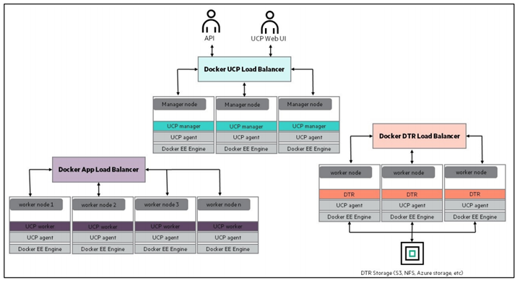

Figure 4. Load balancer architecture

## Sizing considerations

A node is a machine in the cluster (virtual or physical) with Docker Engine running on it. There are two types of nodes: managers and workers. UCP will run on the manager nodes. Although DTR runs on a worker node, Docker does not recommend running other application containers on them. To decide what size the node should be in terms of CPU, RAM, and storage resources, consider the following:

1. All nodes should at least fulfil the minimal requirements, for UCP 3.0, 8GB of RAM and 6GB of storage. For production systems, 16GB of RAM and 25-100GB of free disk space is recommended for manager nodes. More detailed requirements are in the Docker EE UCP documentation at <https://docs.docker.com/ee/ucp/admin/install/system-requirements/>.
2. UCP controller nodes should be provided with more than the minimal requirements, but won’t need much more if nothing else runs on them.
3. Ideally, worker node size will vary based on your workloads so it is impossible to define a universal standard size.

Other considerations like target density (average number of containers per node), whether one standard node type or several are preferred, and other operational considerations might also influence sizing.

If possible, node size should be determined by experimentation and testing actual workloads; and they should be refined iteratively. A good starting point is to select a standard or default machine type for all nodes in the environment. If your standard machine type provides more resources than the UCP controller nodes need, it makes sense to have a smaller node size for these. Whatever the starting choice, it is important to monitor resource usage and cost to improve the model.

For this solution, the following tables describe sizing configurations, assuming 3 Linux workers and 3 Windows workers. The vCPU allocations are described in

Table 1.

Table 1. vCPU

|  |  |  |  |
| --- | --- | --- | --- |
| vCPUs | node01 | node02 | node03 |
| ucp1 | 4 |  |  |
| ucp2 |  | 4 |  |
| ucp3 |  |  | 4 |
| dtr1 | 2 |  |  |
| dtr2 |  | 2 |  |
| dtr3 |  |  | 2 |
| worker1 | 4 |  |  |
| worker2 |  | 4 |  |
| worker3 |  |  | 4 |
| win-worker1 | 4 |  |  |
| win-worker2 |  | 4 |  |
| win-worker3 |  |  | 4 |
| lb1 | 2 |  |  |
| lb2 |  | 2 |  |
| nfs |  |  | 2 |
| logger |  | 2 |  |
| Total vCPU per node | 16 | 18 | 16 |

Note

In the case of one ESX host failure, 2 nodes are enough to accommodate the amount of vCPU required.

### Memory allocation for 3 node solution

The memory allocation for this solution (3 Linux workers and 3 Windows workers), is described in Table 2.

Table 2. Memory allocation

|  |  |  |  |
| --- | --- | --- | --- |
| RAM (GB) | node01 | node02 | node03 |
| ucp1 | 16 |  |  |
| ucp2 |  | 16 |  |
| ucp3 |  |  | 16 |
| dtr1 | 16 |  |  |
| dtr2 |  | 16 |  |
| dtr3 |  |  | 16 |
| worker1 | 64 |  |  |
| worker2 |  | 64 |  |
| worker3 |  |  | 64 |
| win-worker1 | 64 |  |  |
| win-worker2 |  | 64 |  |
| win-worker3 |  |  | 64 |
| lb1 | 4 |  |  |
| lb2 |  | 4 |  |
| nfs |  |  | 4 |
| logger |  | 4 |  |
| Total RAM required (per node) | 164 | 168 | 164 |
| Available RAM | 384 | 384 | 384 |

Note

In the case of one ESX host failure, the two surviving hosts can accommodate the amount of RAM required for all VMs.

### Memory allocation for 6 node solution

For a 6 node solution, Table 3 outlines the memory requirements where the control plane is on 3 nodes and the worker nodes are on the other 3 nodes. In this example, it is assumed that there are 2 Linux worker nodes and 1 Windows worker node, but the actual number of worker nodes is not limited to 3 and depends entirely on the workload requirements.

Table 3. Memory allocation for 6 nodes

|  |  |  |  |  |  |  |
| --- | --- | --- | --- | --- | --- | --- |
| RAM (GB) | node01 | node02 | node03 | node04 | node05 | node06 |
| ucp1 | 16 |  |  |  |  |  |
| ucp2 |  | 16 |  |  |  |  |
| ucp3 |  |  | 16 |  |  |  |
| dtr1 | 16 |  |  |  |  |  |
| dtr2 |  | 16 |  |  |  |  |
| dtr3 |  |  | 16 |  |  |  |
| worker1 |  |  |  | 64 |  |  |
| worker2 |  |  |  |  | 64 |  |
| win-worker1 |  |  |  |  |  | 64 |
| lb1 | 4 |  |  |  |  |  |
| lb2 |  | 4 |  |  |  |  |
| nfs |  |  | 4 |  |  |  |
| logger |  | 4 |  |  |  |  |
| Total RAM required (per node) | 36 | 44 | 44 | 64 | 64 | 64 |
| Available RAM | 128 | 128 | 128 | 128 | 128 | 128 |

Note

In the case of one ESX host failure, the two surviving hosts can accommodate the amount of RAM required for all VMs.

## Disaster Recovery

Recovery Time Objective (RTO) refers to the time that it takes to recover your data and applications while Recovery Point Objective (RPO) refers to the point in time you can recover to, in the event of a disaster. In essence, RPO tells you how often you will need to make new backups.

In order to protect your installation from disasters, you need to take regular backups and transfer the backups to a safe location. This solution provides a range of convenience scripts and Ansible playbooks to help automate the backup of UCP, DTR, your swarm and your Docker volumes. See the section Backup and restore for best practices, procedures and utilities for implementing disaster recovery.

## Security

The Docker Reference architecture for Securing Docker EE and Security Best Practices is available at <https://success.docker.com/article/Docker_Reference_Architecture-_Securing_Docker_EE_and_Security_Best_Practices>

In addition to having all logs centralized in a single place and the image scanning feature enabled for the DTR nodes, there are other guidelines that should be followed in order to keep your Docker environment as secure as possible. The HPE Reference Configuration paper for securing Docker on HPE Hardware places a special emphasis on securing Docker in DevOps environments and covers best practices in terms of Docker security. The document can be found at <http://h20195.www2.hpe.com/V2/GetDocument.aspx?docname=a00020437enw>.

In addition, the Sysdig product also provides a strong level of container security and monitoring (see the section Monitoring with Sysdig).

# Solution components

This section describes the various components that were utilized in this Reference Configuration.

## Hardware

Table 4 lists the hardware components that are utilized in this Reference Configuration.

Table 4. Hardware

| Component | Purpose |
| --- | --- |
| HPE Synergy 12000 Frame | Rack enclosure for compute, storage, and network hardware |
| HPE Synergy 480 Gen10 Compute Modules | Hosts for running ESX servers that support UCP, DTR, worker and other nodes in the solution |
| HPE 3PAR StoreServ 8200 | Provides the storage for the virtual machines and the Docker backups |
| HPE StoreOnce | High performance backup system |

### About HPE Synergy

HPE Synergy, the first platform built from the ground up for composable infrastructure, empowers IT to create and deliver new value instantly and continuously. This single infrastructure reduces operational complexity for traditional workloads and increases operational velocity for the new breed of applications and services. Through a single interface, HPE Synergy composes compute, storage and fabric pools into any configuration for any application. It also enables a broad range of applications from bare metal to virtual machines to containers, and operational models like hybrid cloud and DevOps. HPE Synergy enables IT to rapidly react to new business demands.

HPE Synergy Frames contain a management appliance called the HPE Synergy Composer which hosts HPE OneView. HPE Synergy Composer manages the composable infrastructure and delivers:

* Fluid pools of resources, where a single infrastructure of compute, storage and fabric boots up ready for workloads and demonstrates self-assimilating capacity.
* Software-defined intelligence, with a single interface that precisely composes logical infrastructures at near-instant speeds; and demonstrates template-driven, frictionless operations.

Unified API access, which enables simple line-of-code programming of every infrastructure element; easily automates IT operational processes; and effortlessly automates applications through infrastructure deployment.

### Server requirements

The minimum platform requirement for this configuration, shown in Figure 2, is a three node HPE Synergy 480 Gen10 deployment with 1 node in each Synergy frame and

* 384 GB DDR4-2133 RAM
* 2 Intel® Xeon® CPU Gold 6130 2.10GHz x 16 core

Single ESXi cluster with control plane and Docker workers spread out on all 3 nodes

The solution has also been tested on a 6 node HPE Synergy environment, with 2 nodes in each frame. In this setup, the extra 3 nodes are dedicated to Docker worker nodes. The 6 node deployment is depicted graphically in Figure 3 with the following suggested requirements for each node.

* 128 GB DDR4-2133 RAM
* 2 Intel® Xeon® CPU Gold 6130 2.10GHz x 16 core

Single ESXi cluster with the control plane on 3 nodes and the Docker workers spread on the other 3 nodes.

### Storage requirements

An HPE 3PAR array is required for the ESXi datastore. This solution makes use of an HPE 3PAR StoreServ 8200 populated with:

* 8x 480GB SSD for the vSphere cluster datastore

8x 1.8TB HDD for the backup datastore

You should create a large virtual volume on the HPE 3PAR StoreServ to host the virtual machines and another large virtual volume for Docker backups. Create datastores on your vSphere cluster using these virtual volumes. If desired, you can create separate HPE 3PAR StoreServ virtual volumes and attach them to all vSphere cluster hosts for backing up Docker persistent volumes. It is recommended that you configure the volumes that are used for virtual machine deployments on the SSD. Storage for backups can be configured on the HDDs.

## Software

The software components used in this Reference Configuration are listed in Table 5 and Table 6.

Table 5. Third-party software

| Component | Version |
| --- | --- |
| Ansible | 2.7 |
| Docker EE | 2.1 with Docker EE Engine 18.09 (tested with UCP 3.1.4 and DTR 2.6.4) |
| Red Hat Enterprise Linux | 7.6 |
| Microsoft Windows | Server 2016 |
| VMware | ESXi 6.5.0 and vCenter 6.5.0 |

Table 6. HPE Software

| Component | Version |
| --- | --- |
| HPE Recovery Manager Central | 5.0.1 |
| HPE Synergy OneView | 4.1 |
| HPE Image Streamer | 4.1 |

### About Ansible

Ansible is an open-source automation engine that automates software provisioning, configuration management and application deployment.

As with most configuration management software, Ansible has two types of servers: the controlling machine and the nodes. A single controlling machine orchestrates the nodes by deploying modules to the Linux nodes over SSH. The modules are temporarily stored on the nodes and communicate with the controlling machine through a JSON protocol over the standard output. When Ansible is not managing nodes, it does not consume resources because no daemons or programs are executing for Ansible in the background. Ansible uses one or more inventory files to manage the configuration of the multiple nodes in the system.

When deploying Windows nodes in a hybrid deployment, the Ansible playbooks make use of the Python pywinrm module which carries out actions via the Windows remote manager.

More information about Ansible can be found at [http://docs.ansible.com](http://docs.ansible.com/).

### About Docker Enterprise Edition

Docker Enterprise Edition (EE) is the leading enterprise-ready container platform for IT that manages and secures diverse applications across disparate infrastructure, both on-premises and in the cloud. Docker EE provides integrated container management and security from development to production. Enterprise-ready capabilities like multi-architecture orchestration and secure software supply chain give IT teams the ability to manage and secure containers without breaking the developer experience.

Docker EE provides:

* Integrated management of all application resources from a single web admin UI.
* Frictionless deployment of applications and Compose files to production in a few clicks.
* Multi-tenant system with granular role-based access control (RBAC) and LDAP/AD integration.
* Self-healing application deployment with the ability to apply rolling application updates.

End-to-end security model with secrets management, image signing and image security scanning.

More information about Docker Enterprise Edition can be found at <https://www.docker.com/enterprise-edition>.

## Application software

A number of different logging and monitoring solutions are supported by this solution:

* Splunk
* Sysdig

Prometheus and Grafana

The application software components used in this Reference Configuration are listed in Table 7.

Table 7. Application software

| Component | Version |
| --- | --- |
| Splunk | 7.1.2 |
| Sysdig | latest |
| Prometheus | V2.3.2 |
| Grafana | 5.2.3 |

### Monitoring with Splunk and Sysdig

The solution can be configured to use either Splunk or Sysdig or to enable both simultaneously. While there is some overlap in the functionality provided by these tools, they are ultimately complimentary in what they offer. Splunk aggregates logging and tracing for a wide variety of sources and provides a clean, high-level dashboard for all your enterprise systems. Sysdig, on the other hand, has been engineered from the ground up to focus on containerized environments and includes both monitoring and security features, with built-in understanding of the different workloads running on your cloud.

More information on configuring Splunk and running the relevant playbooks can be found in the section Deploying Splunk.

For more information on configuring Sysdig and running the relevant playbooks, see the section Deploying Sysdig monitoring.

### Monitoring with Prometheus and Grafana

The solution can be configured to enable the use of Prometheus and Grafana for monitoring. In this setup, there is no need for native installs and all the required monitoring software runs in containers, deployed as either services or stacks.

The solution supports two separate monitoring stacks, with one running on Kubernetes and the other using Docker swarm.

For more information on running Prometheus and Grafana on Kubernetes, see section Monitoring Kubernetes with Prometheus and Grafana.

For more information on running Prometheus and Grafana on Docker swarm, see section Deploying Prometheus and Grafana on Docker swarm.

# Preparing the environment

This section describes in detail how to prepare the environment that was outlined in the architecture section. The following high level steps are required:

* Verify prerequisites
* Enable vSphere High Availability (HA)
* Install vSphere Docker Volume Service driver on all ESXi hosts
* Create the Ansible node
* Create the Red Hat Linux Template and configure the yum repositories
* Create the Windows Template (optional)

Finalize the template

## Verify prerequisites

Before you start deployment, you must assemble the information required to assign values for each and every variable used by the playbooks. The variables are fully documented in the section Configuring the solution components. A brief overview of the information required is presented in Table 8.

Table 8. Summary of information required

| Component | Details |
| --- | --- |
| Virtual Infrastructure | The FQDN of your vCenter server and the name of the Datacenter. You will also need administrator credentials in order to create templates and spin up virtual machines. |
| L3 Network requirements | You will need one IP address for each and every VM configured in the Ansible inventory (see the section Configuring the solution components). The recommended minimal deployment (Linux-only) configures 13 virtual machines so you would need to allocate 13 IP addresses to use this example inventory. If you have a hybrid environment with Windows workers, you will need to increase the allocation. Note that the Ansible playbooks do not support DHCP so you need static IP addresses. All the IPs should be in the same subnet. You will also have to specify the size of the subnet (for example /22 or /24) and the L3 gateway for this subnet. |
| DNS | You will need to know the IP addresses of your DNS server. In addition, all the VMs you configure in the inventory must have their names registered in DNS prior to deployment. In addition, you will need to know the domain name to use for configuring the virtual machines (such as example.com) |
| NTP Services | You need time services configured in your environment. The deployed solution uses certificates that are time-sensitive. You will need to specify the IP addresses of your time servers (NTP). |
| RHEL Subscription | A RHEL subscription is required to pull extra packages that are not on the DVD. |
| Docker Prerequisites | You will need a URL for the official Docker EE software download and a license file. Refer to the Docker documentation to learn more about this URL and the licensing requirements at: <https://docs.docker.com/engine/installation/linux/docker-ee/rhel/> in the section entitled “Docker EE repository URL” |
| Proxy | The playbooks pull the Docker packages from the Internet. If your environment accesses the Internet through a proxy, you will need the details of the proxy including the fully qualified domain name and the port number. |

## Enable vSphere High Availability (HA)

You must enable vSphere High Availability (HA) to support virtual machine failover during a HA event such as a host failure. Sufficient CPU and memory resources must be reserved across the system so that all VMs on the affected host(s) can fail over to remaining available hosts in the system. You configure an Admission Control Policy (ACP) to specify the percentage CPU and memory to reserve on all the hosts in the cluster to support HA functionality.

Note

You should not use the default Admission Control Policy. Instead, you should calculate the memory and CPU requirements that are specific to your environment.

## Install vSphere Docker Volume Service driver on all ESXi hosts

vSphere Docker Volume Service technology enables stateful containers to access the storage volumes. Setting this up is a one-off manual step. In order to be able to use Docker volumes using the vSphere driver, you must first install the latest release of the vSphere Docker Volume Service (vDVS) driver, which is available as a vSphere Installation Bundle (VIB). To perform this operation, log in to each of the ESXi hosts and then download and install the latest release of vDVS driver.

# esxcli software vib install -v /tmp/vmware-esx-vmdkops-<version>.vib --no-sig-check

More information on how to download and install the driver can be found at <http://vmware.github.io/vsphere-storage-for-docker/documentation/install.html>.The version of the driver tested in this configuration is 0.21.2.

## Create the Ansible node on Fedora

The Docker Synergy playbooks rely on the [Ansible Modules for HPE OneView](https://github.com/HewlettPackard/oneview-ansible) project when deploying bare metal resources. As a result, there is a requirement to run a newer version of Python than is available by default on RHEL. In this release of the Docker Synergy solution, it is required to deploy your Ansible contoller on Fedora, to take advantage of the built-in support for Python 3.

### Create Fedora VM

Create a Virtual Machine with the following characteristics:

* Guest OS: Red Hat Fedora (64-bit)
* Disk: 50G (thin provisioning)
* CPU: 2
* RAM: 4 GB

Ethernet Adapter: VMXNET 3, connected to your Ansible or management network

Install Fedora Server 29 using the appropriate ISO image for the distro (x86 64 bit) and in the Software Selection section, choose:

* Base Environment: Fedora Server Edition
* Add-Ons for Selected Environment: Guest Agent

Select your language, keyboard, and timezone settings and re-boot when the installation finishes.

Configure your networking and check your connectivity before moving on to the next section. If you are operating behind a proxy, configure DNF by editing /etc/dnf/dnf.conf, as outlined [here](https://www.cyberciti.biz/faq/how-to-use-dnf-command-with-a-proxy-server-on-fedora/).

### Install Ansible and required modules

Login the root account and run the following commands:

dnf update –y  
dnf install -y git  
dnf install -y ansible  
dnf install -y python3-netaddr  
dnf install -y python3-requests  
dnf install -y python3-pyvmomi  
dnf install -y python3-pip  
dnf install -y python3-winrm  
   
cd /usr/bin  
ln -s python3.7 python  
  
# install the python HPE OneView SDK  
cd  
git clone https://github.com/HewlettPackard/python-hpOneView.git  
cd python-hpOneView/  
pip3 install .  
  
# Install the ONeview Ansible Modules  
cd  
git clone https://github.com/HewlettPackard/oneview-ansible.git  
  
# Configure ansible  
cat <<EOF >>~/.bashrc  
export ANSIBLE_LIBRARY=/root/oneview-ansible/library  
export ANSIBLE_MODULE_UTILS=/root/oneview-ansible/library/module_utils  
EOF  
  
source ~/.bashrc

## Create the Red Hat Linux template

To create the Red Hat Linux VM template that you will use as the base for all your nodes, you first create a Virtual Machine with the OS installed and then convert the Virtual Machine to a VM Template. The VM Template is created as lean as possible, with any additional software installs and/or system configuration performed subsequently using Ansible.

As the creation of the template is a one-off task, this procedure has not been automated. The steps required to manually create a VM template are outlined below.

Log in to vCenter and create a new Virtual Machine with the following characteristics:

* Guest OS Family: Linux, Guest OS Version: Red Hat Enterprise Linux (64-bit)
* Hard Disk size: 50GB, (Thin provisioning)
* A single network controller connected to the network or VLAN of your choice. All VMs will connect to this same network.

Optionally you can remove the floppy drive

Install Red Hat Enterprise 7:

1. Select a language which is supported by Docker
2. For the software selection, choose Infrastructure Server as the base environment and add the Guest Agents from the lists of add-ons available for this environment. The Infrastructure Server environment is selected here versus the Minimal Install because Customization of Linux guest operating systems requires that Perl is installed in the Linux guest operating system.
3. Configure the network settings so that you can later access the VM using SSH. Specify an IP address for the network interface, a default gateway, DNS settings and possibly any HTTP/HTTPS proxies that apply in your environment.
4. Specify a password for the root account and optionally created an admin user.

Wait for the installation to finish and for the VM to reboot.

### Update packages

Use yum update to install the latest packages, configuring a proxy if required.

# subscription-manager config --server.proxy_hostname=<proxy IP> --server.proxy_port=<proxy port>  
# subscription-manager register --auto-attach  
  
# subscription-manager repos \  
--enable=rhel-7-server-rpms \  
--enable=rhel-7-server-extras-rpms  
  
# yum update  
# subscription-manager unregister

### Finalize the template

Log in to the root account on the Ansible box and copy the SSH public key to the VM Template. This will allow your Ansible node to SSH to all the Virtual Machines created from the VM Template without the need for a password.

ssh-copy-id root@<IP of your VM_Template>

Perform the following steps on the VM Template to finalize its creation:

1. Clean up the template by running the following commands from the Virtual Machine Console:

# rm /etc/ssh/ssh_host_*  
# nmcli con del ens192  
# logrotate -f /etc/logrotate.conf  
# rm /var/log/*-201?*  
# history -c

1. Shutdown the VM

# shutdown -h now

1. Turn the VM into a template by right-clicking on your VM and selecting Template -> Convert to Template. This will create a new template visible under VM Templates in Folders, ready for future use.

Note

In both the Ansible node and the VM Template, you might need to configure the network so one node can reach the other. Instructions for this step have been omitted since it is a basic step and could vary depending on the user’s environment.

# Configuring the solution components

Once you have prepared your environment, you need to download the solution software and edit the configuration variables to match your setup.

## Ansible configuration

1. On the Ansible node, retrieve the latest version of the playbooks using Git.

# git clone https://github.com/HewlettPackard/Docker-Synergy.git

1. Change to the directory that you just cloned:

# cd ~/Docker-Synergy

Note

All subsequent file names are relative to the Docker-Synergy directory. For example hosts is located in ~/Docker-Synergy/ and group_vars/all/vars corresponds to ~/Docker-Synergy/group_vars/all/vars.

You now need to prepare the configuration to match your own environment, prior to deploying Docker EE and the rest of the nodes. To do so, you will need to modify a number of files including:

* site.yml, the main entry point for the playbooks.

hosts, the inventory file.

You also need to create and populate a number of files:

* group_vars/all/vars, the group variables file.
* group_vars/all/vault, containing sensitive information that needs to be protected.

group_vars/all/backups, containing backup-related variables.

For the latter group, a set of sample files has been provided to help you get started:

* group_vars/all/vars.sample, a sample group variables file.
* group_vars/all/vault.sample, a sample vault file.

group_vars/all/backups.sample, a sample backup configuration file.

The file group_vars/win_worker.yml supports advanced configuration of Windows remote management and in general should not require modification.

You should work from the root account for the configuration steps and also later on when you run the playbooks.

## Editing the inventory

The inventory is the file named hosts in the ~/Docker-Synergy directory. You need to edit this file to describe the configuration you want to deploy.

The nodes inside the inventory are organized in groups. The groups are defined by brackets and the group names are static so they must not be changed. Other fields (hostnames, specifications, IP addresses…) are edited to match your setup. The groups are as follows:

### Control plane

* [ucp_main]: A group containing one single node which will be the main UCP node and swarm leader. Do not add more than one node under this group.
* [ucp]: A group containing all the UCP nodes, including the main UCP node. Typically you should have either 3 or 5 nodes under this group.
* [dtr_main]: A group containing one single node which will be the first DTR node to be installed. Do not add more than one node under this group.
* [dtr]: A group containing all the DTR nodes, including the main DTR node. Typically you should have either 3 or 5 nodes under this group.
* [nfs]: A group containing one single node which will be the NFS node. Do not add more than one node under this group.

[logger]: A group containing one single node which will be the logger node. Do not add more than one node under this group.

#### Load balancers

If you are deploying the new active-active load balancers, using floating IPs managed by keepalived:

[loadbalancer]: A group containing the UCP, DTR and any worker load balancers you are deploying.

If you are using the legacy, standalone load balancers:

* [ucp_lb]: A group containing one single node which will be the load balancer for the UCP nodes. Do not add more than one node under this group.
* [dtr_lb]: A group containing one single node which will be the load balancer for the DTR nodes. Do not add more than one node under this group.
* [worker_lb]: A group containing one single node which will be the load balancer for the worker nodes. Do not add more than one node under this group.

[lbs]: A group containing all the load balancers. This group will have 3 nodes, also defined individually in the three groups above.

Note

Even if you are using the new [loadbalancer] group, you must still declare the legacy group [lbs] and its sub-groups in your inventory.

### Worker nodes

* [vm_wrk_lnx]: A group containing all the Linux worker nodes on Virtual Machines.
* [bm_wrk_lnx]: A group containing all the bare metal Linux worker nodes.
* [vm_wrk_win]: A group containing all the Windows worker nodes on Virtual Machines.

[bm_wrk_win]: A group containing all the bare metal Windows worker nodes.

### Ansible controller

[local]: A group containing the local Ansible host. It contains an entry that should not be modified.

### Groups of groups

A number of "groups of groups" simplify the handling of sets of nodes:

#### ctlrplane group

All the nodes that make up the control plane:

[ctlrplane:children]  
ucp  
dtr  
lbs  
nfs  
loadbalancer  
logger

#### worker group

All the Docker worker nodes:

[worker:children]  
vm_wrk_lnx  
vm_wrk_win  
bm_wrk_lnx  
bm_wrk_win

#### bms group

All the bare metal nodes:

[bms:children]  
bm_wrk_lnx  
bm_wrk_win

#### docker group

All the nodes running Docker:

[docker:children]  
ucp  
dtr  
worker

#### linux_box group

All the nodes running Linux:

[linux_box:children]  
ctlrplane  
vm_wrk_lnx  
bm_wrk_lnx

#### windows_box group

All the nodes running Windows:

[windows_box:children]  
bm_wrk_win  
vm_wrk_win

### Bare metal variables

When deploying bare metal worker nodes, you must specify the name of the Server Profile Template (SPT), together with the names of the two connections for your Ansible controller. If you have multiple server types in your HPE Synergy setup, you will need to set the name of the server profile template for each individual bare metal node, typically on the node decalration in the inventory file itself, rather than using a common name in the group file.

#### Bare metal Linux variables

Variables specific to bare metal Linux worker nodes are specified in group_vars/bm_wrk_lnx.yml

ov_template: 'RedHat760_fcoe_v1.0.2'   
ov_ansible_connection_name: 'ansibleA'   
ov_ansible_redundant_connection_name: ansibleB   
  
disk2: '/dev/mapper/mpatha'   
disk2_part: '/dev/mapper/mpatha1'  
orchestrator: kubernetes # or swarm  
fcoe_devices: ['ens3f2','ens3f3']

#### Bare metal Windows variables

Variables specific to bare metal Windows worker nodes are specified in group_vars/bm_wrk_win.yml

ov_template: 'Windows Worker Node (Gen9)'  
ov_ansible_connection_name: 'Ansible-A'   
ov_ansible_redundant_connection_name: 'Ansible-B'

## Inventory group variables

Additional configuration files for each group in the inventory are available, including group_vars/vms.yml, group_vars/ucp.yml, group_vars/dtr.yml, group_vars/worker.yml and group_vars/nfs.yml.

The following files, in the group_vars folder, contain variable definitions for each group.

* ucp.yml: Variables defined for all UCP nodes.
* dtr.yml: Variables defined for all DTR nodes.
* nfs.yml: Variables defined for all NFS nodes.
* logger.yml: Variables defined for all logger nodes.
* loadbalancer.yml: Variables defined for all nodes in the [loadbalancer] group.
* lbs.yml: Variables defined for all nodes in the legacy [lbs] group.
* vm_wrk_lnx.yml: Variables defined for all Linux VM worker nodes.
* vm_wrk_win.yml: Variables defined for all Windows VM worker nodes.
* worker.yml: Variables defined for all worker nodes.
* windows_box.yml: Variables defined for all Windows nodes.
* vms.yml: Variables defined for all the VMware Virtual Machines deployed by the solution.
* bms.yml: Variables defined for all the bare metal machines deployed by the solution.

These group files facilitate more sophisticated settings, such as additional drives and additional network interfaces. For example, here is the group_vars/nfs.yml file.

networks:  
 - name: '{{ vm_portgroup }}'  
 ip: "{{ ip_addr | ipaddr('address') }}"  
 netmask: "{{ ip_addr | ipaddr('netmask') }}"  
 gateway: "{{ gateway }}"  
   
disks_specs:  
 - size_gb: '{{ disk1_size }}'  
 type: thin  
 datastore: "{{ datastores | random }}"  
 - size_gb: '{{ disk2_size }}'  
 type: thin  
 datastore: "{{ datastores | random }}"  
 - size_gb: 10  
 type: thin  
 datastore: "{{ datastores | random }}"

In this example, the size of the first two drives is specified using the values of the variables disk1_size and disk2_size that are declared in the group_vars/all/vars file. This maintains compatibility with hosts inventories from the previous release of the playbooks. However, it is possible to provide explicit values, depending on your requirements, for the individual UCP, DTR, worker or NFS VMs. For example, you may want to increase the size of the second disk for the NFS VM as this is used to store the DTR images, so the default value of 500GB may not be sufficient to meet your needs.

In this release, support has been added for configuring a third drive that can be used to hold Kubernetes persistent volume data. The default size (10GB) is set low as the use of the NFS VM for storing persistent volume data is only considered suitable for demo purposes and should not be used in a production environment.

In the following example, the group_vars/nfs.yml has been modified to configure the NFS VM with a 50GB boot disk, a 500GB drive for DTR images and an 800GB drive for Kubernetes persistent volumes data.

networks:  
 - name: '{{ vm_portgroup }}'  
 ip: "{{ ip_addr | ipaddr('address') }}"  
 netmask: "{{ ip_addr | ipaddr('netmask') }}"  
 gateway: "{{ gateway }}"

disks_specs:  
 - size_gb: 50  
 type: thin  
 datastore: "{{ datastores | random }}"  
 - size_gb: 500  
 type: thin  
 datastore: "{{ datastores | random }}"  
 - size_gb: 800  
 type: thin  
 datastore: "{{ datastores | random }}"

Note

The number of drives and the purpose of each drive is determined by the role of the VM and the specific playbooks that use the information. The first disk is always used as the boot disk, irrespective of VM role, while the purpose of the second or third disk is specific to the role.

## Overriding group variables

If you wish to configure your nodes with different specifications to the ones defined by the group, it is possible to declare the same variables at the node level, overriding the group value. For instance, you could have one of your workers with higher specifications by setting:

In the file vm_wrk_lnx.yml:

cpus: '4'  
ram: '65536'  
disk2_size: '500'

In the hosts file:

[vm_wrk_lnx]   
worker01 ip_addr='10.0.0.10/16' esxi_host='esxi1.domain.local'   
worker02 ip_addr='10.0.0.11/16' esxi_host='esxi1.domain.local'   
worker03 ip_addr='10.0.0.12/16' esxi_host='esxi1.domain.local' cpus='16' ram'131072'

In the example above, the worker03 Linux VM node would have 4 times more CPU and double the RAM compared to the rest of the Linux VM worker nodes.

The different variables you can use are described in Table 9 below. They are all mandatory unless otherwise specified.

Table 9. Variables

| Variable | Scope | Description |
| --- | --- | --- |
| ip_addr | Node | IP address in CIDR format to be given to a node |
| esxi_host | Node | ESXi host where the node will be deployed. If the cluster is configured with DRS, this option will be overridden |
| cpus | Node/Group | Number of CPUs to assign to a VM or a group of VMs |
| ram | Node/Group | Amount of RAM in MB to assign to a VM or a group of VMs |
| disk2_size | Node/Group | Size of the second disk in GB to attach to a VM or a group of VMs. This variable is only mandatory on Docker nodes (UCP, DTR, worker) and NFS node. It is not required for the logger node or the load balancers. |

## 

## VMware configuration

All VMware-related variables are mandatory and are described in Table 10.

Table 10. VMware variables

|  |  |  |
| --- | --- | --- |
| Variable | File | Description |
| vcenter_hostname | group_vars/all/vars | IP or hostname of the vCenter appliance |
| vcenter_username | group_vars/all/vars | Username to log in to the vCenter appliance. It might include a domain, for example, 'administrator@vsphere.local'. |
| vcenter_password | group_vars/all/vault | The password corresponding to the vcenter_username user above. |
| vcenter_validate_certs | group_vars/all/vars | ‘no’ |
| datacenter | group_vars/all/vars | Name of the datacenter where the environment will be provisioned |
| vm_username | group_vars/all/vars | Username to log into the VMs. It needs to match the one from the VM Template, so unless you have created a user, you must use 'root'. |
| vm_password | group_vars/all/vault | The password for the vm_username user above. |
| vm_template | group_vars/all/vars | Name of the RHEL VM Template to be use. Note that this is the name from a vCenter perspective, not the hostname. |
| folder_name | group_vars/all/vars | vCenter folder to deploy the VMs. If you do not wish to deploy in a particular folder, the value should be /. Note: If you want to deploy in a specific folder, you need to create this folder in the inventory of the selected datacenter before starting the deployment. |
| datastores | group_vars/all/vars | List of datastores to be used, in list format, i.e. ['Datastore1','Datastore2'...]. The datastores must exist before you run the playbooks. Note that each datastore should be mounted on each of the ESXi hosts. |
| disk2 | group_vars/all/vars | UNIX® name of the second disk for the Docker VMs. Typically /dev/sdb |
| disk2_part | group_vars/all/vars | UNIX name of the partition of the second disk for the Docker VMs. Typically /dev/sdb1 |
| vsphere_plugin_version | group_vars/all/vars | Version of the vSphere plugin for Docker. The default is 0.21.2 which is the latest version at the time of writing this document. The version of the plugin should match the version of the vSphere Installation Bundle (VIB) that you installed on the ESXi servers. |
| vm_portgroup | group_vars/all/vars | Used by the playbook create_vms.yml, this variable is used to specify the portgroup connected to the network that connects all the VMs. There is currently only one network.  It is recommended that the template which is used as the base for all deployed VMs specifies a network adapter but it is not required. If a network adapter is specified, you should not attach this adapter to a standard switch if the portgroup designated by vm_portgroup is connected to a distributed vSwitch. In addition, you should make sure that the adapter specifies Connect At Power On. |

## Networking configuration

All network-related variables are mandatory and are described in Table 11.

Table 11. Network variables

| Variable | File | Description |
| --- | --- | --- |
| nic_name | group_vars/all/vars | Name of the device, for RHEL this is typically ens192 and it is recommended to leave it as is. |
| gateway | group_vars/all/vars | IP address of the gateway to be used |
| dns | group_vars/all/vars | List of DNS servers to be used, in list format, i.e. ['10.10.173.1','10.10.173.2'...] |
| domain_name | group_vars/all/vars | Domain name for your Virtual Machines |
| ntp_servers | group_vars/all/vars | List of NTP servers to be used, in list format, i.e. ['1.2.3.4','[0.us.pool.net.org](http://0.us.pool.net.org/)'...] |

## 

## Environment configuration

All Environment-related variables are described in Table 12 below.

Table 12. Environment variables

| Variable | File | Description |
| --- | --- | --- |
| env | group_vars/all/vars | Dictionary containing all environment variables. It contains three entries described below. Please leave the proxy related settings empty if not required:  http_proxy: HTTP proxy URL, such as 'http://15.184.4.2:8080'. This variable defines the HTTP proxy URL if your environment is behind a proxy.  https_proxy: HTTPS proxy URL, such as 'http://15.184.4.2:8080'. This variable defines the HTTPS proxy URL if your environment is behind a proxy.  no_proxy: List of hostnames or IPs that don't require proxy, such as 'localhost,127.0.0.1,.cloudra.local,10.10.174.' |

## 

## Docker configuration

All Docker-related variables are mandatory and are described in Table 13.

Table 13. Docker variables

|  |  |  |
| --- | --- | --- |
| Variable | File | Description |
| docker_ee_url | group_vars/all/vault | Note: This is a private link to your Docker EE subscription. The value for docker_ee_url is the URL documented at the following address: <https://docs.docker.com/engine/installation/linux/docker-ee/rhel/>. |
| docker_ee_reponame | group_vars/all/vars | For Docker EE 2.1, this variable must be set to the value stable-18.09 |
| docker_ee_version | group_vars/all/vars | Specify an exact version of Docker EE to download from the repo defined by docker_ee_reponame |
| rhel_version | group_vars/all/vars | For the Docker installation, this sets the version of your RHEL OS, such as 7.6. The playbooks were tested with RHEL 7.6. |
| dtr_version | group_vars/all/vars | Version of the Docker DTR you wish to install. You can use a numeric version or latest for the most recent one. The playbooks were tested with 2.6.4. |
| ucp_version | group_vars/all/vars | Version of the Docker UCP you wish to install. You can use a numeric version or latest for the most recent one. The playbooks were tested with UCP 3.1.4. |
| images_folder | group_vars/all/vars | Directory in the NFS server that will be mounted in the DTR nodes and that will host your Docker images. |
| license_file | group_vars/all/vars | Full path to your Docker EE license file on your Ansible host. The license file is available from the Docker Store |
| ucp_username | group_vars/all/vars | Username of the administrator user for UCP and DTR, typically admin. |
| ucp_password | group_vars/all/vault | The password for the ucp_username account. |
| docker_storage_driver | group_vars/all/vars | Storage driver for Docker nodes. Accepted values are overlay2 (the default) and devicemapper. For RHEL 7.6, only overlay2 is supported. |

To see how to use customer-supplied certificates with UCP and DTR, see Appendix B.

## Orchestrator configuration

The variable orchestrator in the [worker] group is used to specify if a worker node should be assigned to the Kubernetes orchestrator (orchestrator: 'kubernetes') or to the swarm orchestrator (orchestrator: 'swarm'). In general, you should only change the orchestrator for worker nodes.

Note

Docker supports a third type, mixed, that enables workloads to be scheduled by both Kubernetes and Docker swarm on the same node. Mixing orchestrator types on the same node is not recommended for production deployments because of the likelihood of resource contention. As a result, these playbooks do not support the mixed type.

The following example shows how to set Kubernetes as the default orchestrator for worker nodes, and how to override the default to use Docker swarm on one specific node instead.

In the vm_wrk_lnx.yml file:

cpus: '4'  
ram: '65536'  
disk2_size: '500'  
disk2: '/dev/sdb'  
disk2_part: '/dev/sdb1'  
orchestrator: kubernetes

In the hosts file:

[vm_wrk_lnx]  
hpe-worker01 ip_addr='10.10.174.122/22' esxi_host='esx04.cloudra.local'   
hpe-worker02 ip_addr='10.10.174.123/22' esxi_host='esx05.cloudra.local'   
hpe-worker03 ip_addr='10.10.174.124/22' esxi_host='esx06.cloudra.local' orchestrator=swarm

Note

The playbooks do not change Docker's default orchestrator type which is swarm. Instead, the inventory is used to configure worker nodes for Kubernetes workloads or swarm workloads as explained above. If you want to change the default orchestrator type, use the method explained in the Docker documentation at <https://docs.docker.com/ee/ucp/admin/configure/set-orchestrator-type/#set-the-default-orchestrator-type-for-new-nodes>.

It is possible to manually change the orchestrator type for a node. When you do this, existing workloads are evicted and they are not migrated automatically to the new orchestrator. If you want the workloads to be scheduled by the new orchestrator, you must migrate them manually. More information is available in the Docker documentation at<https://docs.docker.com/ee/ucp/admin/configure/set-orchestrator-type/#what-happens-when-you-change-a-nodes-orchestrator>.

## Kubernetes configuration

The current playbooks support the deployment of UCP 3.1.* which deploys Kubernetes version 1.11.*. This version of the playbooks will not work with a version of UCP that is lower than 3. If you wish to deploy using UCP 2.*, you will need to download a previous release of the playbooks, which is available on the GitHub site.

The preceding section Orchestrator configuration explains how to assign a worker node to the Kubernetes orchestrator. This section covers specific Kubernetes configuration, including how to set the pod CIDR and how to configure Kubernetes Persistent Volumes.

### Pod CIDR

The variable k8s_pod_cidr is specified in group_vars/all/vars and configures a custom range of IP addresses to be used by pods. The specific range that you use should be dedicated to the cluster.

The default value is 192.168.0.0/16. To set an alternative value, use the variable as shown in the example:

k8s_pod_cidr: 192.168.128.0/17

### Kubernetes Persistent Volume configuration

Variables related to the configuration of Kubernetes Persistent Volumes are shown in Table 14.

Table 14. Kubernetes Persistent Volume variables

| Variable | File | Description |
| --- | --- | --- |
| nfs_provisioner_namespace | group_vars/all/vars | The Kubernetes namespace, for example, nfsstorage |
| nfs_provisioner_role | group_vars/all/vars | Name of the role to create, for example, nfs-provisioner-runner. |
| nfs_provisioner_serviceaccount | group_vars/all/vars | The Kubernetes service account name to use for RBAC purposes, for example, nfs-provisioner |
| nfs_provisioner_name | group_vars/all/vars | Name of the provisioner, for example, hpe.com/nfs |
| nfs_provisioner_storage_class_name | group_vars/all/vars | Name of the storage class to create, for example, nfs |
| nfs_provisioner_server_ip | group_vars/all/vars | IP address (or FQDN) of your external NFS server, for example, hpe2-nfs.cloudra.local |
| nfs_provisioner_server_share | group_vars/all/vars | Name of the NFS share where all the persistent volume data will be stored, for example, /k8s |

#### Related playbooks

The playbook playbooks/nfs-provisioner.yml is used to enable a dynamic NFS provisioner which can be used to automatically create and allocate Kubernetes persistent volumes. The backend storage is provided by an NFS backend. This playbook is run from the Ansible box after downloading a UCP client bundle for the admin account and sourcing the downloaded env.sh file. For more information on using this playbook, see the section Configuring storage .

## Protecting sensitive information

A vault file is used to protect any sensitive variables that should not appear in clear text in your group_vars/all/vars file. The vault file will be encrypted and will require a password to be entered before it can be read or updated.

A sample vault file is provided named group_vars/all/vault.sample that you can use as a model for your vault file. To create a vault, you create a new file called group_vars/all/vault and add entries similar to:

---  
docker_ee_url: 'your_url_here'  
vcenter_password: 'xxxx'  
vm_password: 'xxxx'  
simplivity_password: 'xxxx'  
ucp_password: 'zzzz'  
win_password: 'yourpass'  
sysdig_access_key: 'enter_sysdig_access_key'  
rhn_orgid: "YourOrgId"  
rhn_key: "YourActivationKey"  
redhat_user: 'YourUserName'  
redhat_pass: 'YourPassword'

#password for the splunk universal forwarder. Must meet password complexiy requirement (see splunk donc)  
splunk_uf_password: 'YourPa$$word12'  
oneview_config_password: 'EnterOneViewPa$$word'  
#backup_passphrase must be at least 12 characters long  
backup_passphrase: 'EnterYourSecretpassphrase123'

rhn_orgid and rhn_key are the credentials needed to subscribe the virtual machines with Red Hat Customer Portal. If these are not supplied, the playbooks will fallback to using the redhat_user/redhat_pass combination instead. For more information regarding activation keys, see the following URL: <https://access.redhat.com/articles/1378093>

To encrypt the vault you need to run the following command:

# ansible-vault encrypt group_vars/all/vault

You will be prompted for a password that will decrypt the vault when required. You can update the values in your vault by running:

# ansible-vault edit group_vars/all/vault

In order for Ansible to be able to read the vault, you need to specify a file where the password is stored, for instance, in a file called .vault_pass. Once the file is created, take the following precautions to avoid illegitimate access to this file:

* Change the permissions so only root can read it using # chmod 600 .vault_pass

Add the file to your .gitignore file if you are using a Git repository to manage your playbooks.

# Overview of the playbooks

The Ansible playbooks are available to download at [https://github.com/HewlettPackard/Docker-Synergy](https://github.com/HewlettPackard/Docker-SimpliVity). Once you have cloned the repository, change directory to /root/Docker-Synergy.

You can use the playbook site.yml as the day 0 playbook to deploy the solution. It is simply a wrapper around a number of required and optional playbooks that allow you to configure the deployment to your needs.

To start a deployment, use the following command:

# ansible-playbook -i hosts site.yml --vault-password-file .vault_pass

The playbooks should run for approximately 35-40 minutes for the default deployment with 3 UCP, 3 DTR and 3 Linux VM worker nodes (depending on your server specifications and the size of your environment).

## Core components

The playbooks for deploying the core components are described in the following sections:

* Provisioning RHEL VMs
* Provisioning load balancers for UCP and DTR
* Installing Docker UCP and DTR on RHEL VMs

Deploying RHEL workers

## Optional components

The playbooks for deploying optional components are described in the following sections:

* Playbooks for adding Windows workers
* Playbooks for deploying bare metal workers on Linux and Windows
* Playbooks for installing Sysdig on RHEL
* Playbooks for installing Splunk
* Playbooks for installing Prometheus and Grafana on Kubernetes

Playbooks for installing Prometheus and Grafana on Docker swarm

## Backup and restore playbooks

Best practices and procedures are described in the section Backup and restore. The following playbooks are used to perform backups:

* playbooks/backup_swarm.yml is used to back up the swarm data
* playbooks/backup_ucp.yml is used to back up UCP
* playbooks/backup_dtr_meta.yml is used to back up DTR metadata

playbooks/backup_dtr_images.yml is used to back up DTR images

The following playbooks are used to restore the system:

* playbooks/restore_dtr_images.yml is used to restore DTR images
* playbooks/restore_dtr_metadata.yml is used to restore DTR metadata

playbooks/restore_ucp.yml is used to restore UCP

## Convenience playbooks

* playbooks/install_kubectl.yml downloads and installs kubectl on the Ansible controller.
* playbooks/install_client_bundle.yml installs and configures the UCP bundle on the Ansible controller.
* playbooks/install_helm.yml downloads and installs helm on the Ansible controller.
* playbooks/clean_all.yml powers off and deletes all VMs in your inventory.

playbooks/distribute_keys.yml distributes public keys between all nodes, to allow each node to password-less log in to every other node. As this is not essential and can be regarded as a security risk (a worker node probably should not be able to log in to a UCP node, for instance), this playbook is not included in site.yml by default.

## Convenience scripts

* backup.sh can be used to take a backup of the swarm, UCP, DTR metadata and the DTR images in one go.
* restore_dtr.sh can be used to restore DTR metadata and DTR images.

scale_worker.sh can be used to scale the worker nodes.

# Deploying the core components

At this point, the system is ready to be deployed. Make sure you are logged on as root in your Ansible box and that your current directory is /root/Docker-Synergy

Note

As well as configuring your vars and vault files, you must also provide a backups configuration file in the group_vars/all folder when running site.yml. An example file is provided in the repository named backups.sample. Rename it to backups before running the playbooks. Details on how to configure this file are available in the section Backup and restore.

## Provisioning RHEL VMs

The following playbooks are used to provision RHEL VMs:

* playbooks/provision_nodes.yml will create all the necessary virtual machines for the environment from the VM Template defined in the vm_template variable. All Linux VMs are now created in one go, regardless of the number of drives they have. This playbook also has the potential to configure additional network adapters. Note that this playbook will also provision any Linux or Windows bare metal nodes that are configured in the inventory.
* playbooks/config_networking.yml will configure the network settings in all the virtual machines.
* playbooks/resize_syspart.yml resizes the logical volume that holds the / partition of the Linux VMs to use all the space available on the drive.
* playbooks/config_subscription.yml registers and subscribes all virtual machines to the Red Hat Customer Portal.

playbooks/config_ntp.yml configures the chrony client package in all virtual machines in order to have a synchronized clock across the environment. It will use the list of servers specified in the ntp_servers variable in the file group_vars/all/vars.

## Provisioning load balancers for UCP and DTR

The playbook playbooks/loadbalancer.yml is used to deploy load balancers in an active-active configuration to provide highly-available access to UCP and DTR.

At least two nodes are specified in the [loadbalancer] group in the inventory, along with group variables defining CPU and RAM requirements. These nodes run keepalived and HAproxy.

[loadbalancer]  
hpe-lb1 ip_addr='10.10.174.248/22' esxi_host='simply04.am2.cloudra.local' ucp=true  
hpe-lb2 ip_addr='10.10.174.249/22' esxi_host='simply05.am2.cloudra.local' dtr=true  
  
[loadbalancer:vars]  
cpus='2'  
ram='4096'  
node_policy='hpe-bronze'

The virtual IP for UCP will be handled by hpe-lb1 by default, which will split the traffic across the three UCP VMs hpe-ucp01, hpe-ucp02 and hpe-ucp03. In the case of a failure of hpe-lb1, the virtual IP for UCP will automatically move to the second load balancer node hpe-lb2 which will again distribute the traffic to the UCP VMs.

Similarly, the virtual IP for DTR will be handled by default by the load balancer hpe-lb2, splitting the traffic across the three DTR VMs hpe-dtr01, hpe-dtr02 and hpe-dtr03. In the case of a failure of hpe-lb2, the virtual IP for DTR will automatically move to the first load balancer node hpe-lb1 which will again distribute the traffic to the DTR VMs.

To configure the virtual IPs for UCP and DTR, you need to add a loadbalancers dictionary to your group_vars/all/vars file as shown in the excerpt below:

loadbalancers:  
 ucp:  
 public_interface: 'ens192'  
 public_vip: '10.60.59.251'  
 public_fqdn: hpe-ucpvip.cloudra.local  
 virtual_router_id: 54  
 dtr:  
 public_interface: 'ens192'  
 public_vip: '10.60.59.252'  
 public_fqdn: hpe-dtrvip.cloudra.local  
 virtual_router_id: 55

Warning

If you re-run playbooks/loadbalancer.yml after a configuration change, you may need to subsequently run playbooks/reconfigure_dtr.yml as the latter playbook configures the virtual IP address for accessing the UCP Single-Sign-On (SSO) page. If there is no virtual IP or FQDN defined for UCP in the variables file, the playbook will choose the address of the first UCP node in the [ucp] group. This scenario introduces a single point of failure and should be avoided.

Note

By default, the playbook supports ports 443 and 6443 for UCP and port 433 for DTR. If you deploy Prometheus and Grafana on Docker Swarm, the Grafana port 3000 will be handled as well.

Note

The playbook playbooks/loadbalancer.yml can be used to create one or more load balancers for applications running on your worker nodes. However, it is impossible for the playbooks to know what ports to support, so manual configuration of HAproxy and keepalived may be required. By default, the playbooks support ports 80 and 443 for worker nodes.

### Legacy stand-alone load balancers

The playbook playbooks/install_haproxy.yml is used to deploy three separate load balancers, for the UCP, DTR and worker nodes. It is recommended that you use the HAproxy and keepalived solution documented above instead of this option.

### Deploying without load balancers

If you do not want to deploy load balancers when running site.yml, you should comment out any declarations in the inventory and variables files. This includes any legacy stand-alone load balancers.

### Deploying with your own load balancers

If you are using external load balancers for UCP and DTR, you can configure UCP and DTR to use these external load balancers by specifying FQDNs in the loadbalancers dictionary in group_vars/all/vars:

loadbalancers:  
 ucp:  
 public_fqdn: external-ucpvip.am2.cloudra.local  
 dtr:  
 public_fqdn: external-dtrvip.am2.cloudra.local

## Installing Docker UCP and DTR on RHEL VMs

The following playbooks are used to install Docker UCP and DTR on RHEL VMs.

* playbooks/config_storage_driver.yml prepares drives for local Docker volumes and container images. It also configures Docker with either the overlay2 storage driver (the default) or the devicemapper storage driver, depending on the value of the docker_storage_driver variable in group_vars/all/vars. This playbook was previously called playbooks/config_docker_lvs.yml in earlier releases of the solution.
* playbooks/install_docker.yml installs Docker along with all of its dependencies.
* playbooks/install_rsyslog.yml installs and configures rsyslog in the logger node and in all Docker nodes. The logger node will be configured to receive all syslogs on port 514 and the Docker nodes will be configured to send all logs (including container logs) to the logger node.
* playbooks/docker_post_config.yml performs a variety of tasks to complete the installation of the Docker environment, including configuration of the HTTP/HTTPS proxies, if any, and installation of the VMware vSphere Storage for Docker volume plugin.
* playbooks/install_nfs_server.yml installs and configures an NFS server on the NFS node.

This playbook has been updated to configure a third drive which is used to hold the data of the persistent volumes created with the NFS provisioner. The default size for this drive is purposefully kept small because using the NFS VM to store persistent volumes is not recommended for production use. However, this can be useful for demo purposes.

* playbooks/install_nfs_clients.yml installs the required packages on the DTR nodes to be able to mount an NFS share.
* playbooks/create_main_ucp.yml installs and configures the first Docker UCP instance on the target node defined by the group ucp_main in the hosts inventory.
* playbooks/scale_ucp.yml installs and configures additional instances of UCP on the target nodes defined by the group ucp in the hosts inventory, except for the node defined in the group ucp_main.
* playbooks/create_main_dtr.yml installs and configures the first Docker DTR instance on the target node defined by the group dtr_main in the hosts inventory.
* playbooks/config_scheduler.yml configures the scheduler to prevent regular users (i.e. non-admin users) scheduling containers on the Docker nodes running instances of UCP and DTR.
* playbooks/scale_dtr.yml installs and configures additional instances (or replicas) of DTR on the target nodes defined by the group dtr in the hosts inventory, with the exception of the node defined in the group dtr_main.

playbooks/reconfigure_dtr.yml is used to reconfigure DTR with the FQDN of the UCP Load Balancer and also enables image scanning.

## Deploying RHEL workers

By default, site.yml will automatically deploy any RHEL (and / or Windows) worker nodes that are declared in the inventory.

If you subsequently want additional RHEL worker nodes, add them to the inventory as appropriate and then run the playbooks for Provisioning RHEL VMs, followed by the specific playbooks for RHEL worker nodes outlined below:

* playbooks/scale_workers.yml installs and configures additional Linux workers on the target nodes defined by the group worker in the hosts inventory.

A utility script scale_worker.sh is provided to assist you in adding worker nodes after the initial deployment.

# Post deployment

The playbooks are intended to be used to deploy a new environment. You should only use them for Day 0 deployment purposes.

The Ansible log is stored in the folder /root/Docker-Synergy. If the deployment fails, you may find useful hints in this log. To see how to check if your certs have been deployed correctly, see Appendix D: How to check that certs were deployed correctly.

## Installing kubectl

A convenience playbook is provided to make it easy to install kubectl on the Ansible controller. This playbook uses variables in group_vars/all/vars to determine which version to download. The default version specified by the variable kubectl_version in the sample variables file is 1.11.5. Details of the 1.11 release are available at <https://github.com/kubernetes/kubernetes/blob/master/CHANGELOG-1.11.md>. In particular, the playbook requires a checksum to be present in the variable kubectl_checksum. The appropriate value can be found in the details for the specific version of kubectl to be downloaded, in this case for version 1.11.5 of kubernetes-client-linux-amd64.tar.gz, available at <https://github.com/kubernetes/kubernetes/blob/master/CHANGELOG-1.11.md#downloads-for-v1115>.

The vars.sample file that ships with this release has the following values:

kubectl_version: "1.11.5"  
kubectl_checksum: "sha512:7028d357f65603398c35b7578793a153248e17c2ad631541a587f4ae13ef93f058db130390eea4820c2fd7707509ed0eb581cb129790b12680e869829a6fc241"

To run the playbook:

# cd ~/Docker-Synergy  
# ansible-playbook -i hosts playbooks/install_kubectl.yml

Test the installation by running the kubectl version command:

# kubectl version

Client Version: version.Info{Major:"1", Minor:"11", GitVersion:"v1.11.5", GitCommit:"753b2dbc622f5cc417845f0ff8a77f539a4213ea", GitTreeState:"clean", BuildDate:"2018-11-26T14:41:50Z", GoVersion:"go1.10.3", Compiler:"gc", Platform:"linux/amd64"}

The connection to the server localhost:8080 was refused - did you specify the right host or port?

The client version is reported correctly. However, kubectl cannot connect to the server until you set up a client bundle - this is described in the section titled Installing the client bundle.

### Manually installing kubectl

You can find the version number for the current stable version of kubectl at <https://kubernetes.io/docs/tasks/tools/install-kubectl/>. At the time of writing, the stable version is 1.13.

The following is an example of manually downloading and installing a specific version of kubectl.

# version=v1.10.4  
# wget -O kubectl https://storage.googleapis.com/kubernetes-release/release/${version}/bin/linux/amd64/kubectl  
# chmod +x ./kubectl  
# sudo mv ./kubectl /usr/local/bin/kubectl

# kubectl version  
Client Version: version.Info{Major:"1", Minor:"10", GitVersion:"v1.10.4", GitCommit:"5ca598b4ba5abb89bb773071ce452e33fb66339d", GitTreeState:"clean", BuildDate:"2018-06-06T08:13:03Z", GoVersion:"go1.9.3", Compiler:"gc", Platform:"linux/amd64"}  
  
Server Version: version.Info{Major:"1", Minor:"8+", GitVersion:"v1.8.11-docker-8d637ae", GitCommit:"8d637aedf46b9c21dde723e29c645b9f27106fa5", GitTreeState:"clean", BuildDate:"2018-04-26T16:51:21Z", GoVersion:"go1.8.3", Compiler:"gc", Platform:"linux/amd64"}

More details on installing kubectl are available at <https://kubernetes.io/docs/tasks/tools/install-kubectl/>.

## Installing the client bundle

A convenience playbook is provided to install and apply the client bundle on the Ansible controller. To run the playbook:

# cd ~/Docker-Synergy  
# ansible-playbook -i hosts playbooks/install_client_bundle.yml --vault-password-file .vault_pass

The client bundle is downloaded to ~/certs.<<ucp_instance>>.<<ucp_username>> where ucp_instance will be specific to the cluster you are running against, for example, hpe2-ucp01 and the ucp-username is typically admin.

The playbook downloads the client bundle, but does not configure it for use. Change to the download folder and execute eval "$(<env.sh)"

# cd ~/certs.hpe2-ucp01.admin  
# eval "$(<env.sh)"

Test the configuration by again running the kubectl version command. It should now report the server version as well as the client version:

# kubectl version

Client Version: version.Info{Major:"1", Minor:"11", GitVersion:"v1.11.5", GitCommit:"753b2dbc622f5cc417845f0ff8a77f539a4213ea", GitTreeState:"clean", BuildDate:"2018-11-26T14:41:50Z", GoVersion:"go1.10.3", Compiler:"gc", Platform:"linux/amd64"}

Server Version: version.Info{Major:"1", Minor:"11+", GitVersion:"v1.11.5-docker-1", GitCommit:"d512ba512d0de40cd80258f480ff66bf71f2d8a4", GitTreeState:"clean", BuildDate:"2018-12-03T19:55:14Z", GoVersion:"go1.10.3", Compiler:"gc", Platform:"linux/amd64"}

More information on the client bundle is available at <https://docs.docker.com/ee/ucp/user-access/cli/#download-client-certificates-by-using-the-rest-api>.

## Installing Helm

### Prerequisites

* Install the kubectl binary on your Ansible box
* Install the UCP Client bundle for the admin user
* Confirm that you can connect to the cluster by running a test command, for example, kubectl get nodes

### Running the playbook

To run the playbook on your Ansible controller:

# cd ~/Docker-Synergy  
# ansible-playbook -i hosts playbooks/install_helm.yml --vault-password-file .vault_pass

The playbook relies on the variable helm_version to determine the version of Helm to download. The playbooks have been tested using version 2.12.3. You must also specify the appropriate checksum for the download in the variable helm_checksum. This value can be obtained from the downloads page at <https://github.com/helm/helm/releases>. The vars.sample file that ships with this release contains the following values:

helm_version: "2.12.3"  
helm_checksum: "sha256:3425a1b37954dabdf2ba37d5d8a0bd24a225bb8454a06f12b115c55907809107"

### Install sample charts

A number of sample charts are delivered with the solution, for the purposes of demonstration.

#### Alpine

A simple chart is provided in the ~/Docker-Synergy/test/files/helm/alpine directory to run a single pod of Alpine Linux.

The templates/ directory contains a very simple pod resource with a couple of parameters. The values.yaml file contains the default values for the alpine-pod.yaml template.

# cd ~/Docker-Synergy  
# helm install test/files/helm/alpine

The output shows that a single pod was deployed.

NAME: old-mole  
LAST DEPLOYED: Fri Feb 8 17:27:35 2019  
NAMESPACE: default  
STATUS: DEPLOYED

RESOURCES:  
==> v1/Pod  
NAME READY STATUS RESTARTS AGE  
old-mole-alpine 1/1 Running 0 0s

#### Nginx

An example chart is provided in the ~/Docker-Synergy/test/files/helm/nginx directory to install a simple nginx server according to the following pattern:

* A ConfigMap is used to store the files the server will serve. (templates/configmap.yaml)
* A Deployment is used to create a Replica Set of nginx pods. (templates/deployment.yaml)
* A Service is used to create a gateway to the pods running in the replica set (templates/service.yaml)

The values.yaml exposes a few of the configuration options in the charts.

# cd ~/Docker-Synergy  
# helm install test/files/helm/nginx

The output shows a service being created with a NodePort at 34567. This value comes from the values.yml file in the folder.

NAME: worn-olm  
LAST DEPLOYED: Fri Feb 8 16:23:21 2019  
NAMESPACE: default  
STATUS: DEPLOYED  
  
RESOURCES:  
==> v1/Deployment  
NAME DESIRED CURRENT UP-TO-DATE AVAILABLE AGE  
worn-olm-nginx 1 1 1 1 14s  
  
==> v1/Pod(related)  
NAME READY STATUS RESTARTS AGE  
worn-olm-nginx-7d648f7dfb-gg2jk 1/1 Running 0 14s  
worn-olm-nginx-vhwc7 0/1 Completed 0 14s

==> v1/ConfigMap  
NAME DATA AGE  
worn-olm-nginx 2 14s

==> v1/Service  
NAME TYPE CLUSTER-IP EXTERNAL-IP PORT(S) AGE  
worn-olm-nginx NodePort 10.96.30.222 <none> 80:34567/TCP 14s

Helm also allows you to easily delete installed releases. List the installed releases to find the name of the release you wish to delete.

# helm list  
NAME REVISION UPDATED STATUS CHART APP VERSION NAMESPACE  
worn-olm 1 Fri Feb 8 16:23:21 2019 DEPLOYED nginx-0.1.0 default

Use the helm delete command to remove the named release.

# helm delete worn-olm  
release "worn-olm" deleted

## Post-deploy validation

Many sample Kubernetes applications are available at <https://kubernetes.io/docs/tutorials/>. This section details how to deploy the stateless guestbook application with Redis as documented at <https://kubernetes.io/docs/tutorials/stateless-application/guestbook/>.

When deploying applications, you must be aware that Kubernetes version 1.11 shipped with Docker 2.1. If you are testing examples that are designed to work with a newer (or older) version of Kubernetes, you may have to make changes in some places to the configuration files.

### Prerequisites

* Install the kubectl binary on your Ansible box
* Install the UCP Client bundle for the admin user

Confirm that you can connect to the cluster by running a test command, for example, kubectl get nodes

### Kubernetes guestbook example with Redis

The playbook for the Kubernetes example guestbook is based on the example taken from the GitHub repo at <https://github.com/kubernetes/examples>.

# cd ~/Docker-Synergy  
# ansible-playbook -i hosts test/playbooks/k8s-guestbook.yml --vault-password-file .vault_pass

You can run the playbook directly, but it can be informative to walk through the individual files to see what is going on under the covers.

### Quickstart

# cd ~/Docker-Synergy/test/files/k8s-examples/guestbook  
# kubectl apply -f redis-master-deployment.yaml  
# kubectl apply -f redis-master-service.yaml  
# kubectl apply -f redis-slave-deployment.yaml  
# kubectl apply -f redis-slave-service.yaml  
# kubectl apply -f frontend-deployment.yaml  
# kubectl apply -f frontend-service.yaml  
# kubectl get svc frontend

### Details

Change to the directory containing the guestbook YAML files.

# cd ~/Docker-Synergy/test/files/k8s-examples/guestbook

The manifest file redis-master-deployment.yaml, included below, specifies a deployment controller that runs a single replica Redis master pod.

# cat redis-master-deployment.yaml

apiVersion: apps/v1 # for k8s versions before 1.9.0 use apps/v1beta2 and before 1.8.0 use extensions/v1beta1  
kind: Deployment  
metadata:  
 name: redis-master  
spec:  
 selector:  
 matchLabels:  
 app: redis  
 role: master  
 tier: backend  
 replicas: 1  
 template:  
 metadata:  
 labels:  
 app: redis  
 role: master  
 tier: backend  
 spec:  
 containers:  
 - name: master  
 image: k8s.gcr.io/redis:e2e # or just image: redis  
 resources:  
 requests:  
 cpu: 100m  
 memory: 100Mi  
 ports:  
 - containerPort: 6379

Apply the Redis master deployment from the redis-master-deployment.yaml file:

# kubectl apply -f redis-master-deployment.yaml

Query the list of Pods to verify that the Redis master pod is running.

# kubectl get pods | grep redis  
redis-master-57657796fc-psvhc 1/1 Running 0 32s

Use the kubectl logs command to view the logs from the Redis master pod:

# kubectl logs -f redis-master-57657796fc-psvhc

_._  
 _.-``__ ''-._  
 _.-`` `. `_. ''-._ Redis 2.8.19 (00000000/0) 64 bit  
 .-`` .-```. ```\/ _.,_ ''-._  
 ( ' , .-` | `, ) Running in stand alone mode  
 |`-._`-...-` __...-.``-._|'` _.-'| Port: 6379  
 | `-._ `._ / _.-' | PID: 1  
 `-._ `-._ `-./ _.-' _.-'  
 |`-._`-._ `-.__.-' _.-'_.-'|  
 | `-._`-._ _.-'_.-' | http://redis.io  
 `-._ `-._`-.__.-'_.-' _.-'  
 |`-._`-._ `-.__.-' _.-'_.-'|  
 | `-._`-._ _.-'_.-' |  
 `-._ `-._`-.__.-'_.-' _.-'  
 `-._ `-.__.-' _.-'  
 `-._ _.-'  
 `-.__.-'

[1] 07 Feb 15:04:32.189 # Server started, Redis version 2.8.19  
[1] 07 Feb 15:04:32.189 # WARNING you have Transparent Huge Pages (THP) support enabled in your kernel. This will create latency and memory usage issues with Redis. To fix this issue run the command 'echo never > /sys/kernel/mm/transparent_hugepage/enabled' as root, and add it to your /etc/rc.local in order to retain the setting after a reboot. Redis must be restarted after THP is disabled.  
[1] 07 Feb 15:04:32.189 # WARNING: The TCP backlog setting of 511 cannot be enforced because /proc/sys/net/core/somaxconn is set to the lower value of 128.  
[1] 07 Feb 15:04:32.190 * The server is now ready to accept connections on port 6379

The guestbook application needs to communicate with the Redis master to write its data. You need to apply a service to proxy the traffic to the Redis master pod. A service defines a policy to access the pods.

# cat redis-master-service.yaml

apiVersion: v1  
kind: Service  
metadata:  
 name: redis-master  
 labels:  
 app: redis  
 role: master  
 tier: backend  
spec:  
 ports:  
 - port: 6379  
 targetPort: 6379  
 selector:  
 app: redis  
 role: master  
 tier: backend

Apply the Redis master service from the redis-master-service.yaml file:

# kubectl apply -f redis-master-service.yaml  
service "redis-master" created

Query the list of services to verify that the Redis master service is running.

# kubectl get svc  
NAME TYPE CLUSTER-IP EXTERNAL-IP PORT(S) AGE  
redis-master ClusterIP 10.96.240.18 <none> 6379/TCP 1m

Although the Redis master is a single pod, you can make it highly available to meet traffic demands by adding replica Redis slaves.

# cat redis-slave-deployment.yaml

apiVersion: apps/v1 # for k8s versions before 1.9.0 use apps/v1beta2 and before 1.8.0 use extensions/v1beta1  
kind: Deployment  
metadata:  
 name: redis-slave  
spec:  
 selector:  
 matchLabels:  
 app: redis  
 role: slave  
 tier: backend  
 replicas: 2  
 template:  
 metadata:  
 labels:  
 app: redis  
 role: slave  
 tier: backend  
 spec:  
 containers:  
 - name: slave  
 image: gcr.io/google_samples/gb-redisslave:v1  
 resources:  
 requests:  
 cpu: 100m  
 memory: 100Mi  
 env:  
 - name: GET_HOSTS_FROM  
 value: dns  
 # If your cluster config does not include a dns service, then to  
 # instead access an environment variable to find the master  
 # service's host, comment out the 'value: dns' line above, and  
 # uncomment the line below:  
 # value: env  
 ports:  
 - containerPort: 6379

Create the Redis slaves from the redis-slave-deployment.yaml file.

# kubectl apply -f redis-slave-deployment.yaml  
deployment.apps "redis-slave" created

Query the list of Pods to verify that the Redis slave pods are running.

# kubectl get pods | grep redis  
redis-master-57657796fc-psvhc 1/1 Running 0 7m  
redis-slave-5cb5956459-bqqlg 1/1 Running 0 19s  
redis-slave-5cb5956459-gql5x 1/1 Running 0 19s

The guestbook application needs to communicate to Redis slaves to read data. To make the Redis slaves discoverable, you need to set up a service that provides transparent load balancing to the set of pods.

# cat redis-slave-service.yaml  
apiVersion: v1  
kind: Service  
metadata:  
 name: redis-slave  
 labels:  
 app: redis  
 role: slave  
 tier: backend  
spec:  
 ports:  
 - port: 6379  
 selector:  
 app: redis  
 role: slave  
 tier: backend

Deploy the Redis slave service from the redis-slave-service.yaml file.

# kubectl apply -f redis-slave-service.yaml  
service "redis-slave" created

Query the list of services to verify that the Redis slave service is running.

# kubectl get services | grep redis  
redis-master ClusterIP 10.96.240.18 <none> 6379/TCP 4m  
redis-slave ClusterIP 10.96.200.85 <none> 6379/TCP 22s

The guestbook application has a web frontend written in PHP serving the HTTP requests. It is configured to connect to the redis-master service for write requests and the redis-slave service for read requests.

# cat frontend-deployment.yaml  
apiVersion: apps/v1 # for k8s versions before 1.9.0 use apps/v1beta2 and before 1.8.0 use extensions/v1beta1  
kind: Deployment  
metadata:  
 name: frontend  
spec:  
 selector:  
 matchLabels:  
 app: guestbook  
 tier: frontend  
 replicas: 3  
 template:  
 metadata:  
 labels:  
 app: guestbook  
 tier: frontend  
 spec:  
 containers:  
 - name: php-redis  
 image: gcr.io/google-samples/gb-frontend:v4  
 resources:  
 requests:  
 cpu: 100m  
 memory: 100Mi  
 env:  
 - name: GET_HOSTS_FROM  
 value: dns  
 # If your cluster config does not include a dns service, then to  
 # instead access environment variables to find service host  
 # info, comment out the 'value: dns' line above, and uncomment the  
 # line below:  
 # value: env  
 ports:  
 - containerPort: 80

Create the frontend deployment using the frontend-deployment.yaml file.

# kubectl apply -f frontend-deployment.yaml  
deployment.apps "frontend" created

Query the list of pods to verify that the three frontend replicas are running.

# kubectl get pods -l app=guestbook -l tier=frontend  
NAME READY STATUS RESTARTS AGE  
frontend-7f5cd767dc-28j6b 1/1 Running 0 23s  
frontend-7f5cd767dc-mqcbv 1/1 Running 0 23s  
frontend-7f5cd767dc-v6lwc 1/1 Running 0 23s

If you want guests to be able to access your guestbook, you must configure the frontend service to be externally visible, so a client can request the service from outside the container cluster.

# cat frontend-service.yaml  
apiVersion: v1  
kind: Service  
metadata:  
 name: frontend  
 labels:  
 app: guestbook  
 tier: frontend  
spec:  
 # comment or delete the following line if you want to use a LoadBalancer  
 type: NodePort  
 # if your cluster supports it, uncomment the following to automatically create  
 # an external load-balanced IP for the frontend service.  
 # type: LoadBalancer  
 ports:  
 - port: 80  
 selector:  
 app: guestbook  
 tier: frontend

Deploy the frontend service using the frontend-service.yaml file.

# kubectl apply -f frontend-service.yaml  
service "frontend" created

Query the list of services to verify that the frontend service is running.

# kubectl get services | grep frontend  
frontend NodePort 10.96.16.200 <none> 80:33444/TCP 25s

Access the UI using the identified port on any node in your cluster, for example, http://hpe2-ucp01.am2.cloudra.local:33444/ as shown in Figure 5.

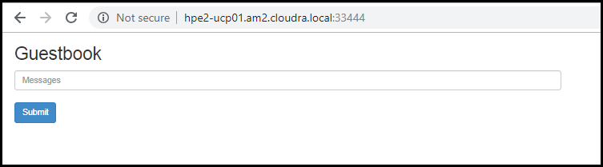

Figure 5. Guestbook UI

### Teardown

A playbook is provided to remove the deployed guestbook artifacts.

# cd ~/Docker-Synergy  
# ansible-playbook -i hosts test/playbooks/k8s-guestbook-teardown.yml --vault-password-file .vault_pass

## UCP metrics in Prometheus

Docker EE 2.1 uses a built-in deployment of Prometheus to power the performance graphs in the web UI for UCP. The metrics that UCP generates can be routed to a separate Prometheus, if required. A convenience playbook has been provided to configure a minimal Prometheus and Grafana deployment that can help vizualize all of the metrics that UCP generates.

For more information on UCP cluster metrics, see the article at <https://docs.docker.com/ee/ucp/admin/configure/collect-cluster-metrics/>.

### Prerequisites

* Install the kubectl binary on your Ansible box
* Install the UCP Client bundle for the admin user

Confirm that you can connect to the cluster by running a test command, for example, kubectl get nodes

### Deploy Prometheus and Grafana

The playbook playbooks/ucp-metrics-prometheus.yml deploys pods for Prometheus and Grafana and configures them to use the client bundle to access the UCP metrics. To run the playbook:

# cd ~/Docker-Synergy  
# ansible-playbook -i hosts playbooks/ucp-metrics-prometheus.yml --vault-password-file .vault_pass

### Prometheus UI

The playbook exposes a port to access the user interface for Prometheus - to find the port, get the details of the prometheus service:

# kubectl get svc Prometheus  
NAME TYPE CLUSTER-IP EXTERNAL-IP PORT(S) AGE  
prometheus NodePort 10.96.216.220 <none> 9090:34713/TCP 6d

The Prometheus UI can be accessed on any node in your cluster, using the port returned by kubectl get svc. In this instance, it is accessed at http://hpe2-ucp01.am2.cloudra.local:34713 as shown in Figure 6.

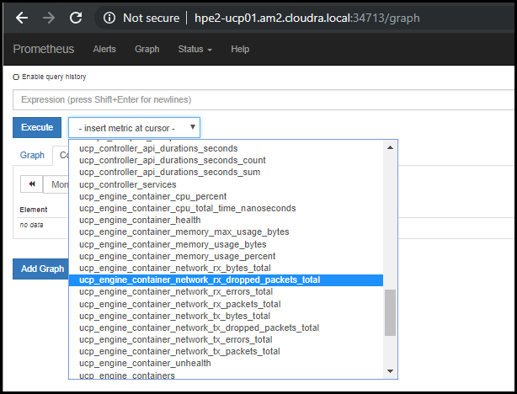

Figure 6. UCP metrics in Prometheus

### Using Grafana to vizualize UCP metrics

The playbook also exposes a port to access the Grafana UI - to find the port, get the details of the grafana service:

# kubectl get svc Grafana  
NAME TYPE CLUSTER-IP EXTERNAL-IP PORT(S) AGE  
grafana NodePort 10.96.177.108 <none> 3000:33118/TCP 6d

The Grafana UI can be accessed on any node in your cluster, using the port returned by kubectl get svc. In this instance, it is accessed at http://hpe2-ucp01.am2.cloudra.local:33118. The example UCP Dashboard shown in Figure 7 is taken from <https://grafana.com/dashboards/9309>.

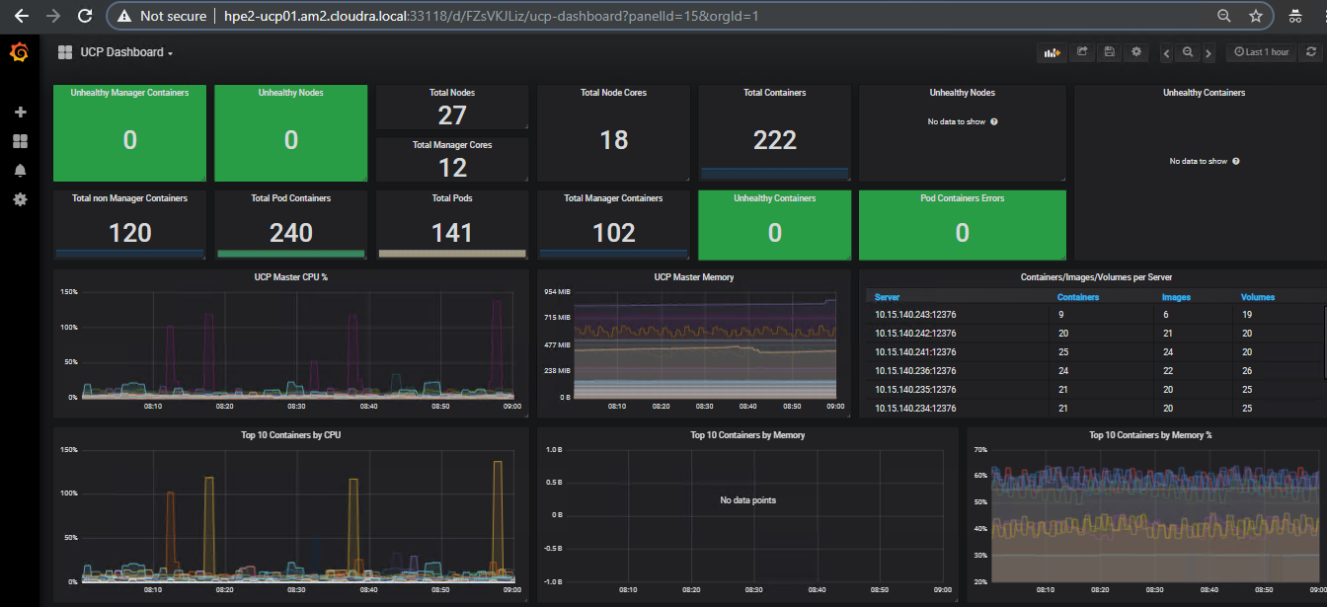

Figure 7. UCP Dashboard in Grafana

# Configuring storage

## Using HPE 3PAR when deploying NFS provisioner for Kubernetes

### Prerequisites

* Configure the variables described in the section Kubernetes Persistent Volume configuration
* Install the kubectl binary on your Ansible box
* Install the UCP Client bundle for the admin user

Confirm that you can connect to the cluster by running a test command, for example, kubectl get nodes

### Setting up HPE 3PAR

The following section outlines the steps you need to follow in order to configure a Virtual File Server and a share for use by the Kubernetes NFS provisioner.

Log in to the HPE 3PAR StoreServ Management console and perform the following tasks.

Create a virtual file server (VFS):

1. In the General section, specify a name, in this instance hpe_vfs3par

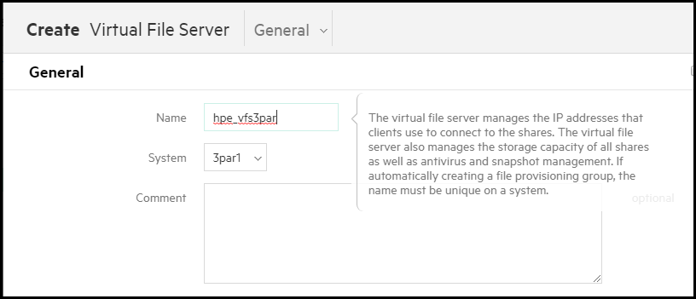

Figure 8. Create Virtual File Server - General

1. In the Storage Allocation Settings section, set the Provisioning to Thin Provisioned, select an appropriate CPG, in this instance FC_r1, and set the size, for example, 1 terabyte.

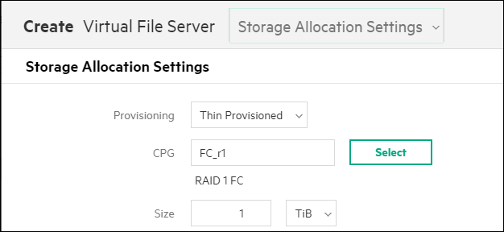

Figure 9. Create Virtual File Server - Storage Allocation Settings

1. Add a virtual IP address

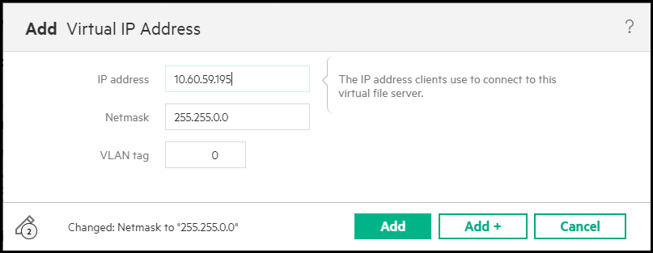

Figure 10. Create Virtual File Server - Add Virtual IP Address

These steps result in a Virtual File Server:

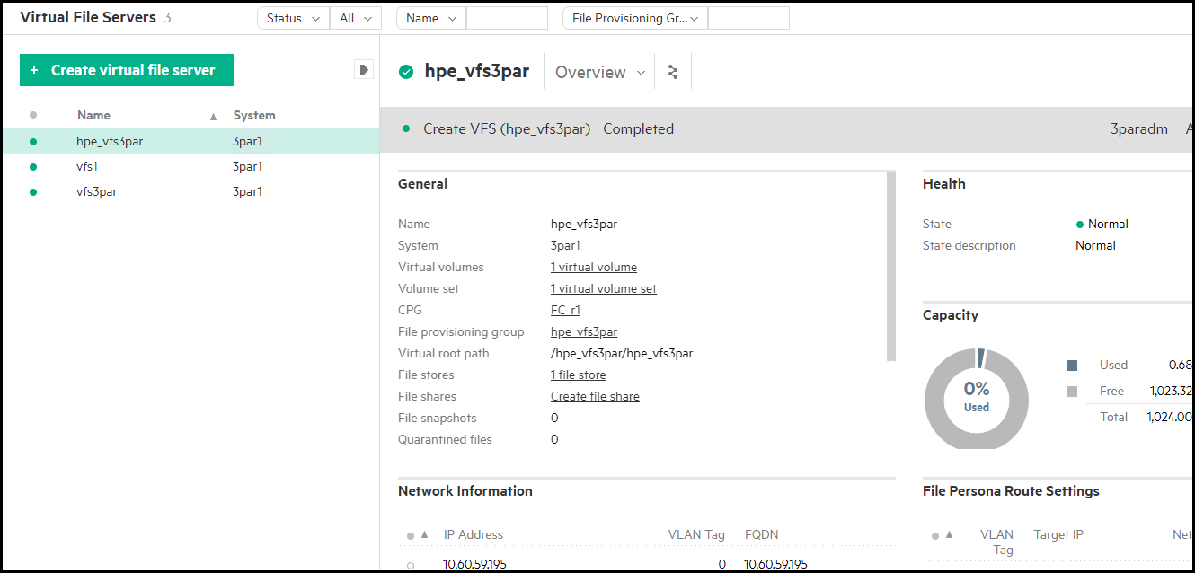

Figure 11. Virtual File Server

Create a File Store:

1. In the General section, specify a name, in this instance HPE_filestore3par, and select the Virtual File Server that you just created.

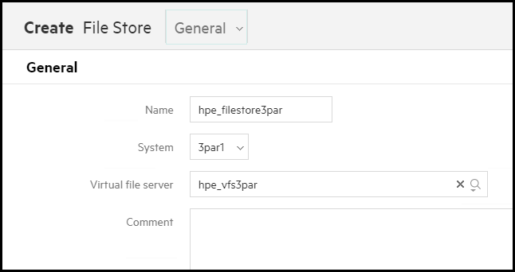

Figure 12. Create File Store – General

1. Use the default Security settings:

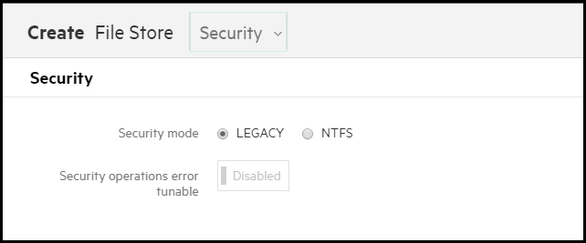

Figure 13. Create File Store – Security

These steps result in the File Store shown below:

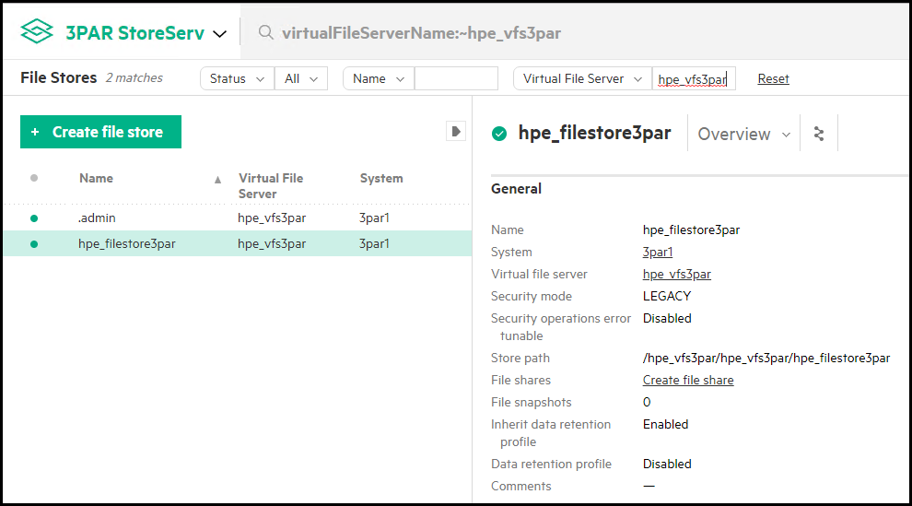

Figure 14. File Store

Create a File Share:

1. In the General section of the Create File Share dialog, set the share type to NFS Share and set a share name, for example, hpe_fileshare3par.

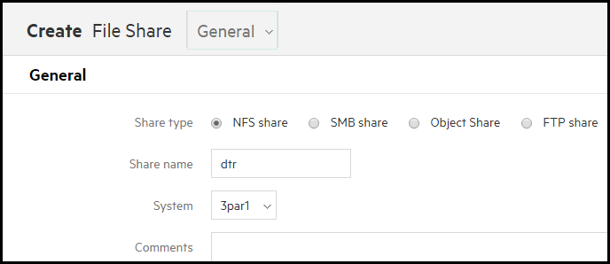

Figure 15. Create File Share – General

1. In the Share Path section, select the virtual file server and file store that you created earlier and set the sub-directory to k8s.

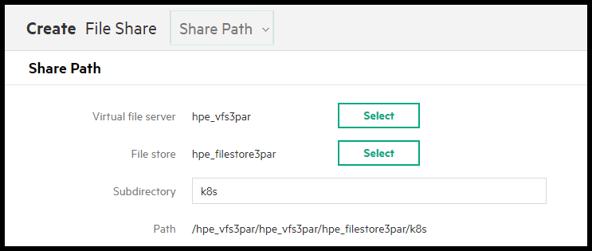

Figure 16. Create File Share - Share Path

1. In the Additional Settings section, set the Permission to Read/Write allowed and the Privilege to root squashing is off (no root squash):

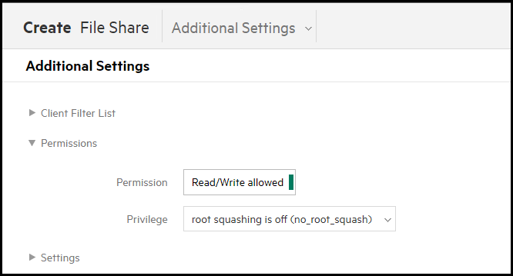

Figure 17. Create File Share - Additional Settings

The overview for the created File Share is shown below and contains the information you need to specify the configuration variables.

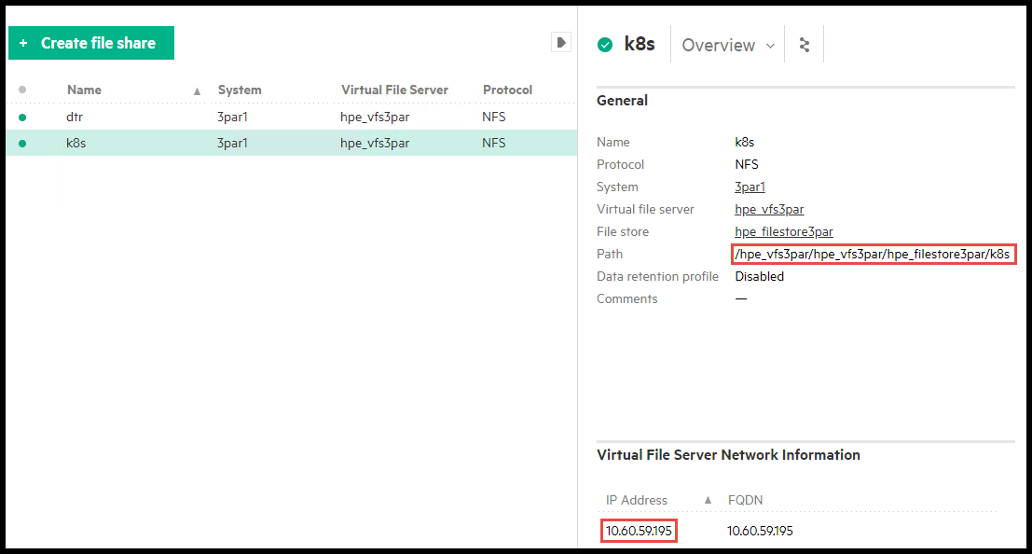

Figure 18. File Share

### Configurating NFS on HPE 3PAR for post-deployment verification

In this example, it is assumed that the relevant variables are configured as follows:

Table 15. NFS on HPE 3PAR configuration

|  |  |
| --- | --- |
| Variable | Value |
| nfs_provisioner_namespace | nfsstorage |
| nfs_provisioner_role | nfs-provisioner-runner-3par |
| nfs_provisioner_serviceaccount | nfs-provisioner |
| nfs_provisioner_name | hpe.com/nfs -3par |
| nfs_provisioner_storage_class_name | nfs -3par |
| nfs_provisioner_server_ip | hpe_vfs3par.cloudra.local |
| nfs_provisioner_server_share | /hpe_vfs3par/hpe_vfs3par/hpe_filestore3par/k8s |
| nfs_mount_options | 'rw,sync,actimeo=0' |

### Running the playbook

Once the appropriate configuration has been establised, run the playbook:

# cd ~/Docker-Synergy  
# ansible-playbook -i hosts playbooks/nfs-provisioner.yml --vault-password-file .vault_pass

Running the command kubectl get sc will show the storage class named nfs-3par:

# kubectl get sc  
  
NAME PROVISIONER AGE  
nfs-3par hpe.com/nfs-3par 5m

The playbook has a built-in test to validate the provisioining. A pod is deployed to write some test content:

templates/nfs-provisioner/nfs-provisioner-writer-pod.yml.j2  
  
kind: Pod  
apiVersion: v1  
metadata:  
 name: writer-pod  
spec:  
 containers:  
 - name: writer-pod  
 image: gcr.io/google_containers/busybox:1.24  
 command:  
 - "/bin/sh"  
 args:  
 - "-c"  
 - "echo '{{ TestMessage }}' >/mnt/bar.txt && while [ 1 ] ; do sleep 2 ; done "  
 volumeMounts:  
 - name: nfs-pvc  
 mountPath: "/mnt"  
 restartPolicy: "Never"  
 volumes:  
 - name: nfs-pvc  
 persistentVolumeClaim:  
 claimName: test-claim

This pod is then deleted, and a new pod is deployed to check that the test content has been persisted after the writer pod went away.

templates/nfs-provisioner/nfs-provisioner-reader-pod.yml.j2

kind: Pod  
apiVersion: v1  
metadata:  
 name: reader-pod  
spec:  
 containers:  
 - name: reader-pod  
 image: gcr.io/google_containers/busybox:1.24  
 command:  
 - "/bin/sh"  
 args:  
 - "-c"  
 - "cat /mnt/bar.txt && while [ 1 ] ; do sleep 1 ; done "  
 volumeMounts:  
 - name: nfs-pvc  
 mountPath: "/mnt"  
 restartPolicy: "Never"  
 volumes:  
 - name: nfs-pvc  
 persistentVolumeClaim:  
 claimName: test-claim

You should see the following output if the provisioning succeeds:

ok: [localhost] => {  
 "msg": "Successfully tested NFS persistent storage"  
}

## Using NFS VM when deploying NFS provisioner for Kubernetes

NFS can be provisioned using the NFS VM for proof of concept or demo systems.

### Prerequisites

* Configure the variables described in the section Kubernetes Persistent Volume configuration
* Install the kubectl binary on your Ansible box
* Install the UCP Client bundle for the admin user

Confirm that you can connect to the cluster by running a test command, for example, kubectl get nodes

### Using NFS VM for post-deployment verification

In this example, it is assumed that the relevant variables are configured as shown in Table 16.

Table 16. NFS provisioner configuration values

|  |  |
| --- | --- |
| Variable | Value |
| nfs_provisioner_namespace | nfsstorage |
| nfs_provisioner_role | nfs-provisioner-runner-vm |
| nfs_provisioner_serviceaccount | nfs-provisioner |
| nfs_provisioner_name | hpe.com/nfs-vm |
| nfs_provisioner_storage_class_name | nfs-vm |
| nfs_provisioner_server_ip | hpe-nfs.cloudra.local |
| nfs_provisioner_server_share | /k8s |
| nfs_mount_options | 'rw,sync,actimeo=0' |

In this instance, the variable nfs_external_server is commented out, resulting in the NFS VM being used, rather than any external server.

Note

When using an external NFS server such as the one hosted by 3PAR, you need to create the file shares manually as shown in the previous section. If you are using the NFS VM, the file share is created automatically when running site.yml by the playbook playbooks/install_nfs_server.yml. If you wish to change the file share after initial deployment, you must update the variable nfs_provisioner_server_share and then re-run the playbook playbooks/install_nfs_server.yml.

### Running the playbook

Once the prerequisites are satisfied, run the appropriate playbook on your Ansible node.

# cd Docker-Synergy  
# ansible-playbook -i hosts playbooks/nfs-provisioner.yml --vault-password-file .vault_pass

Running the command kubectl get sc will show the storage class named nfs-vm:

# kubectl get sc  
  
NAME PROVISIONER AGE  
nfs-vm hpe.com/nfs-vm 5m

The playbook has a built-in test to validate the provisioining. A pod is deployed to write some test content:

The playbook has a built-in test to validate the provisioining. A pod is deployed to write some test content:

templates/nfs-provisioner/nfs-provisioner-writer-pod.yml.j2  
  
kind: Pod  
apiVersion: v1  
metadata:  
 name: writer-pod  
spec:  
 containers:  
 - name: writer-pod  
 image: gcr.io/google_containers/busybox:1.24  
 command:  
 - "/bin/sh"  
 args:  
 - "-c"  
 - "echo '{{ TestMessage }}' >/mnt/bar.txt && while [ 1 ] ; do sleep 2 ; done "  
 volumeMounts:  
 - name: nfs-pvc  
 mountPath: "/mnt"  
 restartPolicy: "Never"  
 volumes:  
 - name: nfs-pvc  
 persistentVolumeClaim:  
 claimName: test-claim

This pod is then deleted, and a new pod is deployed to check that the test content has been persisted after the writer pod went away.

templates/nfs-provisioner/nfs-provisioner-reader-pod.yml.j2

kind: Pod  
apiVersion: v1  
metadata:  
 name: reader-pod  
spec:  
 containers:  
 - name: reader-pod  
 image: gcr.io/google_containers/busybox:1.24  
 command:  
 - "/bin/sh"  
 args:  
 - "-c"  
 - "cat /mnt/bar.txt && while [ 1 ] ; do sleep 1 ; done "  
 volumeMounts:  
 - name: nfs-pvc  
 mountPath: "/mnt"  
 restartPolicy: "Never"  
 volumes:  
 - name: nfs-pvc  
 persistentVolumeClaim:  
 claimName: test-claim

You should see the following output if the provisioning succeeds:

ok: [localhost] => {  
 "msg": "Successfully tested NFS persistent storage"  
}

## Validating the NFS provisioner using WordPress and MySQL

A sample playbook has been provided to show how to use the NFS provioner for perstent storage for a WordPress and MySQL deployment.

### Prerequisites

* Install the kubectl binary on your Ansible box
* Install the UCP Client bundle for the admin user

Confirm that you can connect to the cluster by running a test command, for example, kubectl get nodes

Deploy the NFS provisioner as outlined in the preceeding section. The article assumes that the NFS configuration is the same as used in that section, as shown in Table 17:

Table 17. NFS provisioner configuration values

|  |  |
| --- | --- |
| Variable | Value |
| nfs_provisioner_namespace | nfsstorage |
| nfs_provisioner_role | nfs-provisioner-runner |
| nfs_provisioner_serviceaccount | nfs-provisioner |
| nfs_provisioner_name | hpe.com/nfs |
| nfs_provisioner_storage_class_name | nfs |
| nfs_provisioner_server_ip | hpe2-nfs.cloudra.local |
| nfs_provisioner_server_share | /k8s |

### Running the playbook

The playbook test/playbooks/wordpress-mysql-nfs.yml creates Persistent Volume Claims for both Wordpress and MySQL, deploys both applications and makes the WordPress UI available via a NodePort.

# cd ~/Docker-Synergy  
# ansible-playbook -i hosts ./test/playbooks/wordpress-mysql-nfs.yml --vault-password-file .vault_pass

The output shows the components created along with the NodePort for the wordpress service.

ok: [localhost] => {  
 "ps.stdout_lines": [  
 "Cluster \"ucp_hpe2-ucp01.am2.cloudra.local:6443_admin\" set.",  
 "User \"ucp_hpe2-ucp01.am2.cloudra.local:6443_admin\" set.",  
 "Context \"ucp_hpe2-ucp01.am2.cloudra.local:6443_admin\" modified.",  
 "namespace/wordpress-mysql created",  
 "secret/mysql-pass created",  
 "persistentvolumeclaim/mysql-pv-claim created",  
 "persistentvolumeclaim/wp-pv-claim created",  
 "deployment.apps/wordpress-mysql created",  
 "deployment.apps/wordpress created",  
 "service/wordpress-mysql created",  
 "service/wordpress created",  
 "NAME TYPE CLUSTER-IP EXTERNAL-IP PORT(S) AGE",  
 "wordpress NodePort 10.96.216.103 <none> 80:33790/TCP 0s",  
 "wordpress-mysql ClusterIP None <none> 3306/TCP 0s"  
 ]

Browse to the specified port on any node in your cluster.

http://hpe2-ucp01.am2.cloudra.local:33790

### Configuring WordPress

You need to configure the language and password before WordPress is ready to use, as shown in Figure 19.

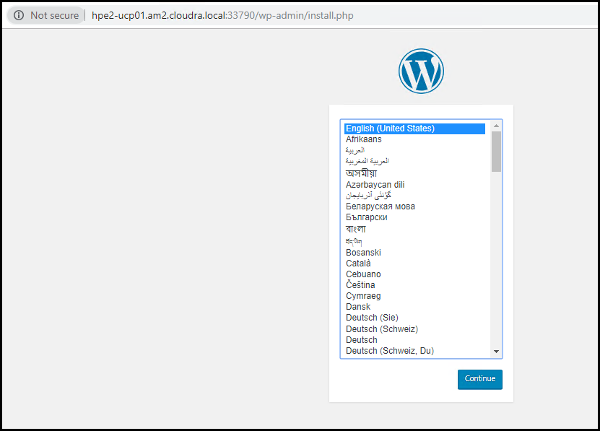

Figure 19. Configure WordPress language

Add a username, password and other configuration details, as shown in Figure 20.

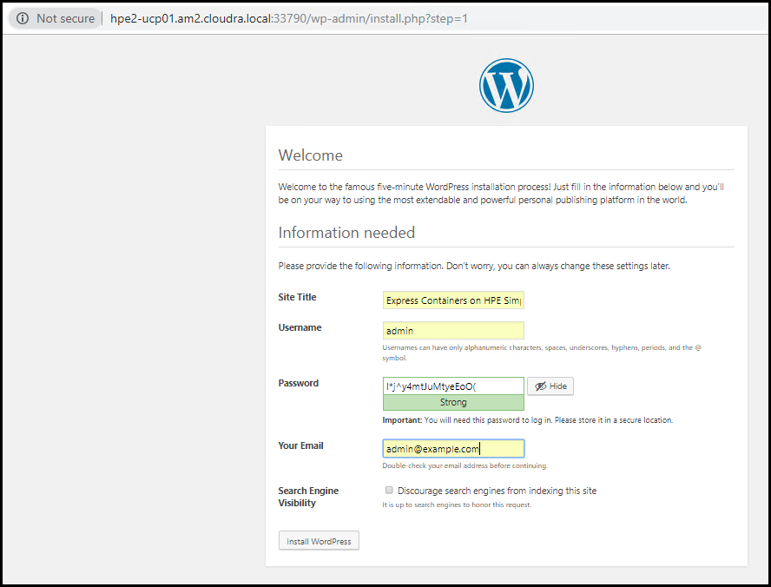

Figure 20. Configure WordPress password

Log in to WordPress, as shown in Figure 21, with the user name and password you have just set up.

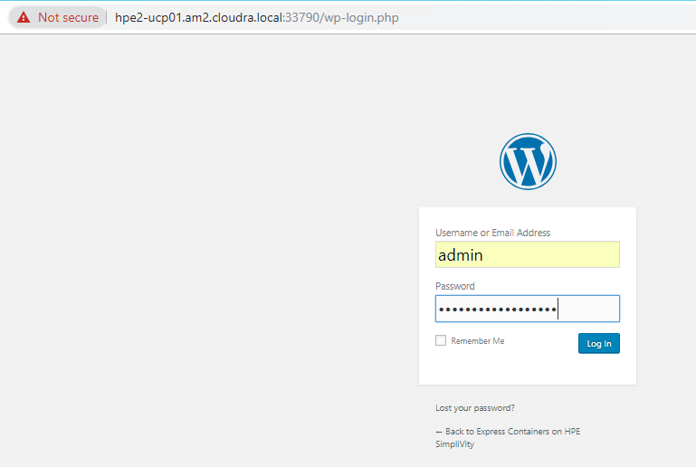

Figure 21. WordPress login

The welcome page is displayed, as shown in Figure 22.

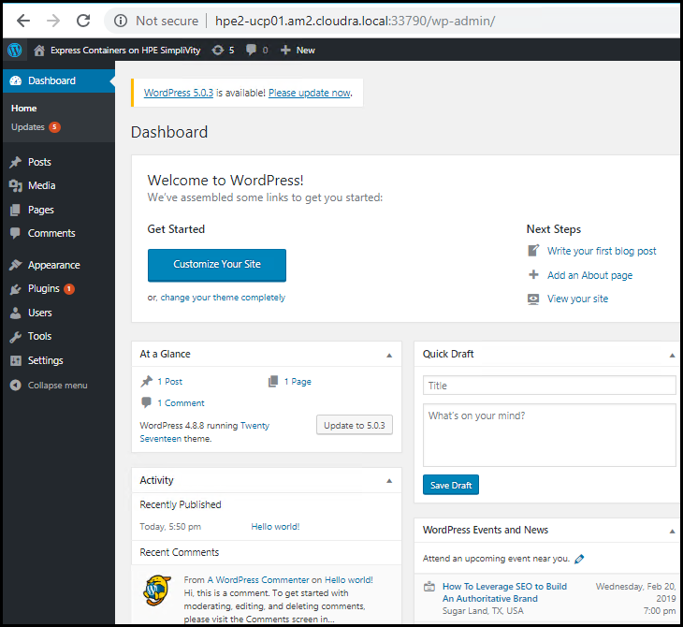

Figure 22. WordPress welcome

### Create your first post

Click on Write your first blog post and start creating some content. Add a blog title and then click Add Media to upload an image to the Media Library and then Insert into post. In this example, as shown in Figure 23, the image is a file named 380 with OmniStack.jpg.

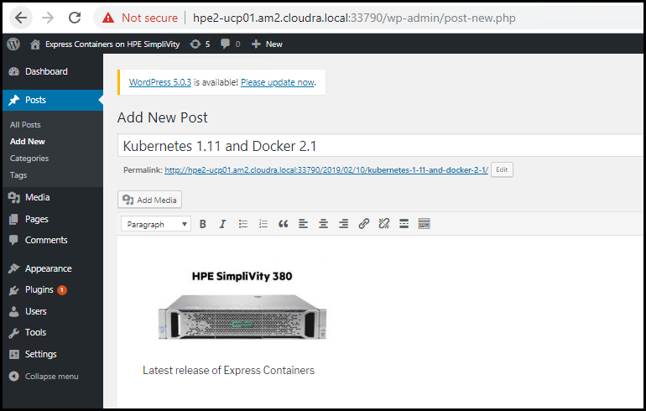

Figure 23. Create your first WordPress blog post

Click Publish and then View post to see your new blog post, as shown in Figure 24.

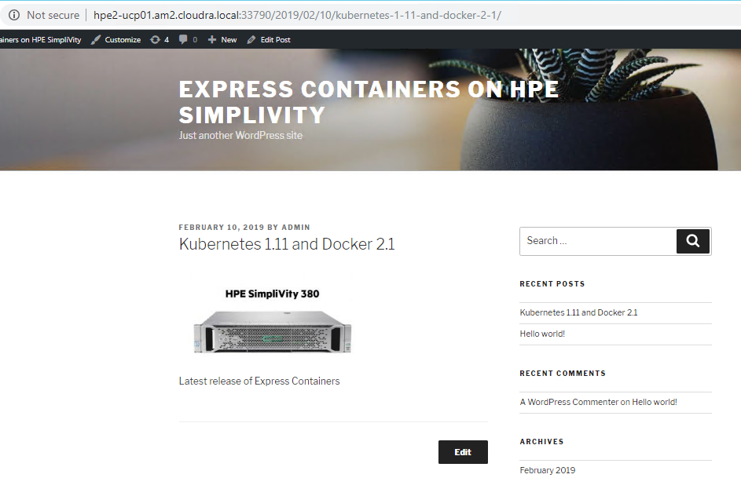

Figure 24. View your first post

### Test persistence for WordPress

Find your WordPress Persistent Volume Claim (PVC).

# kubectl -n wordpress-mysql get pvc  
NAME STATUS VOLUME CAPACITY ACCESS STORAGECLASS AGE  
mysql-pv-claim Bound pvc-d48880e3-2d58-11e9-adb2-0242ac110003 1Gi RWO nfs 1h  
wp-pv-claim Bound pvc-d4bc101f-2d58-11e9-adb2-0242ac110003 20Gi RWO nfs 1h

Connect to the NFS VM and browse the /k8s folder to find the volume for the WordPress claim wp-pv-claim.

# ssh hpe2-nfs ls /k8s  
wordpress-mysql-mysql-pv-claim-pvc-d48880e3-2d58-11e9-adb2-0242ac110003  
wordpress-mysql-wp-pv-claim-pvc-d4bc101f-2d58-11e9-adb2-0242ac110003

Locate the wp-content folder.

# ssh hpe2-nfs ls /k8s/wordpress-mysql-wp-pv-claim-pvc-d4bc101f-2d58-11e9-adb2-0242ac110003  
index.php  
license.txt  
readme.html  
wp-activate.php  
wp-admin  
wp-blog-header.php  
wp-comments-post.php  
wp-config.php  
wp-config-sample.php  
wp-content  
wp-cron.php  
wp-includes  
wp-links-opml.php  
wp-load.php  
wp-login.php  
wp-mail.php  
wp-settings.php  
wp-signup.php  
wp-trackback.php  
xmlrpc.php

Now find the image used in the blog post.

# ssh hpe2-nfs ls /k8s/wordpress-mysql-wp-pv-claim-pvc-d4bc101f-2d58-11e9-adb2-0242ac110003/wp-content/uploads/2019/02  
380-with-OmniStack-100x100.jpg  
380-with-OmniStack-150x150.jpg  
380-with-OmniStack-300x150.jpg  
380-with-OmniStack-768x384.jpg  
380-with-OmniStack.jpg

Note that WordPress has created a number of variations of the original image, for different screen sizes. Shutdown wordpress (leave MySQL running for now).

# kubectl -n wordpress-mysql delete -f /tmp/wordpress-mysql-nfs/wordpress-deployment.yml  
deployment.apps "wordpress" deleted

Refresh the page in the browser to confirm that WordPress is indeed inaccessible.

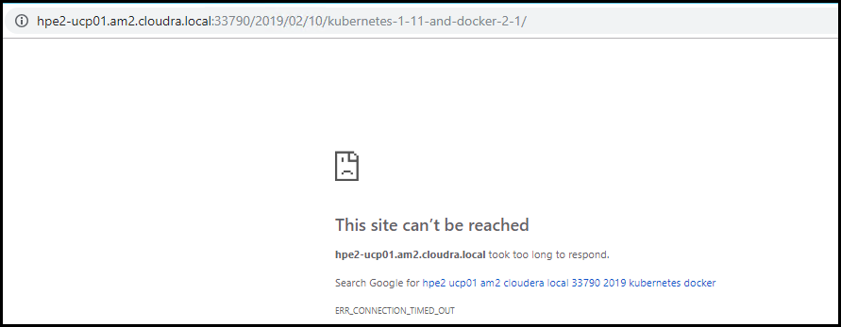

Figure 25. Cannot connect to WordPress

Now redeploy Wordpress

# kubectl -n wordpress-mysql apply -f /tmp/wordpress-mysql-nfs/wordpress-deployment.yml  
deployment.apps/wordpress created

Refresh the page in the browser to confirm that WordPress is now accessible and that the image in the blog post has survived the shutdown, as shown in Figure 26.

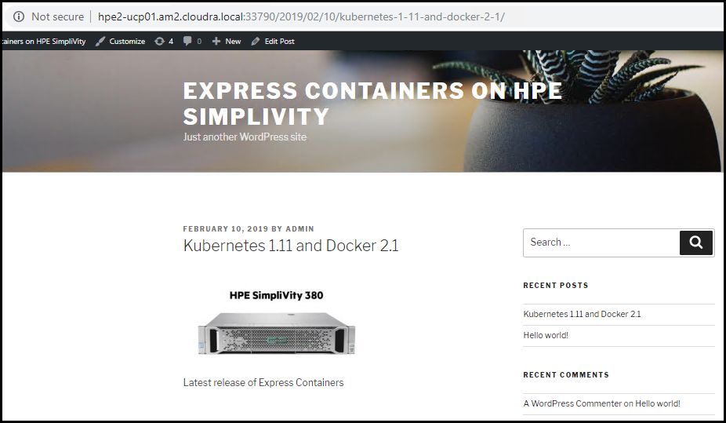

Figure 26. View restored post

### Test persistence in MySQL

A similar procedure can be performed for MySQL. While assets such as images, CSS files, etc are stored in the WordPress volume, information about users, posts, comments, tags, etc are stored in the MySQL database. It is possible to browse the tables in the database and identify the rows related to the blog post you created.

Shut down MySQL as follows:

# kubectl -n wordpress-mysql delete -f /tmp/wordpress-mysql-nfs/mysql-deployment.yml

deployment.apps "wordpress-mysql" deleted

Refresh the page for your blog post, and you will see that WordPress can no longer connect to the database, as shown in Figure 27.

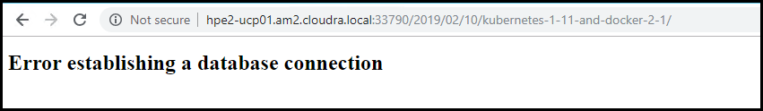

Figure 27. Cannot connect to MySQL

Restore the MySQL deployment:

# kubectl -n wordpress-mysql apply -f /tmp/wordpress-mysql-nfs/mysql-deployment.yml  
deployment.apps/wordpress-mysql created

Refresh the page in the browser, as shown in Figure 28, to confirm that WordPress can now access the database and that the blog post has survived the database shutdown.

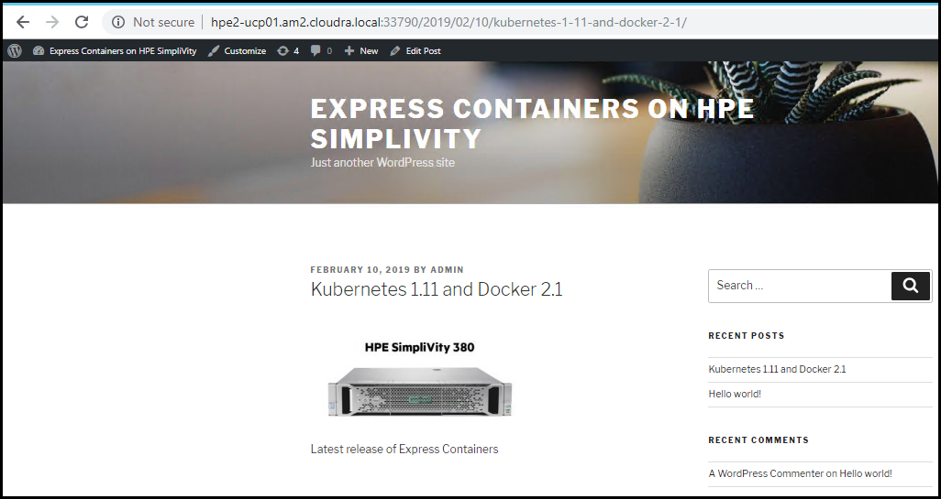

Figure 28. Check after MySQL restored

# Deploying Windows workers

The site.yml playbook will automatically deploy any Windows workers declared in the inventory. The playbooks should run for approximately 70-80 minutes with 3 Windows workers added to the default deployment (depending on your server specifications and the size of your environment). The increase in running time is primarily due to the need to update Windows after creating the VMs.

This section describes the functionality and configuration of the Windows-specific playbooks. It also details how to create the initial Windows template and how to manage deploying Windows worker nodes behind a proxy.

## Create the Windows Template

To create the Windows VM Template that you will use as the base for all your Windows worker nodes, you will first create a Virtual Machine with the OS installed and then convert the Virtual Machine to a VM Template. The VM Template is created as lean as possible, with any additional software installs and/or system configuration performed subsequently using Ansible.

As the creation of the template is a one-off task, this procedure has not been automated. The steps to create a VM template manually are outlined below.

Log in to vCenter and create a new Virtual Machine with the following characteristics:

* Guest OS Family: Windows, Guest OS Version: Microsoft Windows Server 2016 (64-bit)
* Hard Disk size: 100GB (Thin provisioning), 1 vCPU and 4 GB of RAM. Both vCPU and memory can be altered later after you deploy from this template.
* A single network controller connected to the network or VLAN of your choice. All VMs will connect to this same network.
* Change the network type to VMXNET3, and attach the Windows Server 2016 ISO image from a datastore ensuring you connect the CD/DVD drive on boot.
* Click on the VM Options tab, and in the Boot Options section, select Force BIOS setup(*) to ensure that the machine enters the BIOS setup screen on next boot of this VM. This will allow you to adjust the boot order, placing the virtual CDROM in front of your hard drive.

Optionally you can remove the floppy drive.

Install Windows Server 2016:

1. Power on the selected VM and then Open Console. Once connected to the console, you will be placed in the BIOS setup screen.
2. Select the Boot tab, click on CD-ROM Drive and move up the CDROM drive above the hard drive. This allows your Windows Server 2016 ISO image to be loaded first on boot. F10 Save and exit is next step.
3. Enter your choices for Language, Time/Currency Format, Keyboard and then Install Now.
4. Select the OS you want to install, and then select Custom: Install Windows Only.
5. Select drive 0, the 100 GB drive you specified earlier, as the location for installing windows.
6. Add a password for the Administrator user.
7. Install VMware Tools and reboot.
8. Once the VM has re-booted, add a temporary network IP address.
9. Use the sconfig utility from (MS-DOS) command line to install Windows updates and enable remote desktop.
10. Perform any other customizations you require at this point.
11. Prior to converting the VM to Template, run Sysprep: C:\Windows\System32\Sysprep\Sysprep.exe
12. Ensure ‘System Out-of-Box Experience (OOBE)’ is selected.
13. Select the ‘Generalize’ option.
14. Select ‘Shutdown’ from the Shutdown Options.
15. Shutdown VM, and untick Connect CD/DVD so that the Windows Server 2016 ISO is no longer mounted.

Boot the Windows VM one final time and enter regional settings applicable to your location and keyboard mapping, then enter a password and Shutdown VM.

Note

The vmware_guest module used by the playbooks will generate a new SID.

Turn the VM into a template by right-clicking on your VM and selecting Template -> Convert to Template. This will create a new template visible under VM Templates in Folders, ready for future use.

## Playbooks for adding Windows workers

* playbooks/provision_nodes.yml will create all the necessary Windows 2016 VMs for the environment based on the Windows VM Template defined in the win_vm_template variable. Windows VM workers nodes are defined in the group vm_wrk_win in the hosts inventory.
* playbooks/install_docker.yml installs Docker along with all its dependencies on your Windows VMs
* playbooks/scale_workers.yml installs and configures additional Windows workers on the target nodes defined by the group vm_wrk_win in the hosts inventory.

playbooks/splunk_uf_win.yml installs and configures the Splunk Universal Forwarder on each Windows machine in the inventory.

## Windows configuration

Window-related variables are shown in Table 18. Variables for all Windows nodes (VM and bare metal) are in the file group_vars/windows_box.yml. Windows VM-specific variables are in group_vars/vm_wrk_win.yml while Windows bare metal variables are in group_vars/bm_wrk_win.yml

Table 18. Windows variables

|  |  |  |
| --- | --- | --- |
| Variable | File | Description |
| win_username | group_vars/windows_box.yml | Windows user name. The default is Administrator |
| win_password | group_vars/all/vault | The password for the Windows account. |
| docker_ee_version_windows | group_vars/windows_box.yml | It is important that the version of the Docker engine running on your Windows worker nodes is the same as that running on RHEL in the rest of your cluster. You should use this variable to explicitly match up the versions. For Docker 2.1, the recommended value is '18.09'. If you do not explicitly set this value, you may end up with an incompatible newer version running on your Windows workers. |
| windows_update | group_vars/windows_box.yml | Variable used to determine if Windows updates are automatically downloaded when installing Docker on Windows worker nodes (in the playbooks/install_docker.yml). Defaults to true. |
|  |  |  |
| windows_docker_drive | group_vars/windows_box.yml | 'D' |
| windows_docker_directory | group_vars/windows_box.yml | 'D:\\DockerData' |
| windows_docker_volume_label | group_vars/windows_box.yml | 'DockerVol' |
| windows_tz | group_vars/windows_box.yml | 'Pacific Standard Time' This is different from the windows_timezone variable. It is important that this value matches the timezone used by UCP servers for certificate validation. See <https://msdn.microsoft.com/en-us/library/ms912391.aspx>. |
|  |  |  |
| windows_winrm_script | group_vars/windows_box.yml | Variable used to determine where the winrm Powershell script will be downloaded from. See the following section for more information. |

### Configuring the winrm remoting script

The playbooks for deploying Windows workers rely on a Powershell script for remote access from the Ansible machine. The script ConfigureRemotingForAnsible.ps1 is available online on GitHub at <https://raw.githubusercontent.com/ansible/ansible/devel/examples/scripts/ConfigureRemotingForAnsible.ps1>.

You need to make this script available locally:

1. Download the script:  
     
   wget https://raw.githubusercontent.com/ansible/ansible/devel/examples/scripts/ConfigureRemotingForAnsible.ps1
2. Deploy a local HTTP server, enabling port 80, for example:  
     
   yum install httpd  
   systemctl enable httpd  
   systemctl start httpd  
   firewall-cmd --permanent --add-port 80/tcp --zone=public  
   firewall-cmd –reload
3. Copy the downloaded script to the web server:  
     
   cp ConfigureRemotingForAnsible.ps1 /var/www/html

Configure the variable to point at the local web server, for example,  
  
windows_winrm_script: 'http://10.10.174.230/ConfigureRemotingForAnsible.ps1'

### Windows VM variables

The following table shows the variables specific to Windows VMs.

Table 19. Windows VM variables

|  |  |  |
| --- | --- | --- |
| Variable | File | Description |
| win_vm_template | group_vars/vm_wrk_win.yml | Name of the Windows 2016 VM Template to use. Note that this is the name from a vCenter perspective, not the hostname. |
| windows_vdvs_ps | group_vars/vm_wrk_win.yml | Variable used to download the PowerShell script that is used to install vDVS for Windows. For example, <https://raw.githubusercontent.com/vmware/vsphere-storage-for-docker/master/install-vdvs.ps1> |
| windows_vdvs_path | group_vars/vm_wrk_win.yml | Variable used to download vSphere Docker Volume Service software. This variable is combined with windows_vdvs_version (below) to generate a URL of the form <windows_vdvs_path>_<windows_vdvs_version>.zip to download the software. For example, to download version 0.21, set windows_vdvs_path equal to https://vmware.bintray.com/vDVS/vsphere-storage-for-docker_windows and windows_vdvs_version equal to 0.21 |
| windows_vdvs_version | group_vars/vm_wrk_win.yml | Combined with windows_vdvs_path, this variable is used to generate the URL for downloading the software. |
| windows_vdvs_directory | group_vars/vm_wrk_win.yml | Variable used to determine where vDVS software will be unzipped and installed from. The default is C:\Users\Administrator\Downloads |
| windows_timezone | group_vars/vm_wrk_win.yml | Defaults to 15.  Valid values are available at <https://msdn.microsoft.com/en-us/library/ms912391.aspx> |

### group_vars/win_worker.yml

In general, it should not be necessary to modify the following advanced variables, but they are documented in Table 20 for the sake of completeness.

Table 20. Advanced windows variables

|  |  |  |
| --- | --- | --- |
| Variable | File | Description |
| ansible_user | group_vars/windows_box.yml | Defaults to the Windows user account win_username as specified in group_vars/all/vars |
| ansible_password | group_vars/windows_box.yml | Defaults to the Windows user password win_password as specified in group_vars/all/vault |
| ansible_port | group_vars/windows_box.yml | 5986 |
| ansible_connection | group_vars/windows_box .yml | winrm |
| ansible_winrm_server_cert_validation | group_vars/windows_box .yml | Defaults to ignore |
| ansible_winrm_operation_timeout_sec | group_vars/windows_box .yml | Defaults to 250 |
| ansible_winrm_read_timeout_sec | group_vars/windows_box .yml | Defaults to 300 |
| windows_timezone | group_vars/windows_box .yml | Defaults to 15. Valid values are available at <https://msdn.microsoft.com/en-us/library/ms912391.aspx> |

## Windows operating system and Docker EE

Docker Enterprise Edition for Windows Server (Docker EE) enables native Docker containers on Windows Server. This solution has been tested with Windows worker nodes running Windows Server 2016 and with Docker EE 18.09. More recent versions of Windows Server may work but have not been tested.

Note

Docker Universal Control Plane is not currently supported on Windows Server 1709 due to image incompatibility issues. For more information, see the Docker documentation [Install Docker Enterprise Edition for Windows Server](https://docs.docker.com/install/windows/docker-ee/).

This solution recommends that you only run Windows Server 2016 on your Windows worker nodes and that you install any required updates to your Windows nodes in a timely manner.

For information on how to update Docker EE on Windows Server 2016, see the Docker documentation [Update Docker EE](https://docs.docker.com/install/windows/docker-ee/#update-docker-ee).

# Deploying bare metal workers

## Introduction to bare metal workers

This solution leverages HPE Synergy OneView 4.10 and HPE Image Streamer 4.10 to provision bare metal servers with an operating system so they can be added to a Docker/Kubernetes cluster as worker nodes. Before you can provision servers using the playbooks, you need to create one or more Image Streamer Operating System Deployment Plans (OSDP) and one or more OneView Server Profile Templates (SPT).

HPE OneView Server Profile Templates are used to create the OneView Server Profiles (SP) that are applied to the Synergy compute modules, also known as bare metal servers. Each bare metal server listed in the Ansible inventory maps to exactly one OneView Server Profile Template. Depending on the environment, you may need to create one or more SPTs depending on the type of servers available in your Synergy environment. In the simplest case, where all servers are of the same Server Hardware Type and there is a single enclosure group, a single SPT can be used. If, on the other hand, the pool of compute modules consists of different server types (for example Gen9 and Gen10 compute modules), then a separate SPT must be created for each Server Hardware Type. When creating the SPT, an OSDP is specified. In most cases, the same OSDP can be used for all compute modules running the same operating system. If you want to deploy both Windows and Linux worker nodes in the same cluster, you need to create a minimum of two SPTs and two OSDPs. One SPT will specify an OSDP that deploys Linux, while a separate SPT will specify a different OSDP that deploys Windows.

Image Streamer Operating System Deployment Plans leverage Operating System Build Plans (OSBP), each of which contains one or more Plan Scripts that are used to configure the deployed Operating System. Each Plan Script may expose one or more OS custom attributes. Custom attributes are parameters that can either be hard-coded to specific values or exposed to the deployment plan and configured by the SPT using the deployment plan. Custom attributes can hold various data types such as IP addresses, host names, product keys etc. The OSDP also specifies a golden image, which will be used when deploying the OS on the server.

When it comes to the provisioning of bare metal servers, the Ansible playbooks create Server Profiles (SP) based on specified SPT and assign the server profiles to physical compute modules in the Synergy enclosures. The provisioning of the operating system is done when the server profile is applied using the Image Streamer OSDP specified in the SPT. Once the servers are provisioned, they are powered on by the playbooks.

## Playbooks and configuration

The following table shows the basic variables needed for OneView configuration.

Table 21. HPE OneView variables

|  |  |  |
| --- | --- | --- |
| Variable | File | Description |
| oneview_config_hostname | group_vars/all/vars | The server hosting HPE OneView |
| oneview_config_username | group_vars/all/vars | HPE OneView user name. Defaults to Administrator |
| oneview_config_password | group_vars/all/vault | HPE OneView password. |
| oneview_config_api_version | group_vars/all/vars | HPE OneView API version. Defaults to 600 |

When it comes to the provisioning of bare-metal servers, the Ansible playbooks create Server Profiles (SP) based on specified Server Profile Templates (SPT) and assign the server profiles to physical compute modules in the Synergy enclosures. The provisioning of the operating system is done when the server profile is applied using the Image Streamer OSDP specified in the SPT. Once the servers are provisioned, they are powered on by the playbooks.

The playbook responsible for the provisioning of the bare metal servers uses the following information stored in Ansible variables for each worker node:

* ov_template: The name of the SPT to use when creating the SP for this compute module
* ov_ansible_connection_name and ov_ansible_redundant_connection_name: The names of the network connections in the server profile template that maps to the network where the Ansible controller node resides. Currently redundant connections are supported so you must specify two connections on the Ansible network/VLAN

enclosure and bay: The target compute module to provision, specified by the name of the Synergy enclosure where the compute module resides and the bay number of the compute module

Below is an excerpt of a sample inventory file. The enclosure and bay number is specified for each bare-metal server. Because this particular HPE Synergy environment contains compute modules of different hardware types, each worker node entry also specifies the HPE OneView Server Profile Template to use when deploying the OS.

In this example, both Gen9 and Gen10 compute modules are used and Linux and Windows worker nodes are being deployed.

[bm_wrk_lnx]  
clh-worker04 ip_addr='10.60.59.25/16' enclosure='Rack1-Mid-CN759000BZ' bay=8 ov_template='RedHat760_fcoe_gen9_4_v1.0.3'  
clh-worker06 ip_addr='10.60.59.27/16' enclosure='Rack1-Top-CN7515048P' bay=5 ov_template='RedHat760_fcoe_gen9_3_v1.0.3'  
  
[bm_wrk_win]  
clh-worker05 ip_addr='10.60.59.26/16' enclosure='Rack1-Top-CN7515048P' bay=2 ov_template='Win2016_fcoe_gen10_3_v1.0.3'

Note the difference in the Linux template names for the separate Server Hardware Types of Gen 9 4 and Gen 9 3. This can be seen in the following figure taken from HPE OneView:

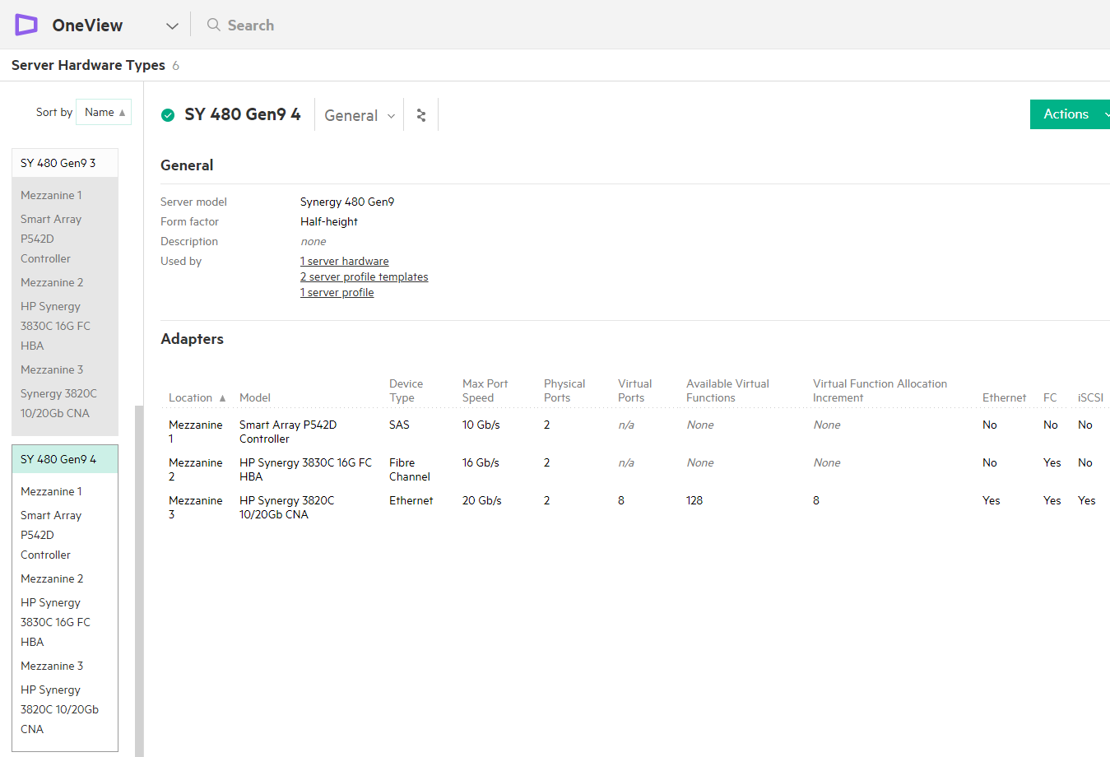

Figure 29. HPE OneView Server Hardware Types

Common variables for all Windows nodes (VM and bare metal) are specified in the file group_vars/windows_box.yml. Windows VM-specific variables are in group_vars/vm_wrk_win.yml while Windows bare metal variables are in group_vars/bm_wrk_win.yml

## OS Deployment Plan Custom Attributes

### RHEL OS Deployment Plan

Currently, the code responsible for the provisioning of server profiles expects the OS Deployment Plans to expose two and only two custom attributes named 'NIC1' and 'NIC2'. This means the server profiles templates using the OSBP will only see the NIC1 and NIC2 attributes as shown in the figure below, which illustrates the OS Deployment section of the RedHat760_fcoe_gen9_4_v1.0.3 server profile template.

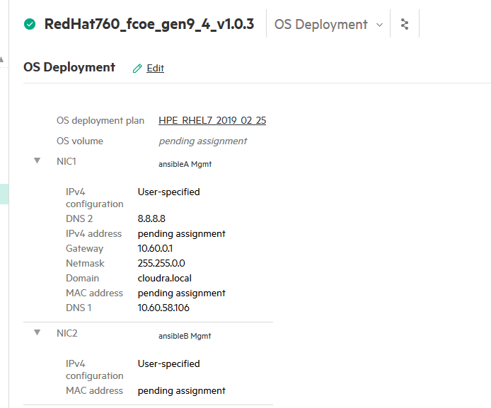

Figure 30. Server Profile Template - OS Deployment

The IPV4 configuration should be configured using "User-specified" because the playbooks will assign the IP addresses from the data in the hosts inventory file. All other attributes are populated automatically.

It is possible to specify additional custom attributes in the OS Deployment Plan and the underlying OS Build Plan but these attributes should be hard-coded to the desired values and should not be made visible on deployment.

For example, the Red Hat OS Deployment Plan includes four custom attributes used by the underlying OS Build Plan that are not exposed by the OS Deployment Plan.

* NewRootPassword: This attribute is used to configure the password for the root account.
* NewUser and NewUserPassword: These two custom attributes are used to configure an additional user.
* ssh: The underlying OS Build Plan specifies that SSH is enabled since this is required for Ansible to work.

Again, these non-visible custom attributes are all hard-coded to specific values in the OS Build Plan, which effectively means any compute module deployed using this OS Deployment Plan will have these custom attributes set to these hard-coded values.

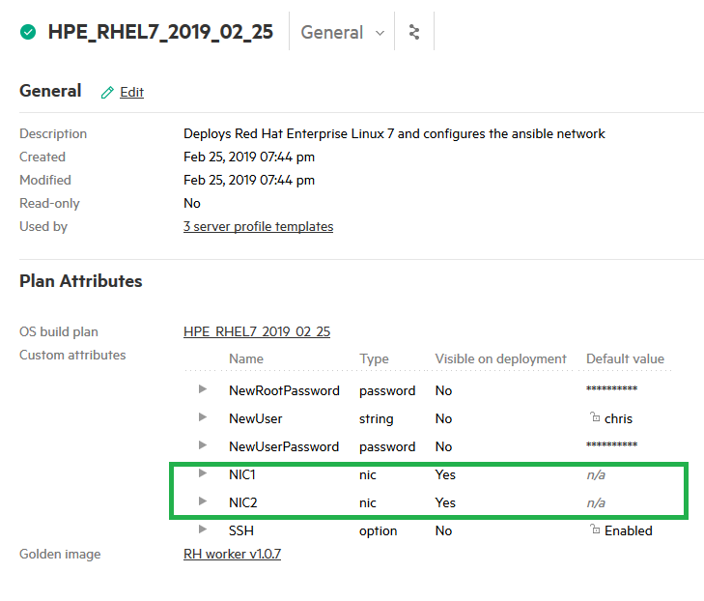

Figure 31. Deployment Plan attributes

### Windows 2016 OS Deployment Plan

The following figure shows the Windows 2016 OS Deployment Plan shipping with this solution where only the NIC1 and NIC2 attributes are exposed but additional custom attributes are present and used to configure the Windows OS during deployment. Among other things, the password for the administrative user, the desired Power Plan, Remote Desktop settings, and the Windows Product Key are specified using custom attributes.

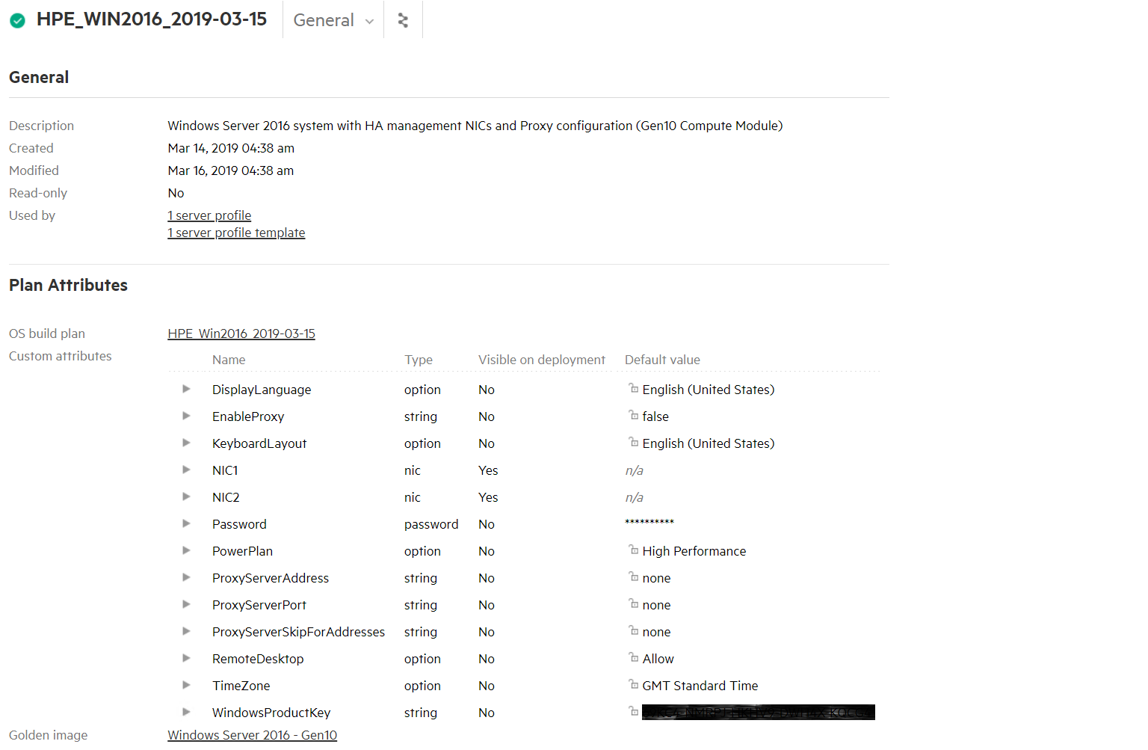

Figure 32. Windows 2016 Deployment Plan attributes

### Windows Proxy Server Configuration

This Deployment Plan includes the ability to configure a Proxy server if needed. There are four custom attributes related to proxy server configuration:

Table 22. Custom attributes for proxy configuration

|  |  |  |
| --- | --- | --- |
| Custom attribute name | Purpose | Default value |
| EnableProxy | Controls whether the remaining proxy-related custom attributes are applied to the server during OS deployment | false |
| ProxyServerAddress | The hostname or IP address of the proxy server | none |
| ProxyServerPort | The numeric port number used by the proxy server | none |
| ProxyServerSkipForAddresses | Hostnames or IP addresses that are excluded from the proxy server | none |

By default the EnableProxy custom attribute is set to "false" which causes the other three proxy-related custom attributes to be ignored. However, all of these custom attributes require a string value be configured (i.e. they cannot be left blank), which is why the remaining proxy attributes are set to "none". In environments where a proxy server is required to reach the internet, the EnableProxy attribute must be set to "true" and the ProxyServerAddress, ProxyServerPort, and ProxyServerSkipForAddresses attributes should be configured with their appropriate values.

For more information about custom attributes and the type of attributes available, see the [HPE Synergy Image Streamer 4.1 User's Guide](https://support.hpe.com/hpsc/doc/public/display?docId=emr_na-a00039930en_us&docLocale=en_US).

## RHEL Golden Images

### OS installation and configuration with HPE Synergy Image Streamer

The bare metal RHEL worker nodes will be deployed and customized using HPE Synergy Image Streamer. This section outlines the steps required to install the host. At a high level, these steps can be described as:

1. Download the artifacts for HPE Image Streamer from the HPE GitHub site.
2. Add the artifact bundles to HPE Image Streamer.
3. Prepare a compute module for the installation of the Operating System.
4. Create a Server Profile.
5. Install and customize the Operating System.
6. Capture a Golden Image from the compute module.

Deploy the hosts.

### Download the artifacts for HPE Synergy Image Streamer

Red Hat Enterprise Linux bundles for HPE Image Streamer may be downloaded from <https://github.com/HewlettPackard/image-streamerrhel/tree/V4.1/artifact-bundles/>.

Sample foundation artifact bundles should be downloaded from <https://github.com/HewlettPackard/imagestreamer-tools/tree/v4.0/foundation/artifact-bundles>.

### Add the artifact bundles to HPE Image Streamer

The following steps show how to add the artifact bundles to Image Streamer:

1. From within the HPE Image Streamer interface navigate to the Artifact Bundles page.
2. From the Actions menu, Add the downloaded RHEL artifact bundle. If not already present, add the sample foundation bundle.

From the Actions menu, select Extract to extract the artifacts from each downloaded bundle.

### Prepare the compute module for the installation of the Operating System

1. Attach a Red Hat Enterprise Linux 7.* Server ISO to the iLO of a worker node host by selecting the Action menu and then Launch Console.

When the console launches, select Virtual Drives and then Image File CD-ROM/DVD. Browse to the location where your ISO resides and select it.

### Create a Server Profile

1. Use a Server Profile Template to deploy a new Server Profile to the worker node host you attached the ISO to in the prior step.
2. Select the new Server Profile and choose Edit.
3. Under the OS Deployment section, choose HPE-Create Empty Volume and enter a Volume Size of 30720 MB.
4. Validate the network and SAN connections exist on the host.
5. Ensure that, under boot settings, Boot mode is set to UEFI optimized and that the Primary boot device is Hard disk.
6. Click OK. It will take some time for the profile to create.

While waiting on profile creation to complete, select the Actions menu and then click Launch Console. Click Allow to launch the console.

### Install and customize the Operating System

1. After profile creation is completed, power on the server. From the console window, select Power Switch and then Momentary Press.
2. When the screen shown in the following figure appears, select Install Red Hat Enterprise Linux 7.* and then hit the letter ‘e’ on the keyboard.

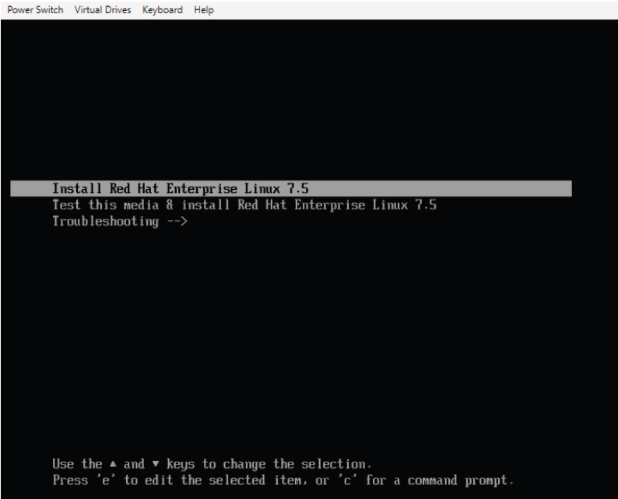

Figure 33. Selecting OS to install

1. Append the following to the install kernel boot parameter: rd.iscsi.ibft=1
2. Type Ctrl-x to continue the boot process.
3. When the installer screen appears, insure you select your local language, set the date and time, keyboard layout and language support. When done, click Installation Destination.
4. At the Installation Destination screen, select Add a disk and then choose the 30 GiB volume from HPE Image Streamer. Select Done once you have chosen this disk.
5. Under Other Storage Options, select the radio button for I will configure partitioning and then click Done.
6. At the Manual Partitioning screen, select Click here to create them automatically. This will display a new Manual Partitioning screen.
7. Highlight the /boot partition and on the right side of the page select ext4 as the File System. Click the Update Settings button.
8. Highlight the / partition and on the right side of the screen, reduce the Desired Capacity to 8 GiB and then choose ext4 as the File System. Click the Update Settings button.
9. Highlight the swap partition and on the right side of the screen, change Desired Capacity from 3000 MiB to 4092 MiB. Click the Update Settings button.
10. Click the “+” button below the list of partitions. For Mount Point, select /var from the dropdown and leave the Desired Capacity blank. This will allow the /var partition to use all remaining space.
11. At the Manual Partitioning screen, highlight the /var partition and choose /ext4 for the File System. Click Update Settings.
12. The screen should appear as shown in the following figure.

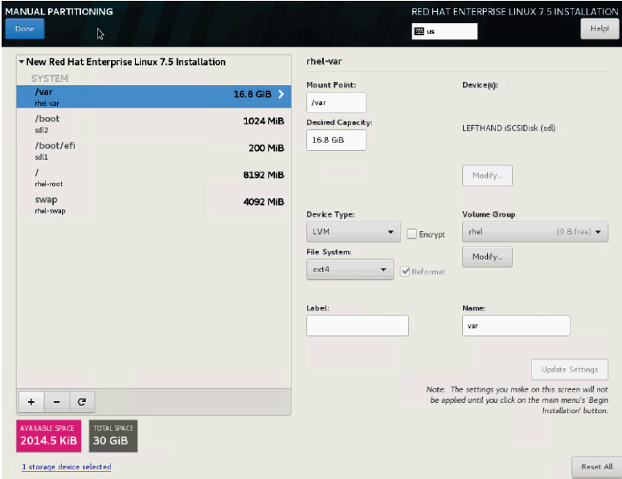

Figure 34. Manual partitioning

1. Once you have validated the file systems and partition sizes are correct, click Done.
2. When prompted, click Accept Changes.
3. Click the Network & Hostname link. At the resulting screen, highlight Ethernet (ens3f4) and set it to ‘ON’ in the descriptor screen as in the following figure. Click Done.

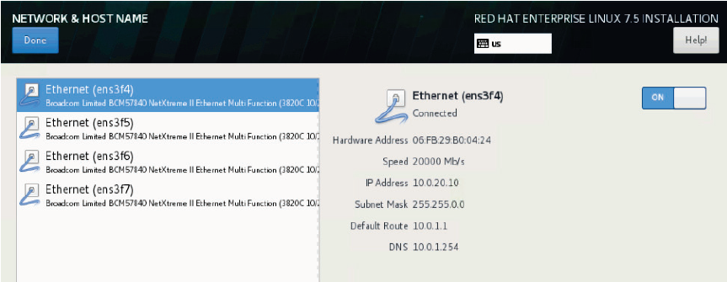

Figure 35. Network & Host Name

1. Click Begin Installation. Set a root password for the host. Do not configure extra users. Click Done.
2. Once the OS installation is complete you can reboot the host. Log on at the iLO console when the host becomes active again.
3. Configure a temporary hostname for the system
4. Configure your networking and ensure you have connectivity.
5. Register the host with Red Hat by running the following command. Enter the username and password when prompted.  
     
   # subscription-manager register
6. Use Red Hat subscription manager to register your system to give you access to the official Red Hat repositories. Use the subscription-manager register command as follows.  
     
   # subscription-manager auto-attach
7. Enable the required repos:  
     
   # subscription-manager repos \  
   --enable=rhel-7-server-rpms \  
   --enable=rhel-7-server-extras-rpms
8. Update the host by running the following command.  
     
   # yum update
9. Copy the SSH public key from your Ansible box. This will allow your Ansible node to SSH without the need for a password to all the bare metal REHL nodes.  
     
   # ssh-copy-id root@<IP of your bare metal node>
10. Gracefully shut down the host.  
      
    # yum update

## Windows Golden Images

### Prepare Image Streamer with Windows Artifact Bundle

* Download the "HPE - Windows - 2018-10-26.zip" artifact bundle from the GitHub repository at <https://github.com/HewlettPackard/image-streamer-windows>. The file is available in the artifact-bundles directory. The artifacts are supported on HPE Image Streamer 4.1 and higher for Windows 2016, while version 4.2 and higher are required for Windows 2019. This solution has been tested using Windows 2016 on HPE Image Streamer 4.1.
* Upload the Artifact bundle to the Image Streamer appliance

Extract the Artifact Bundle on the Image Streamer appliance

### Create Windows Golden Image

The procedure for creating a Windows Server 2016 golden image are documented in the Image Streamer GitHub repostiory at <https://github.com/HewlettPackard/image-streamer-windows>. See the appropriate file in the docs directory here.

The instructions are repeated here for convenience, but you should rely on the Image Streamer repository for the definitive version of the documentation.

1. Ensure that you have access to Windows 2016 or 2019 ISO file.
2. Create a server profile with “HPE - Foundation 1.0 - create empty OS Volume” as OS Deployment plan and a server hardware of desired hardware type (see section on Golden Image Compatibility below). Set an appropriate value for volume size in MiB units, say 40000 MiB. The HPE Synergy Server will be configured for access to this empty OS Volume.
3. Launch iLO Integrated Remote Console of this server and set the Windows 2016 or 2019 ISO file as virtual CD-ROM/DVD image file. Power on the server.
4. Windows should present an option of installing from CD/DVD. Continue with this option.
5. Install Windows 2016 or 2019.
6. (Optional) To take a backup of this installation at this stage:
7. Shutdown the server
8. Perform an as-is capture using "HPE - Windows - Capture - As-Is" build plan to create the "as-is" golden image of the OS.
9. Deploy another server with the golden image captured in previous step and boot the server.
10. Install any additional software or roles if required.

Note

The next six steps can be automated using the “PrepareForImageStreamerOSVolumeCapture.ps1” script in “scripts” directory on the GitHub repository where Windows artifact bundles are available for download.

1. Create a FAT32 partition which will be used by the artifacts for personalization: FAT 32 partition can be created either from UI using Disk Management utility (8.1) or using CMD Diskpart commands (8.2).  
     
   8.1 FAT32 partition creation from UI  
     
   a. Open "Computer Management" > "Disk Management"  
   b. Select C: partition  
   c. Shrink volume  
   d. Change amount of space to shrink to 100 MB  
   e. Select Shrink  
   f. Select new Unallocated space  
   g. Select New Simple Volume  
   h. Leave size  
   i. Assign drive letter, (Choose S)  
   j. Format as FAT32 file system type (this requires changing from the default)  
   k. Give Volume label as "ISDEPLOY"  
   l. Finish  
   m. “ISDEPLOY (S:)” should be shown  
     
   8.2 FAT32 partition creation using CMD commands  
   Use list volume command to get volume number for C: partition. Here C: partition resides in Volume 0.  
     
   C:\Users\Administrator>diskpart  
   DISKPART>list volume   
   DISKPART >select volume 0   
   DISKPART >shrink desired=100   
   DISKPART >create partition primary size=100   
   DISKPART >format fs=fat32 quick label=ISDEPLOY   
   DISKPART >assign letter=S
2. Backup drive-letters  
     
   reg export HKLM\System\MountedDevices C:\driveletters.reg
3. Generalize Windows using Sysprep  
     
   WARNING: This operation is destructive and will remove all configuration. To take backup of the system at this stage, capture an as-is golden image.  
     
   Open Command Prompt window and run the following  
     
   cd Windows\System32\Sysprep  
   Sysprep /generalize /oobe /quit  
     
   This will take a few minutes to complete and will generalize the system. All settings will be lost. This does not remove any additional user accounts that are created. Any user accounts not required in the captured golden image must be manually deleted.
4. Restore drive-letters  
     
   reg import C:\driveletters.reg
5. Set Unattend.xml location to the FAT32 partition  
     
   reg add HKLM\System\Setup /v UnattendFile /t REG_SZ /d "S:\ISdeploy\Unattend.xml"
6. Set SetupComplete.cmd location to the FAT32 partition  
     
   mkdir C:\Windows\Setup\Scripts   
   echo S:\ISdeploy\SetupComplete.cmd > C:\Windows\Setup\Scripts\SetupComplete.cmd
7. Shutdown the server.

Capture a golden image using the "HPE - Windows - Capture - As-Is" build plan as described in the following section.

### Capture the Golden Image

* Determine the OS Volume that was created for the Server Profile created earlier:

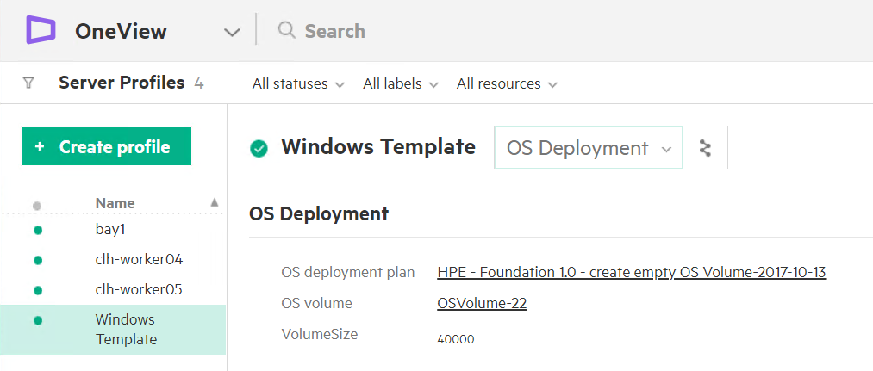

Figure 36. Server profile

* Navigate to the Image Streamer Golden Images page
* Select "Create golden image" specifying the OS Volume and the "HPE - Windows - Capture - As-Is" build plan:

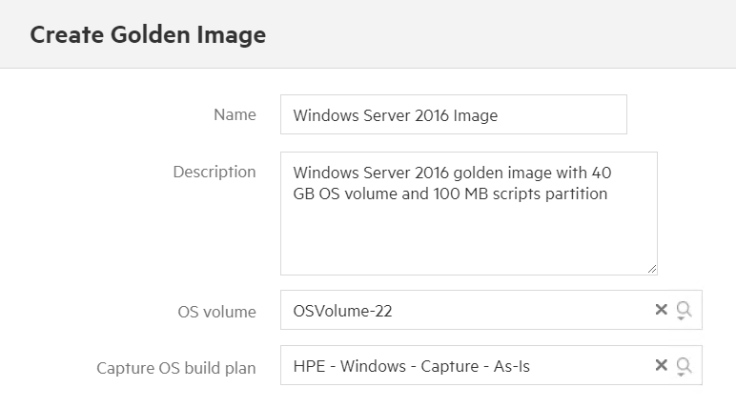

Figure 37. Create Golden Image

* Select "Create"

Delete the Server Profile "Windows Template" used to create the golden image

### Golden Image Compatibility

The golden image created using the above method will work only when the image is deployed on server hardware of the same model. Specifically, if the number of processors on server where the image is deployed is different from the server where the image was captured, server boot after deployment will fail. Also, if the boot controller is moved from one Mezzanine slot on the server to another, Windows will not boot correctly.

## OS Deployment Plans

The solution delivers two artifact bundles, one for Windows Server 2016 systems and one for Red Hat Linux 7 systems. Each artifact bundle contains one Deployment Plan, one OS Build Plan and all dependent Plan Scripts.

The artifact bundles are included in the Docker-Synergy repository:

# cd ~/Docker-Synergy  
# ls ./files/ImageStreamer  
  
HPE_RHEL7_2019_02_25.zip  
HPE_WIN2016_2019-03-15.zip

In the Image Streamer UI, use the Add Artifact bundle button in the Artifact Bundles screen to upload the two files. When the upload is finished, select the Artifact bundles corresponding to the files (without the .zip extension) and use the Actions button to extract artifacts from the bundles, as shown in the following figure.

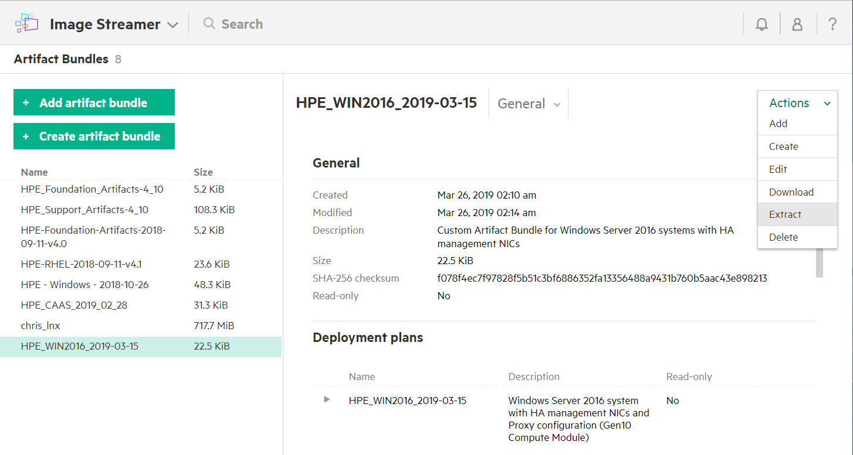

Figure 38. Extract bundle

After the extraction completes, you should find two new deployment plans in your Image Streamer appliance named:

* HPE_RHEL7_2019_02_25 which is the Red Hat Enterprise Linux 7 OS Deployment Plan

HPE_WIN2016_2019-03-15 which is the Microsoft Windows Server 2016 OS Deployment Plan

The deployment plans are shipped without a golden image. Golden images for each OS must be created as outlined in the previous sections.

### Update the Red Hat OS Deployment plan

1. Select the OS Deployment Plan named HPE_RHEL7_2019_02_25 on the Deployment Plans menu in the Image Streamer UI.
2. Click the Action button, then Edit to edit the deployment plan.
3. In the Edit screen, locate the Golden Image drop-down widget and select the golden image created with Red Hat Linux 7.
4. Ensure that the visibility of the custom attributes is configured as explained earlier (i.e. only NIC1 and NIC2 should be visible).

Save your changes.

### Update the Windows Server 2016 Deployment plan

1. Select the OS Deployment Plan named HPE_WIN2016_2019-03-15 on the Deployment Plans menu in the Image Streamer UI.
2. Click the Action button, then Edit to edit the deployment plan.
3. In the Edit screen, locate the Golden Image drop-down widget and select the golden image created with Microsoft Windows Server 2016.
4. Make sure the visibility of the custom attributes is configured as explained earlier (ie only NIC1 and NIC2 should be visible).

Save your changes

## OneView Server Profile Templates

The server profile template must meet the following criteria:

* The template must specify an Image Streamer Deployment Plan and the deployment plan must match the constraints explained in the section OS Deployment Plan Custom Attributes.
* There must be at least one data drive in addition to the boot device provided by the Image Streamer. The playbooks supports local drives as well as drives configured from a Synergy D3940 storage module or LUNs from an HPE 3PAR array.

There must be two Ethernet connections mapped to the Ethernet network used by the Ansible controller node.

# Deploying Sysdig monitoring

By default, the playbooks for deploying Sysdig are commented out in site.yml and must be explicitly enabled in that file if you want it included in the initial deployment. Alternatively, you can run the specific playbooks detailed in this section in a stand-alone manner, subsequent to the initial deployment.

Note

By default, you must have outgoing port 6666 open in your firewall, to allow data to flow to collector.sysdigcloud.com. You can configure the agent to use a different port by using the variable sysdig_collector_port in group_vars/all/vars.

If you are using a proxy, it must be configured to be "fully-transparent". Non-transparent proxies will not allow the agent to connect.

## Monitoring with Sysdig

Sysdig's approach to Docker monitoring uses transparent instrumentation to see inside containers from the outside, with no need for agents in each container. Metrics from Docker containers, and from your applications running inside them, are aggregated in real-time across each service to provide meaningful monitoring dashboards and alerts for your application. Figure 39 provides an overview of the Sysdig architecture.

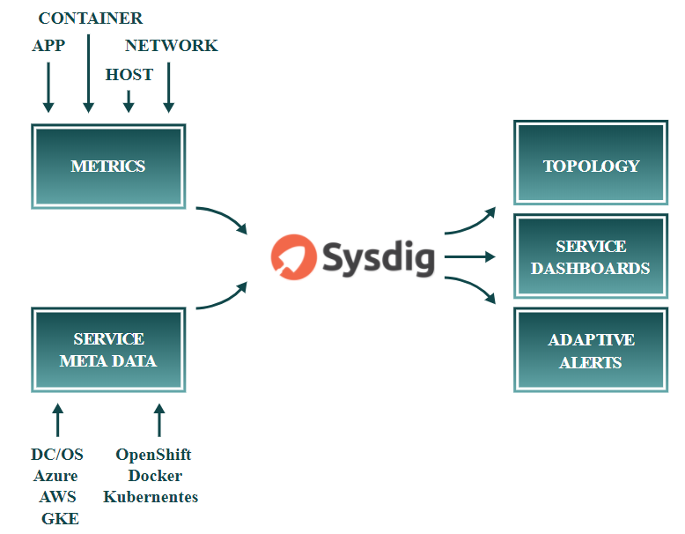

Figure 39. Sysdig architecture

Sysdig Monitor allows you to analyze response times, application performance metrics, container and server utilization metrics, and network metrics. You can build dashboards across applications, micro-services, container and networks, and explore metadata from Docker, Kubernetes, Mesos and AWS. For more information, see the [Sysdig Container Monitoring](https://www.youtube.com/watch?v=NR9XLZw0ndo&t=5s) video overview and the [Sysdig Monitor 101](https://sysdig.teachable.com/p/sysdig-101) training course.

Sysdig Secure provides security at the orchestrator as well as the container level. You create service-aware policies that allow you to take actions (like killing a container) or send alerts (to Slack, Splunk, etc) whenever a policy violation occurs. All commands are audited to help you identify anomalous actions, along with taking snapshots of all activities pre-and-post a policy violation. For more information, see the [Sysdig Secure](https://www.youtube.com/watch?v=e_kdjHjK7mY) video overview and the [Sysdig Secure 101](https://sysdig.teachable.com/p/sysdig-secure-101) training course.

The implementation in this solution uses the Software as a Service (SaaS) version of Sysdig. The playbooks deploy Sysdig Agent software on each UCP, DTR and Linux worker node, as well as the NFS, logger and load balancer VMs and captured data is relayed back to your Sysdig SaaS Cloud portal. The deployment provides access to a 90 day try-and-buy, fully featured version of the Sysdig software.

Note

The Sysdig functionality is not turned on by default in this solution - see the section on Sysdig configuration for more information on how to enable Sysdig. For more information on how to access the 90 day try-and-buy version, see the GitHub repository at [https://hewlettpackard.github.io/Docker-Synergy/sysdig/sysdig-trial.html](https://hewlettpackard.github.io/Docker-SimpliVity/sysdig/sysdig-trial.html).

## Playbooks for installing Sysdig on RHEL

The following playbooks are used when deploying Sysdig:

playbooks/sysdig-k8s-rbac.yml is used to configure Sysdig for Kubernetes.

* playbooks/install_sysdig.yml is used to configure Sysdig for Docker swarm. It opens the required port in the firewall, and installs the latest version of the Sysdig agent image on the nodes. By default, this playbook is commented out in site.yml, so if you want to use the solution to automatically configure Sysdig for Docker swarm, you must uncomment this line.

## Sysdig configuration

Separate playbooks are used to install Sysdig for Docker swarm and Sysdig for Kubernetes.

### Sysdig configuration for Docker swarm

The playbook playbooks/install_sysdig.yml is used to automate the configuration of the SaaS setup for Docker swarm. By default, this playbook is commented out in site.yml and must be explicitly enabled. The variables used to configure Sysdig for Docker swarm are detailed in Table 23.

Table 23. Sysdig variables for Docker swarm

|  |  |  |
| --- | --- | --- |
| Variable | File | Description |
| sysdig_access_key | group_vars/all/vault | After the activation of your account on the Sysdig portal, you will be provided with your access key. This is used by the playbooks to install the agent on each UCP, DTR and Linux worker node, as well as the NFS, logger and load balancer VMs. |
| sysdig_agent | group_vars/all/vars | Specifies the URL to the Sysdig Linux native install agent, for example, https://s3.amazonaws.com/download.draios.com/stable/install-agent |
| sysdig_tags | group_vars/all/vars | Tagging your hosts is highly recommended. Tags allow you to sort the nodes of your infrastructure into custom groups in Sysdig Monitor. Specify location, role, and owner in the format: 'location:City,role:Express Containers,owner:Customer Name' |

### Sysdig configuration for Kubernetes

The playbook playbooks/sysdig-k8s-rbac.yml is used to automate the configuration of the SaaS setup for Kubernetes. The variables used to configure Sysdig for Kubernetes are detailed in Table 24.

Table 24. Sysdig variables for Kubernetes

|  |  |  |
| --- | --- | --- |
| Variable | File | Description |
| sysdig_access_key | group_vars/all/vault | After the activation of your account on the Sysdig portal, you will be provided with your access key. This is used by the playbooks to install the agent on each UCP, DTR and Linux Kubernetes worker nodes. |
| sysdig_collector | group_vars/all/vars | The URL for the Sysdig SaaS, by default, 'collector.sysdigcloud.com' |
| sysdig_collector_port | group_vars/all/vars | The port used by the agent, by default, '6666' |
| sysdig_tags | group_vars/all/vars | Tagging your hosts is highly recommended. Tags allow you to sort the nodes of your infrastructure into custom groups in Sysdig Monitor. Specify location, role, and owner in the format: 'location:City,role:Express Containers,owner:Customer Name' |
| k8s_cluster | group_vars/all/vars | This should match the cluster name displayed when you source the environment setup script, for example.  # source env.sh Cluster "ucp_hpe-ucp.cloudra.local:6443_admin" set. User "ucp_hpe-ucp.cloudra.local:6443_admin" set.  For more information, see the section on installing the UCP client bundle in the section Deploying Sysdig monitoring on Kubernetes. |

## Registering for Sysdig trial

Hewlett Packard Enterprise has teamed up with Sysdig to offer a fully featured 90-day trial version of Sysdig Monitor and Secure as part of the HPE Enterprise Containers as a Service with Docker EE solution. For more details on how to sign up, see the GitHub repository at [https://github.com/HewlettPackard/Docker-Synergy](https://github.com/HewlettPackard/Docker-SimpliVity).

After registering for the trial, you will be presented with options for setting up your environment, as shown in Figure 40.

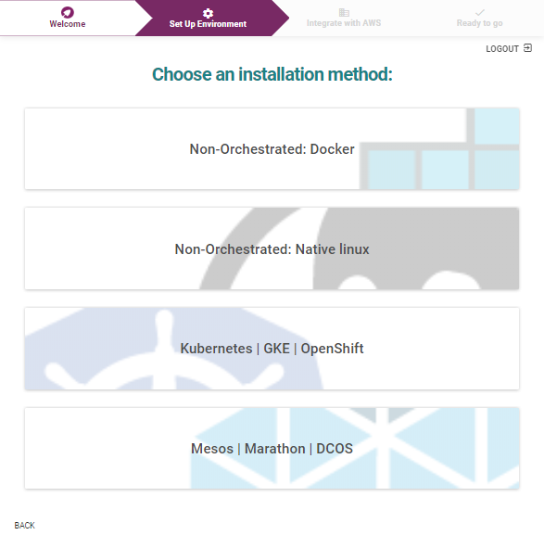

Figure 40. Sysdig Monitor set up environment

### Sysdig Monitoring for Kubernetes

If you are deploying Sysdig monitoring on Kubernetes, select the Kubernetes | GKE | OpenShift option. You will be presented with an access code, as shown in Figure 41.

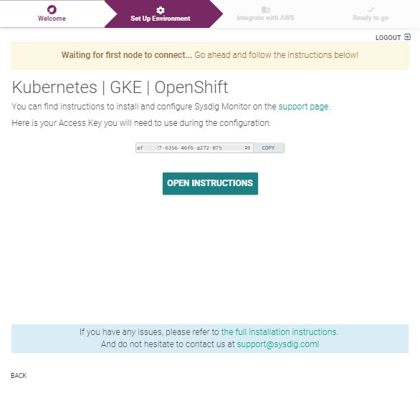

Figure 41. Sysdig Monitor access code for Kubernetes

Use the sysdig_access_key field in your group_vars/all/vault, as described in the section Sysdig configuration for Kubernetes. Once you deploy your environment and your Kubernetes nodes connect to the Sysdig SaaS platform, Sysdig will automatically display information regarding your setup, as shown in Figure 42.

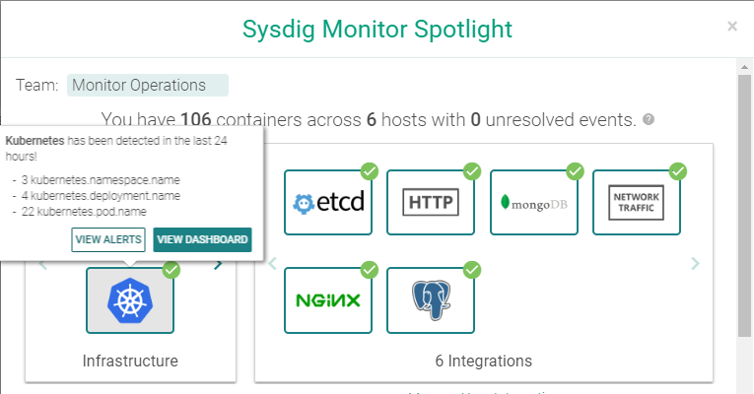

Figure 42. Sysdig Monitor Spotlight for Kubernetes

Select View Dashboard for an entry point to accessing all your monitoring data. Alternatively, you can browse to <https://app.sysdigcloud.com> at any time to access your dashboards.

### Sysdig Monitor for Docker swarm

If you are deploying Sysdig monitoring on Docker swarm, select the Non-Orchestrated: Native Linux option. You will be presented with a screen containing details for the URL to download the Sysdig agent, along with your access code embedded in the command, as shown in Figure 43.

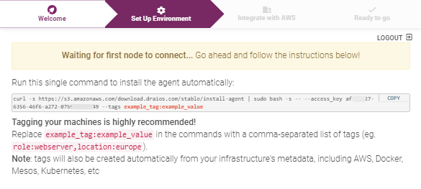

Figure 43. Sysdig Monitor download location and access code for Docker

The download URL is used in the sysdig_agent field in group_vars/all/vars, while the access code is stored in the sysdig_access_key field in your group_vars/all/vault, as described in the section Sysdig configuration for Docker swarm.

Once you deploy your environment and your Docker swarm nodes connect to the Sysdig SaaS platform, Sysdig will automatically display information regarding your setup. Alternatively, you can browse to <https://app.sysdigcloud.com> at any time to access your dashboards.

## Deploying Sysdig monitoring on Kubernetes

The latest version of Sysdig supports monitoring of Kubernetes logs and metrics.

#### Prerequisites

* Install the kubectl binary on your Ansible box.
* Install the UCP Client bundle for the admin user.
* Confirm that you can connect to the cluster by running a test command, for example, kubectl get nodes

Ensure that you have configured the required variables, as described in the section Sysdig configuration for Kubernetes

For example, you add the relevant variables in the group_vars/all/vars file.

sysdig_collector: 'collector.sysdigcloud.com'  
sysdig_collector_port: '6666'  
sysdig_tags: 'location:Enter city,role:Enter role,owner:Customer name'  
k8s_cluster: 'ucp_hpe2-ucp.cloudra.local'

You should add the access key to the encrypted group_vars/all/vault using the command ansible-vault edit group_vars/all/vault.

sysdig_access_key: '10****97-9160-****-9061-84bfd0f****0'

#### Running the playbook

The playbook playbooks/k8s-install-sysdig.yml is used to automate the configuration of the SaaS setup for Docker swarm.

# cd Docker-Synergy  
# ansible-playbook -i hosts playbooks/sysdig-k8s-rbac.yml --vault-password-file .vault_pass

Using the Sysdig software as a solution (SaaS) website <https://app.sysdigcloud.com>, you are able to view, analyze and inspect various different dashboards. Initially, you will just see the monitoring information for the infrastructure itself. Deploy a sample application, as detailed in the section Kubernetes guestbook example with Redis, and use the Sysdig solution to analyze the different facets of the deployed application.

## Deploying Sysdig monitoring on Docker Swarm

The playbook playbooks/install_sysdig.yml is used to automate the configuration of the SaaS setup for Docker swarm. By default, this playbook is commented out in site.yml and must be explicitly enabled. An access key variable must be set in the group_vars/all/vault file as detailed in Table 23.

# cd Docker-Synergy  
# ansible-playbook -i hosts playbooks/install_sysdig.yml --vault-password-file .vault_pass

Using the Sysdig software as a solution (SaaS) website <https://app.sysdigcloud.com>, you are able to view, analyze and inspect various different dashboards.

# Deploying Splunk

This section provides an overview of Splunk, outlines how to configure and run the relevant playbooks and shows how to access the UI to see the resultant Docker and Kubernetes dashboards.

## Monitoring with Splunk

Splunk Enterprise allows you to collect and index any data from any source, and to monitor systems and infrastructure in real time to preempt issues before they happen. It allows you to analyze your data to understand trends, patterns of activity and behavior, giving you valuable intelligence across your entire organization. The solution architecture for Splunk is shown in Figure 44.

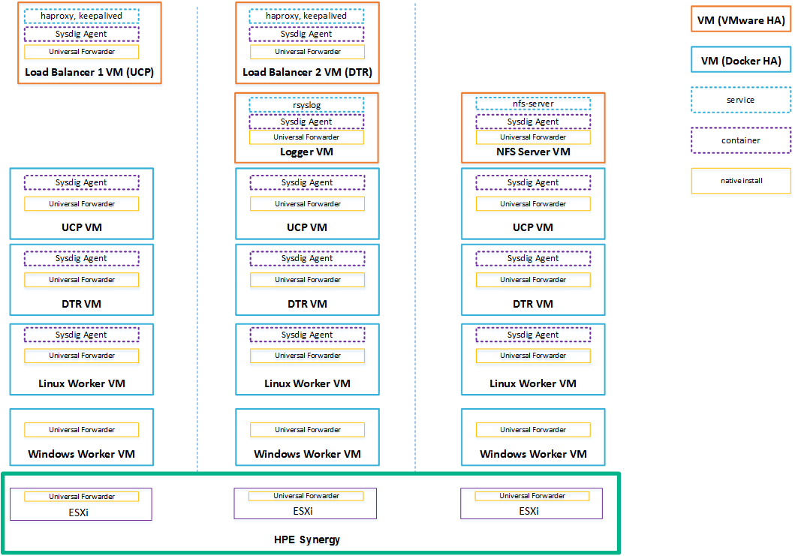

Figure 44. Solution architecture: Hybrid Linux and Windows workers with Splunk and Sysdig

This solution allows you to integrate your CaaS deployment with an existing Splunk Enterprise installation or to deploy a stand-alone Splunk Enterprise demo environment as a Docker stack in your cloud. In both instances, Universal Forwarders are used to collect data from your applications running on your Linux and Windows worker nodes in your cloud, as well as log data from the Docker platform itself and from the infrastructure VMs and servers. Figure 45 shows the Splunk architecture.

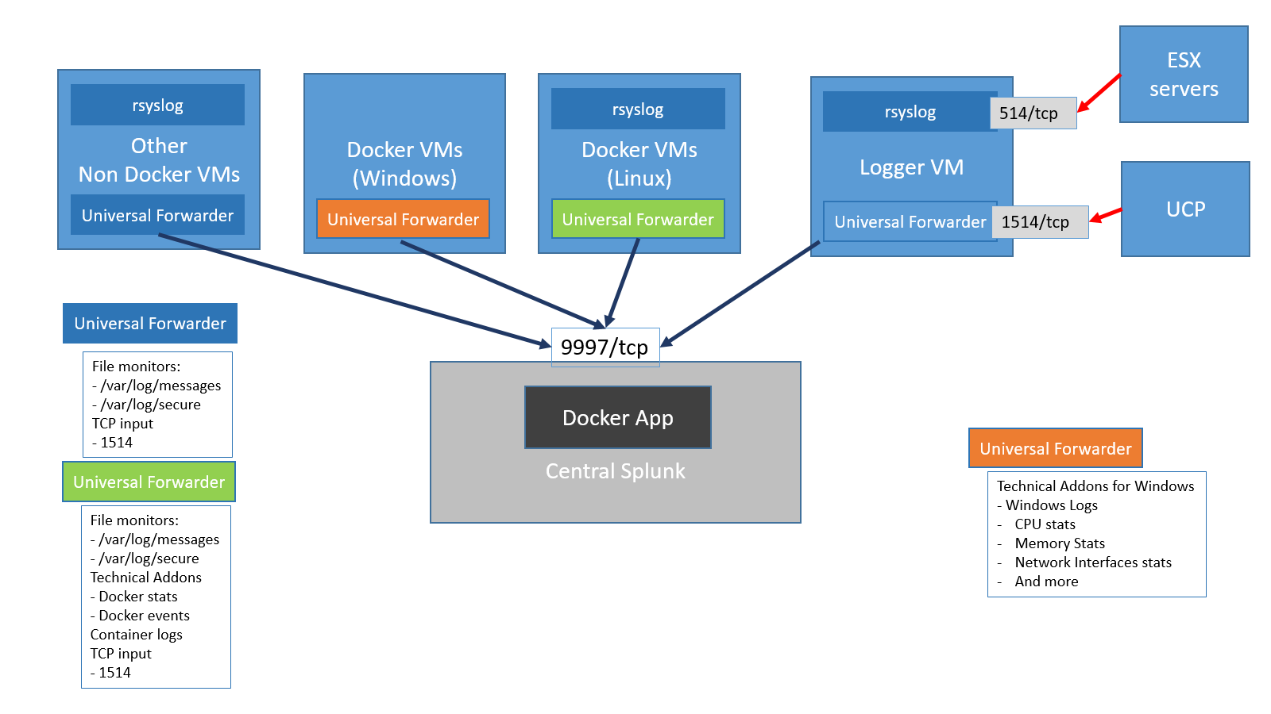

Figure 45. Splunk architecture

All the Universal Forwarders run natively on the operating system to allow greater flexibility in terms of configuration options. Each forwarder sends the data it collects to one or more indexers in the central Splunk.

Linux worker nodes: The Universal Forwarders on the Linux worker nodes collect log and metrics data. The log data includes:

* /var/log/messages from the Docker host (including the daemon engine logs)
* /var/log/secure from the Docker hosts

container logs via a Splunk technical add-on

The metrics data is collected via a technical add-on and includes:

* docker stats
* docker top
* docker events

docker service stats

Windows worker nodes: The Universal Forwarders running on the Windows worker nodes collect the following data:

* Windows logs
* CPU stats
* Memory stats
* Network Interface stats

and more

For more information on configuring standalone Splunk for Linux and Windows worker nodes, see the section on Splunk prerequisites.

UCP and ESXi: UCP operational logs and ESXi logs are forwarded to the logger VM via TCP ports 1514 and 514 respectively. Port 1514 is assigned a special sourcetype of ucp which is then used by the Splunk Docker APP to interpret UCP logs. The Universal Forwarder runs the rsyslog daemon which will record the log messages coming from the ESX machines into the /var/log/messages file on the VM.

Non-Docker VMs: Other VMs, for example, NFS, use a Splunk monitor to collect and forward data from the following files:

* /var/log/messages

/var/log/secure (Red Hat)

Note

You can configure the list of files monitored by the Universal Forwarder.

Other syslog senders can be configured to send their data to the logger VM or directly to central Splunk.

## Playbooks for installing Splunk

The following playbooks are used to install Splunk.

* playbooks/splunk_demo.yml installs a demo of Splunk Enterprise in the cluster (if the splunk_demo deployment option is selected. A value of splunk is used to configure an external production Splunk deployment.)

playbooks/splunk_uf.yml installs and configures the Splunk Universal Forwarder on each Linux and Windows node in the inventory

## Splunk configuration

This solution supports two types of Splunk deployments. Firstly, there is a built-in deployment useful for demos and for getting up to speed with Splunk. Alternatively, the solution can be configured to interact with a standalone, production Splunk deployment that you set up independently. In this case, you must explicitly configure the universal forwarders with external "forward servers" (Splunk indexers), whereas this happens automatically with the built-in option.

In the standalone deployment, you can enable SSL authentication between the universal forwarders and the indexers, by setting the splunk_ssl variable to yes in the file group_vars/all/vars. The built-in demo deployment does not support SSL and so, in this instance, the value of the splunk_ssl variable is ignored. For more information on enabling SSL, see Appendix C.

After the installation is complete, the Splunk UI can be reached at http://<fqdn>:8000, where <fqdn> is the FQDN of one of your Linux Docker nodes. Mesh routing does not currently work on Windows so you must use a Linux node to access the UI.

### Splunk prerequisites

You should select the Splunk deployment type that you require by setting the variable monitoring_stack in the group_vars/all/vars file to either splunk, to use a standalone Splunk deployment, or splunk_demo for the built-in version. If you omit this variable, or if it has an invalid value, no Splunk deployment will be configured.

For both types of deployment, you need to download the Splunk universal forwarder images/packages from <https://www.splunk.com/en_us/download/universal-forwarder.html>. Packages are available for 64-bit Linux and 64-bit Windows 8.1/Windows 10. Download the RPM package for Linux 64-bit (2.6+ kernel Linux distributions) to ./files/splunk/linux. If you are deploying Windows nodes, download the MSI package for Windows 64 bit to ./files/splunk/windows. For a dual Linux/Windows deployment, the images and packages must have same name and version, along with the appropriate extensions, for example:

* files/splunk/windows/splunkforwarder-7.1.2.msi

files/splunk/linux/splunkforwarder-7.1.2.rpm

You need to set the variable splunk_architecture_universal_forwarder_package to the name you selected for the package(s), not including the file extension. Depending on the Splunk deployment you have chosen, edit the file templates/monitoring/splunk/vars.yml or the file templates/monitoring/splunk_demo/vars.yml and set the variable, for example:

splunk_architecture_universal_forwarder_package: 'splunkforwarder-7.1.2'

As of Splunk version 7.1, the Splunk universal forwarder must be deployed with a password. This password is specified using the variable splunk_uf_password which is configured in group_vars/all/vault.

If you are using a standalone Splunk deployment, you must specify the list of indexers using the variable splunk_architecture_forward_servers in group_vars/all/vars, for example:

splunk_architecture_forward_servers:  
- splunk-indexer1.cloudra.local:9997  
- splunk-indexer2.cloudra.local:9997

By default, the indexers are configured in a single load balancing group. This can be changed by editing the file outputs.conf.j2 in the folder template/monitoring/splunk/. For more information on forwarding using Universal Forwarder, see the Splunk documentation at <http://docs.splunk.com/Documentation/Forwarder/7.0.2/Forwarder/Configureforwardingwithoutputs.conf>.

On your standalone Splunk installation, you need to install the following add-ons and apps.

To monitor Linux worker nodes, the Docker app should be installed on central Splunk. More info on this Docker app can be found at <https://github.com/splunk/docker-itmonitoring> and at <https://hub.docker.com/r/splunk/universalforwarder/>.

To monitor the Windows worker nodes, install the Splunk App for Windows Infrastructure on central Splunk and its dependencies:

* Splunk App for Windows Infrastructure. The Splunk App for Windows Infrastructure is not compatible with The Splunk Add-on for Windows 5.0 at this time. See <https://splunkbase.splunk.com/app/1680/>
* Splunk Add-on for Microsoft Windows version 4.8.4 - see <https://splunkbase.splunk.com/app/742/>
* Splunk Add-On for Microsoft Active Directory version 1.0.0 - see <https://splunkbase.splunk.com/app/3207/>
* Splunk Add-on for Microsoft Windows DNS version 1.0.1 (if this is not installed on central Splunk, you will see yellow icons on some dashboards with the message eventtype wineventlog-dns does not exist or is disabled) - see <https://splunkbase.splunk.com/app/3208/>

Splunk Supporting Add-on for Active Directory version 2.1.7 (if this is not installed on central Splunk, you will see yellow icons on some dashboards with the message eventtype wineventlog-ds does not exist or is disabled) - see <https://splunkbase.splunk.com/app/1151/>

If you want to use your own certificates in your standalone Splunk deployment to secure the communications between the indexers and the universal forwarders, see Appendix D.

You can specify advanced Splunk configuration in the following files:

* files/splunk/linux/SPLUNK_HOME
* files/splunk/linux/DOCKER_TAS

files/splunk/windows/SPLUNK_HOME

These files will be copied as-is to the systems running the universal forwarder.

### Configuring syslog in UCP

In order to see some data in the UCP operational dashboard, you need to have UCP send its logs to the VM configured in the [logger] group. For example, for the following vm_host file:

[logger]  
hpe-logger ip_addr='10.60.59.24/16' esxi_host='esxi-hpe-2.cloudra.local'

This will configure UCP to send its logs to hpe-logger.cloudra.local:1514. You need to select the TCP protocol as shown in Figure 46.

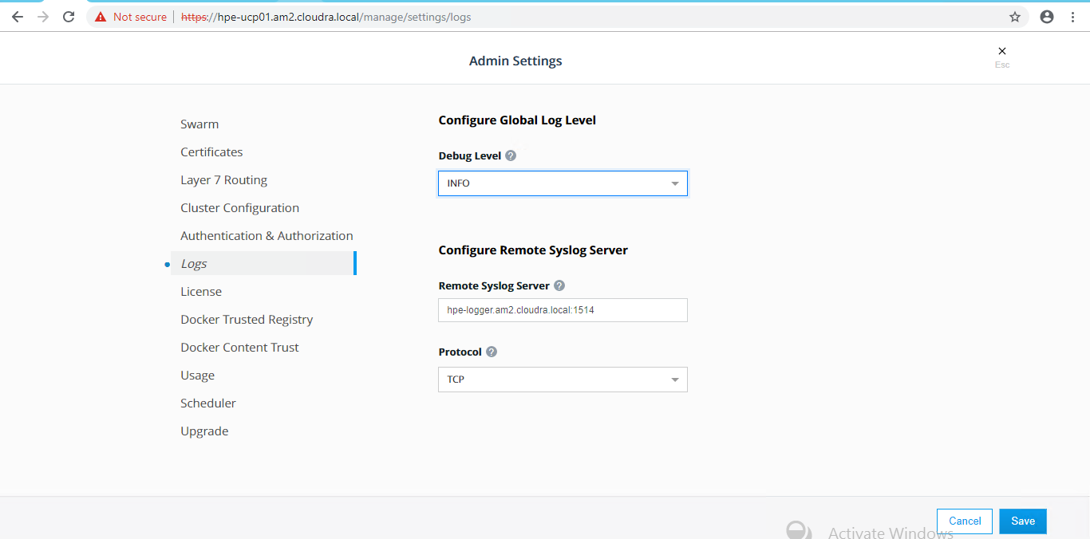

Figure 46. Configure Remote Syslog Server in UCP

### Configuring syslog in ESX

This configuration must be done manually for each ESX server. The syslog server should be the server configured in the [logger] group in your hosts inventory. The protocol should be tcp and the port 514 as shown in Figure 47.

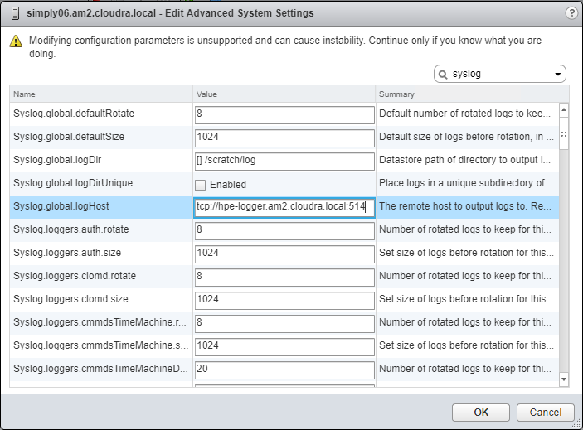

Figure 47. Configure Syslog on ESXi Hosts

For more information, see the VMware documentation at <https://docs.vmware.com/en/VMware-vSphere/6.5/com.vmware.vsphere.security.doc/GUID-9F67DB52-F469-451F-B6C8-DAE8D95976E7.html>.

### Limitations

* The Dockerized Splunk App has a number of open issues
* https://github.com/splunk/docker-itmonitoring/issues/19
* https://github.com/splunk/docker-itmonitoring/issues/20

The Docker events tab is not working

## Accessing Splunk UI

After the installation is complete, the Splunk UI can be reached at http://<fqdn>:8000, where <fqdn> is the FQDN of one of your Linux Docker nodes. Mesh routing does not currently work on Windows so you must use a Linux node to access the UI. For example:

http://hpe-ucp01.am2.cloudra.local:8000/

The default username and password for Splunk is admin / changeme.

Use the Docker App to view the Docker overview as shown in Figure 48 and the Docker stats as shown in Figure 49.

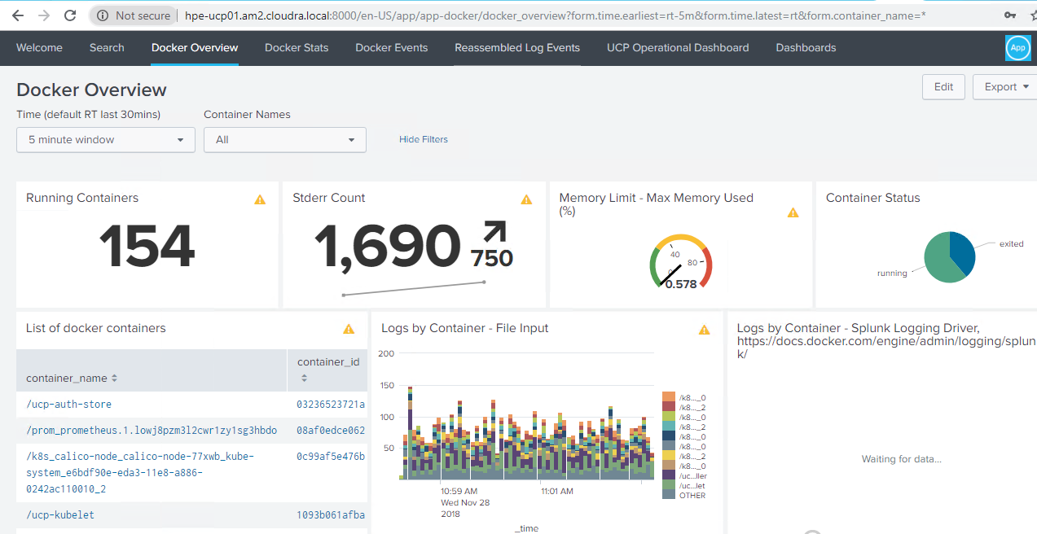

Figure 48. Docker overview

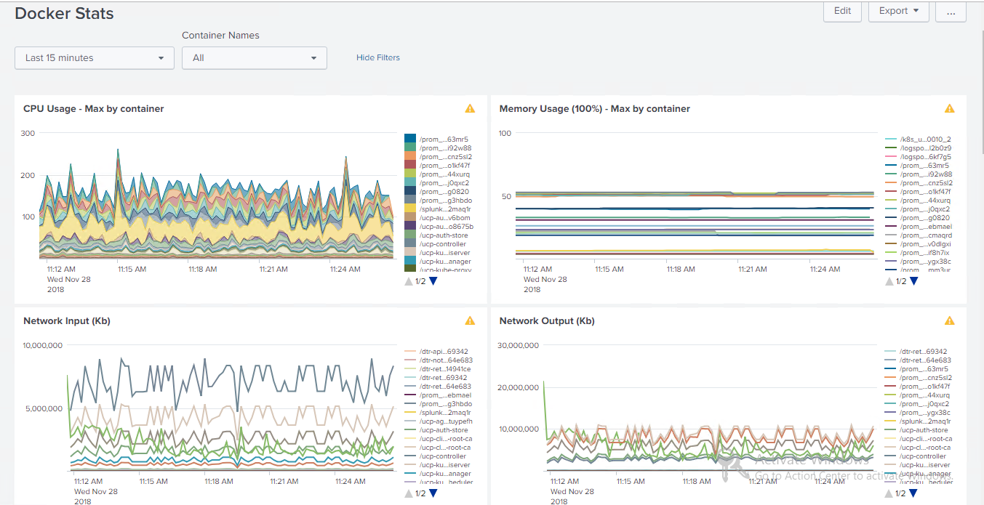

Figure 49. Docker stats

Use the k8s App to see the Kubernetes overview as shown in Figure 50 and then access the details for deployments, daemon sets, replica sets, services, etc.

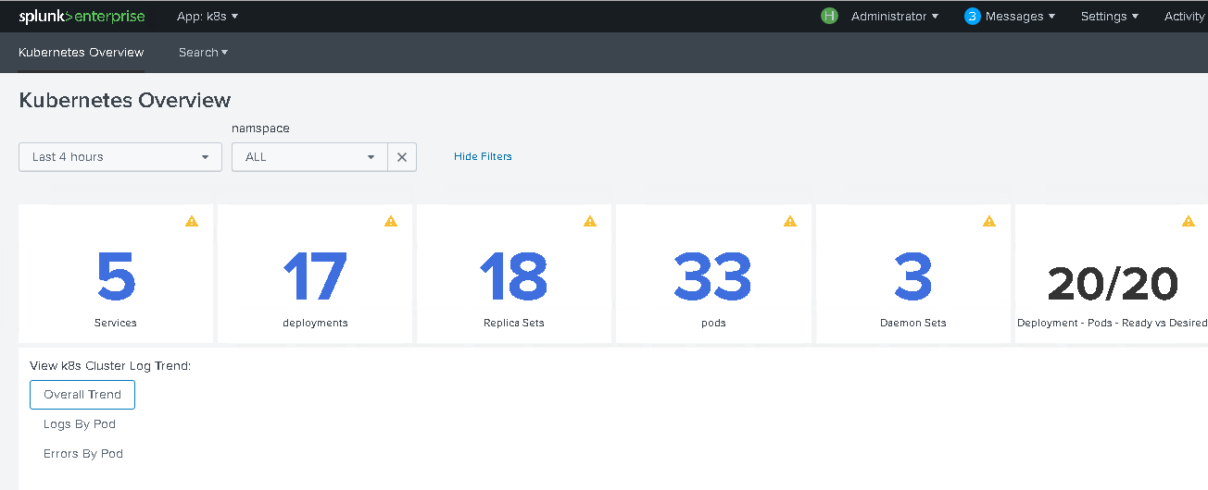

Figure 50. Kubernetes overview

## Redeploying Splunk demo

The Splunk demo deployment, whilst fully featured, is severely restricted in the amount of data it can process. Once this limit has been reached, often after running for just one or two days, it is necessary to redeploy the application if you want to continue experimenting with the demo.

Before you redeploy, it is necessary to remove the corresponding Docker stack and delete the associated volumes.

# ssh hpe-ucp02  
  
# docker stack rm splunk_demo  
Removing service splunk_demo_splunkenterprise  
Removing network splunk_demo_default  
  
# docker volume ls | grep splunk  
vsphere:latest splunk_demo_vsplunk-opt-splunk-etc@Docker_HPE  
vsphere:latest splunk_demo_vsplunk-opt-splunk-var@Docker_HPE  
  
# docker volume rm splunk_demo_vsplunk-opt-splunk-etc@Docker_HPE  
splunk_demo_vsplunk-opt-splunk-etc@Docker_HPE  
  
# docker volume rm splunk_demo_vsplunk-opt-splunk-var@Docker_HPE  
splunk_demo_vsplunk-opt-splunk-var@Docker_HPE

Then re-run the playbook on your Ansible node.

ansible-playbook -i hosts playbooks/splunk_demo.yml --vault-password-file .vault_pass

# Deploying Prometheus and Grafana on Kubernetes

## Monitoring Kubernetes with Prometheus and Grafana

Monitoring a Kubernetes cluster with Prometheus is a natural choice as Kubernetes components themselves are instrumented with Prometheus metrics, therefore those components simply have to be discovered by Prometheus and most of the cluster is monitored.

The solution uses the Prometheus Operator to deploy Prometheus and Grafana. The playbooks install kube-state-metrics and node-exporter components, as well as supporting kubelet and apiserver metrics. Sample dashboards for Grafana are installed to help you monitor your Kubernetes infrastructure.

The Prometheus Operator, shown in Figure 51, makes running Prometheus on top of Kubernetes as easy as possible, while preserving Kubernetes-native configuration options. It introduces additional resources in Kubernetes to declare the desired state and configuration of Prometheus. The Prometheus resource declaratively describes the desired state of a Prometheus deployment, while a ServiceMonitor describes the set of targets to be monitored by Prometheus.

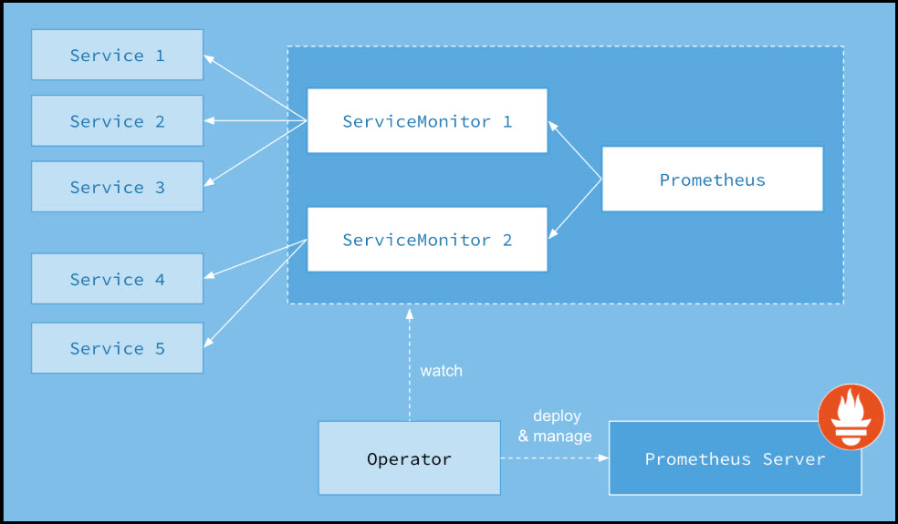

Figure 51. Prometheus Operator

## Playbooks for installing Prometheus and Grafana on Kubernetes

### Prerequisites

Before you run the playbook to install Prometheus and Grafana on Kubernetes, you need to ensure that you have already downloaded and installed kubectl and set up your client bundle. Two convenience playbooks have been provided to make this process easier.

The playbook playbooks/install-kubectl.yml installs a specific version of kubectl based on the settings in your group_vars/all/vars file.

The playbook playbooks/kube-prometheus.yml is used to deploy the Prometheus/Grafana stack on Kubernetes. It is a wrapper for a number of separate playbooks outlined below.

* playbooks/kube-prometheus/operator.yml
* playbooks/kube-prometheus/kube-state-metrics.yml
* playbooks/kube-prometheus/node-exporter.yml
* playbooks/kube-prometheus/monitors.yml
* playbooks/kube-prometheus/prometheus.yml

playbooks/kube-prometheus/grafana.yml

You can choose not to install certain components, such as node-exporter or kube-state-metrics, by commenting out the appropriate line in the wrapper playbook.

### Prometheus Operator

The Prometheus Operator makes running Prometheus on top of Kubernetes as easy as possible, while preserving Kubernetes-native configuration options. For more information on Prometheus Operator, see <https://coreos.com/operators/prometheus/docs/latest/user-guides/getting-started.html>.

The playbook playbooks/kube-prometheus/operator.yml installs the operator itself.

### Kube state metrics

kube-state-metrics is a simple service that listens to the Kubernetes API server and generates metrics about the state of the objects. It is not focused on the health of the individual Kubernetes components, but rather on the health of the various objects inside, such as deployments, nodes and pods. For more information on kube-state-metrics, see <https://github.com/kubernetes/kube-state-metrics>.

The playbook playbooks/kube-prometheus/kube-state-metrics.yml installs kube-state-metrics on all UCP, DTR and Kubernetes worker nodes.

### Node exporter

The node-exporter provides an overview of cluster node resources including CPU, memory and disk utilization and more. For more information on node-exporter, see <https://github.com/prometheus/node_exporter>.

The playbook playbooks/kube-prometheus/node-exporter.yml installs node-exporter as a set of Docker containers on all UCP, DTR and Kubernetes worker nodes. Port 9100 is opened in the firewall on each node where it is installed.

### Monitors

While all the other Kubernetes components run on top of Kubernetes itself, kubelet and apiserver do not, and so they just need service monitors to access these metrics.

The playbook playbooks/kube-prometheus/monitors.yml installs Service Monitors for kubelet and apiserver.

### cAdvisor

Support for cAdvisor is built-in to Kubernetes, so cAdvisor metrics will automatically be available within Prometheus, without any other configuration required.

Note

Because Docker EE provides a hosted version of Kubernetes, it is not possible to access metrics for kube-scheduler and kube-controller-manager.

### Prometheus

For convenience, the playbook sets up a NodePort so that the Prometheus UI can be accessed on port 33090, as shown in the following code extract:

# kubectl -n monitoring patch svc prometheus-k8s --type='json' -p '[{"op":"replace","path":"/spec/type","value":"NodePort"}]'

# kubectl -n monitoring patch svc prometheus-k8s --type='json' -p '[{"op": "add", "path":"/spec/ports/0/nodePort", "value":33090}]'

On a production system, it is likely that you will want to remove this NodePort. The following code segment shows how you can use the patch command to remove the NodePort.

# kubectl -n monitoring patch svc prometheus-k8s --type='json' -p '[{"op": "remove", "path":"/spec/ports/0/nodePort"}]'

# kubectl -n monitoring patch svc prometheus-k8s --type='json' -p '[{"op": "remove", "path":"/spec/type"}]'

### Grafana

For convenience, the playbook sets up a NodePort so that the Grafana UI can be access on the port 33030, as shown in the following code extract:

# kubectl -n monitoring patch svc grafana --type='json' -p '[{"op":"replace","path":"/spec/type", "value":"NodePort"}]'

# kubectl -n monitoring patch svc grafana --type='json' -p '[{"op": "add", "path":"/spec/ports/0/nodePort", "value":33030}]'

On a production system, it is likely that you will want to remove this NodePort. The following code segment shows how you can use the patch command to remove the NodePort.

# kubectl -n monitoring patch svc grafana --type='json' -p '[{"op": "remove", "path":"/spec/ports/0/nodePort"}]'

# kubectl -n monitoring patch svc grafana --type='json' -p '[{"op": "remove", "path":"/spec/type"}]'

### Teardown

The playbook playbooks/kube-prometheus-teardown.yml removes the installed Prometheus\Grafana stack.

## Prometheus UI

The Prometheus UI is available via your UCP, DTR or Kubernetes worker nodes, using HTTP on port 33090, for example,

http://hpe-ucp01.am2.cloudra.local:33090

To see what services are being monitored, access the service discovery page, via Status -> Service Discovery, or using the /service-discovery endpoint:

http://hpe2-ucp01.am2.cloudra.local:33090/service-discovery

The monitored services are listed as shown in Figure 52.

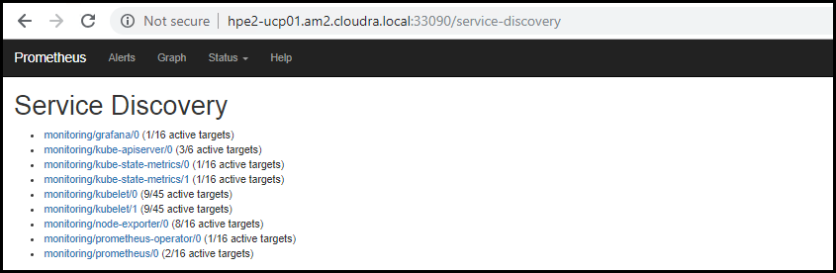

Figure 52. Prometheus service discovery

To see the status for the monitored services, access the targets page via Status -> Targets or using the endpoint /targets.

http://hpe2-ucp01.am2.cloudra.local:33090/targets

The status of the various monitors are displayed, as shown in Figure 53.

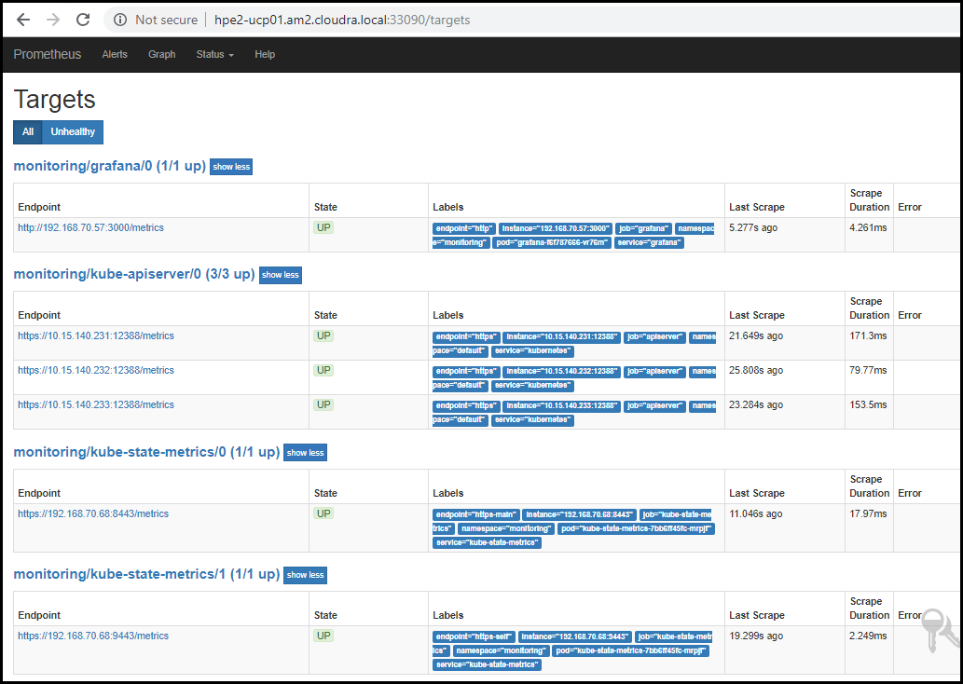

Figure 53. Prometheus targets

To see all the metrics available, click on Graph or use the endpoint /graph:

http://hpe2-ucp01.am2.cloudra.local:33090/graph

Click on the drop-down titled “- insert metric at cursor –“ to see all the metrics that are available to Prometheus as shown in Figure 54.

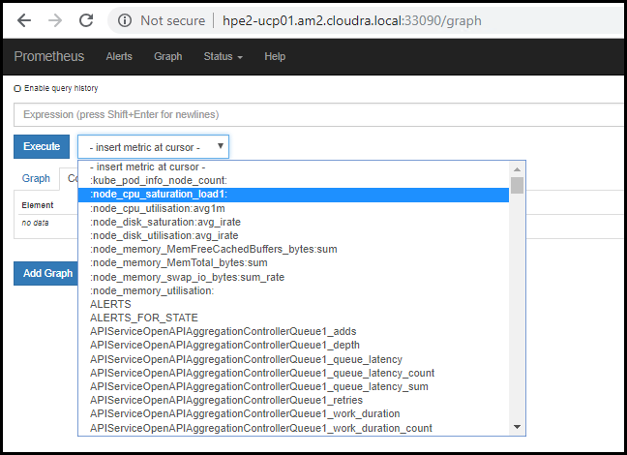

Figure 54. Prometheus metrics

## Node Exporter

Metrics specific to the Node Exporter are prefixed with node_ and include metrics like node_cpu_seconds_total and node_exporter_build_info. Table 25 below lists some example expressions.

Table 25. Sample Node Exporter metrics

| Metric | Meaning |
| --- | --- |
| rate(node_cpu_seconds_total{mode="system"}[1m]) | The average amount of CPU time spent in system mode, per second, over the last minute (in seconds) |
| node_filesystem_avail_bytes | The filesystem space available to non-root users (in bytes) |
| rate(node_network_receive_bytes_total[1m]) | The average network traffic received, per second, over the last minute (in bytes) |

More information on the use of node-exporter metrics is available at <https://github.com/prometheus/node_exporter>.

## cAdvisor

cAdvisor is an open source container resource usage and performance analysis agent. It is purpose-built for containers and supports Docker containers natively. In Kubernetes, cAdvisor is integrated into the Kubelet binary. cAdvisor auto-discovers all containers in the machine and collects CPU, memory, filesystem, and network usage statistics. cAdvisor also provides the overall machine usage by analyzing the ‘root’ container on the machine.

Kubelet exposes a simple cAdvisor UI for containers on a machine, via the default port 4194. However, this feature has been marked deprecated in v1.10 and completely removed in v1.12. For more inforation on how upcoming releases will reduce the set of metrics exposed by the kubelet, see the relevant issue page at <https://github.com/kubernetes/kubernetes/issues/68522>.

The Kubelet also starts an internal HTTP server on port 10255 and exposes endpoints including /metrics and /metrics/cadvisor. As this release of Express Containers uses Kubernetes 1.11, it is able to use this feature. In future releases, it will be necessary to deploy cAdvisor as a DaemonSet for access to the cAdvisor UI.

Table 26 lists some example cAdvisor expressions.

Table 26. Sample cAdvisor metrics

| Expression | Description | For |
| --- | --- | --- |
| rate(container_cpu_usage_seconds_total{name="redis"}[1m]) | The cgroup's CPU usage in the last minute (split up by core) | The redis container |
| container_memory_usage_bytes{name="redis"} | The cgroup's total memory usage (in bytes) | The redis container |
| rate(container_network_transmit_bytes_total[1m]) | Bytes transmitted over the network by the container per second in the last minute | All containers |
| rate(container_network_receive_bytes_total[1m]) | Bytes received over the network by the container per second in the last minute | All containers |

A full listing of cAdvisor-gathered container metrics exposed to Prometheus can be found in the cAdvisor documentation at <https://github.com/google/cadvisor/blob/master/docs/storage/prometheus.md>.

## Grafana UI

The Grafana UI is available via your UCP, DTR or Kubernetes worker nodes, using HTTP on port 33030, for example,

http://hpe-ucp01.am2.cloudra.local:33030

The default username and password for Grafana is admin/admin. The first time you login, you will be asked to reset the default admin password.

A number of dashboards are installed by default. The following figues illustrate some of the dashboard provided.

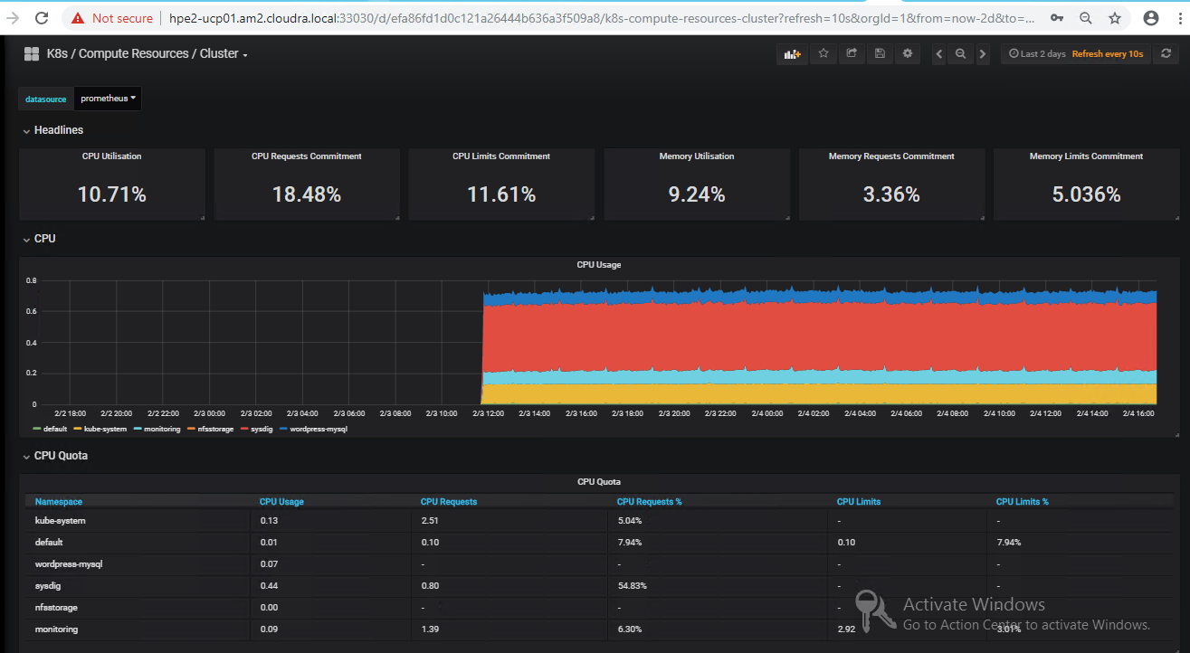

Figure 55. Compute resources dashboard

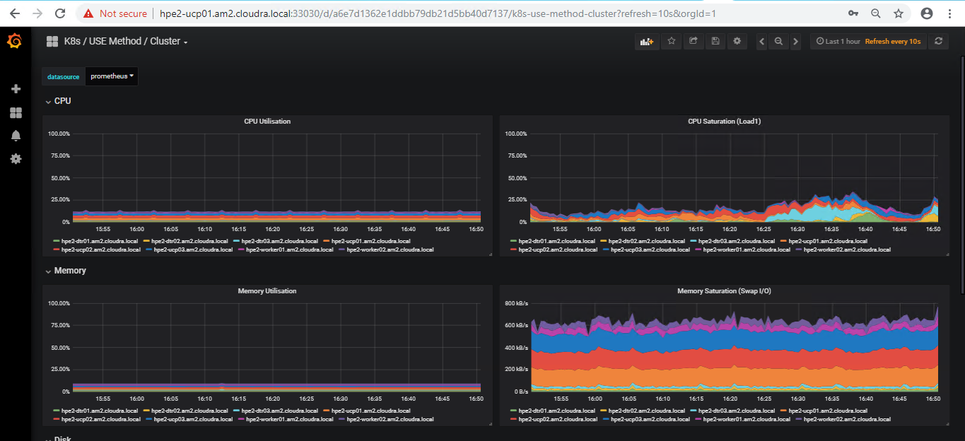

Figure 56. USE method cluster dashboard

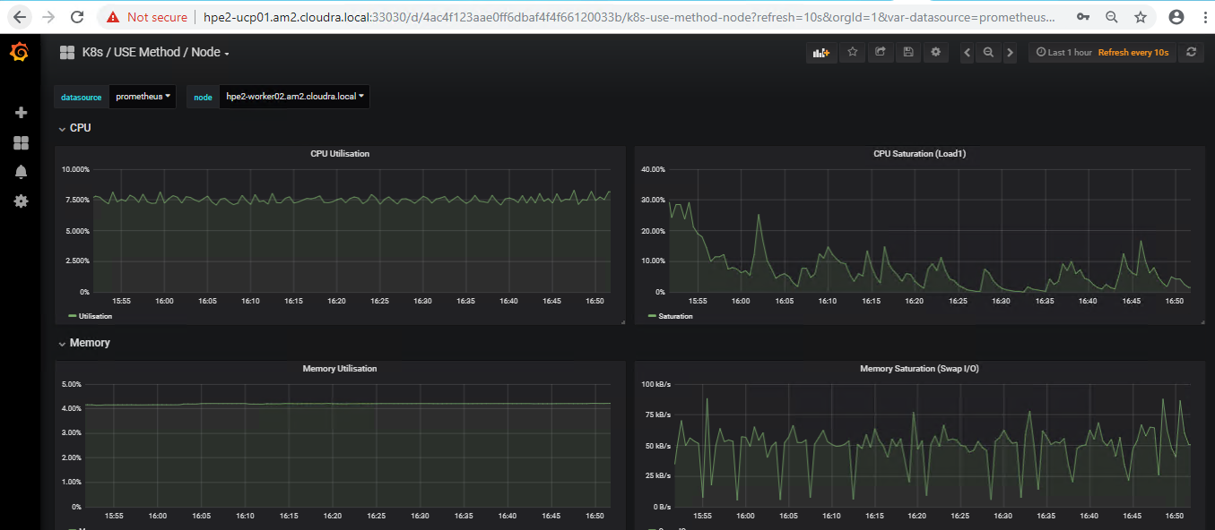

Figure 57. USE method node dashboard

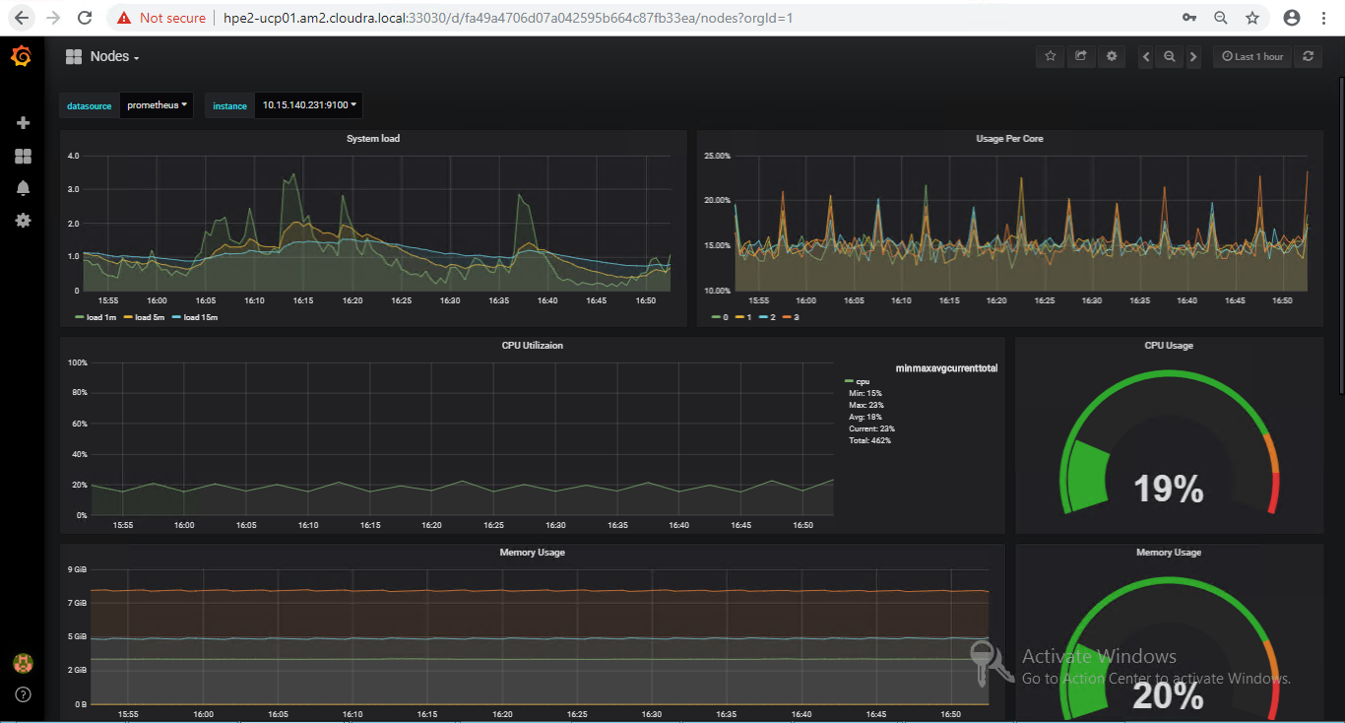

Figure 58. Nodes dashboard

# Deploying Prometheus and Grafana on Docker swarm

## Monitoring with Prometheus and Grafana

The solution can be configured to enable the use of Prometheus and Grafana for monitoring. In this setup, there is no need for native installs and all the required monitoring software runs in containers, deployed as either services or stacks. The load among the three hosts will be shared as per Figure 59.

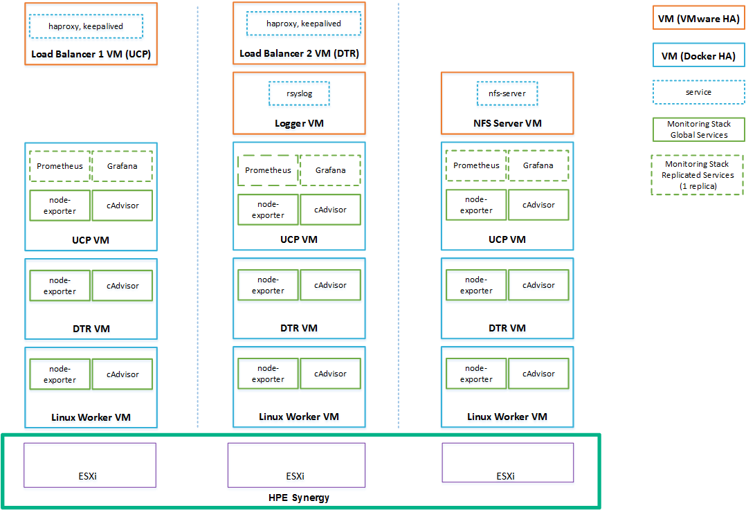

Figure 59. Solution architecture: Linux workers with Prometheus and Grafana

The Prometheus and Grafana services are declared in a Docker stack as replicated services with one replica each, so that if they fail, Docker EE will ensure that they are restarted on one of the UCP VMs. cAdvisor and node-exporter are declared in the same stack as global services, so Docker EE will ensure that there is always one copy of each running on every machine in the cluster.

Note

Prometheus and Grafana functionality is not turned on by default in this solution - see the section on Prometheus and Grafana configuration for more information on how to enable these tools. Additionally, this functionality will not work for the Windows worker nodes in your environment at present.

## Playbooks for installing Prometheus and Grafana on Docker swarm

The following playbooks are used to deploy Prometheus and Grafana on Docker RHEL nodes.

* playbooks/install_logspout.yml installs and configures Logspout on all Docker nodes. Logspout is responsible for sending logs produced by containers running on the Docker nodes to the central logger VM. By default, this playbook is commented out in site.yml.
* playbooks/config_monitoring.yml configures a monitoring system for the Docker environment based on Grafana, Prometheus, cAdvisor and node-exporter Docker containers. By default, this playbook is commented out in site.yml, so if you want to use the solution to automatically deploy a Prometheus/Grafana monitoring system, you must explicitly uncomment both this and the playbooks/install_logspout.yml playbook.

## Prometheus and Grafana configuration

All monitoring-related variables for Prometheus and Grafana are described in Table 27. The variables determine the versions of various software tools that are used and it is recommended that the values given below are used.

Table 27. Monitoring variables

|  |  |
| --- | --- |
| Variable | Description |
| cadvisor_version | v0.28.3 |
| node_exporter_version | v1.15.0 |
| prometheus_version | V2.3.2 |
| grafana_version | 5.2.3 |
| logspout_version | v3.2.4 |
| prom_persistent_vol_name | The name of the volume which will be used to store the monitoring data. The volume is created using the vSphere Docker Volume plugin. |
| prom_persistent_vol_size | The size of the volume which will hold the monitoring data. The exact syntax is dictated by the vSphere Docker Volume plugin. The default value is 10GB. |

## Accessing Grafana UI

The Grafana UI is available at the UCP VIP, using HTTP on port 3000, for example,

http://hpe-ucpvip.am2.cloudra.local:3000

The default username and password for Grafana is admin/admin. The first time you login, you will be asked to reset the default admin password. Select the Docker Swarm Monitor dashboard that has already been loaded by the playbooks, as shown in Figure 60 and Figure 61.

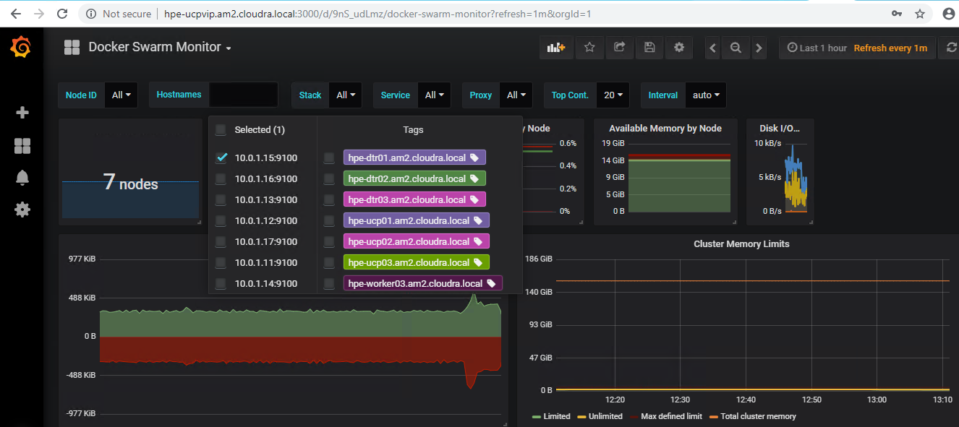

Figure 60. Docker Swarm Monitor dashboard

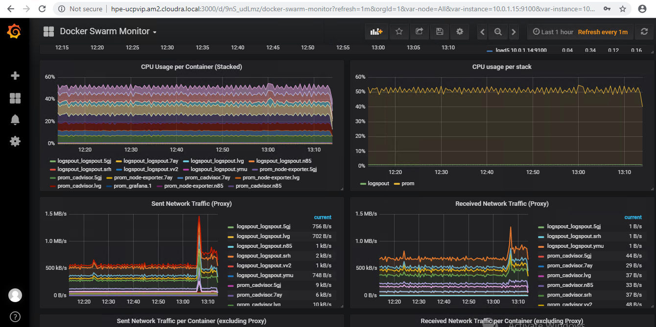

Figure 61. Docker Swarm Monitor dashboard

# Backup and restore

This Reference Configuration provides playbooks and scripts to help you back up and restore:

* Docker UCP and DTR

Docker volumes

## Backup and restore UCP and DTR

The playbooks provided in this solution implement the backup and restore procedures as they are described in the Docker documentation at <https://docs.docker.com/enterprise/backup/>. The solution follows the recommendations in the Docker best practices document at <https://success.docker.com/article/backup-restore-best-practices>.

Note

It is important that you make copies of the backed up data and that you store the copies in a separate physical location. You must also recognize that the backed up data contains sensitive information such as private keys and so it is important to restrict access to the generated files. However, the playbooks do not backup the sensitive information in your group_vars/all/vault file so you should make sure to keep track of the credentials for the UCP Administrator.

Warning

The restore procedures do not restore swarm data. You should follow infrastructure as code (IaC) guidelines and maintain your service, stack and network definitions using source code or configuration management tools. You must also ensure that you safely manage the credentials of your administration accounts, as existing UCP Client bundles will not work when you restore UCP on a new swarm.

### Backup UCP and DTR

The playbooks support backing up the swarm, UCP, DTR metadata and DTR images.

#### Backup configuration variables

Table 28 shows the variables related to backing up UCP and DTR. All these variables are defined in the file group_vars/all/backups. All the data that is backed up is streamed over an SSH connection to the backup server. Currently, the playbooks only support the use of the Ansible box as the backup server.

Table 28. Backup variables

|  |  |  |
| --- | --- | --- |
| Variable | File | Description |
| backup_server | group_vars/all/backups | Currently, the playbooks only support the use of the Ansible box as the backup server. |
| backup_dest | group_vars/all/backups | This variable should point to an existing folder on your Ansible box where the root user has write access. All the backups will be stored in this folder. For example, /root/backups |
| backup_passphrase | group_vars/all/vault | This variable is used to encrypt the tar file with a passphrase that must be at least 12 characters long. |
| swarm_offline_backup | group_vars/all/backups | This variable is commented out by default. More information on this variable is provided below. |

#### Backing up the swarm

When you back up the swarm, your services and stack definitions are backed up together with the networks definitions. However, Docker volumes or their contents will not be backed up. (If Docker volumes are defined in stacks, they will be re-created when you restore the stacks, but their content will be lost). You can back up the swarm using the playbook named backup_swarm.yml which is located in the playbooks folder on your Ansible server. The playbook is invoked as follows:

# ansible-playbook -i hosts playbooks/backup_swarm.yml

This playbook creates two archives in the folder specified by the variable backup_dest in group_vars/all/backups. By default, the file is named using the following pattern:

<backup_dest>/backup_swarm_<vmname>_<timestamp>.tgz  
<backup_dest>/backup_swarm_<vmname>_<timestamp>.vars.tgz

<vmname> is the name of the host (in the inventory) that was used to take the backup, and <timestamp> is the time at which the backup was taken. The file with the extension .vars.tgz contains information regarding the system that was backed up.

You can override the generated file name by defining the variable backup_name on the command line when running the playbook. In the example below:

# ansible-playbook -i hosts playbooks/backup_swarm.yml -e backup_name=my_swarm_backup

The generated files won't have <vmname> or <timestamp> appended:

<backup_dest>/my_swarm_backup.tgz  
<backup_dest>/my_swarm_backup.vars.tgz

Warning

Online versus offline backups: By default, the playbook performs online backups. You can take offline backups by setting the variable swarm_backup_offline to "true". The playbook will then stop the Docker daemon on the machine used to take the backup (a manager or UCP node). Before it does so, the playbook will verify that enough managers are running in the cluster to maintain the quorum. If this is not the case, the playbook will exit with an error. For more information, see the Docker documentation at <https://docs.docker.com/engine/swarm/admin_guide/#recover-from-disasterv>

#### Backing up the Universal Control Plane (UCP)

When you backup UCP, you save the data/metadata outlined in Table 29.

Table 29. UCP data backed up

|  |  |
| --- | --- |
| Data | Description |
| Configurations | The UCP cluster configurations, as shown by docker config ls, including Docker EE license and swarm and client CAs |
| Access control | Permissions for team access to swarm resources, including collections, grants, and roles |
| Certificates and keys | The certificates, public keys, and private keys that are used for authentication and mutual TLS communication |
| Metrics data | Monitoring data gathered by UCP |
| Organizations | Your users, teams, and orgs |
| Volumes | All [UCP named volumes](https://docs.docker.com/datacenter/ucp/2.2/guides/architecture/#volumes-used-by-ucp), which include all UCP component certs and data |

To make a backup of UCP, use playbook/backup_ucp.yml as follows:

# ansible-playbook -i vm_host playbooks/backup_ucp.yml

This playbook creates two archives in the folder specified by the variable backup_dest in group_vars/all/backups. By default, the files are named using the following pattern:

<backup_dest>/backup_ucp_<ucpid>_<vmname>_<timestamp>.tgz  
<backup_dest>/backup_ucp_<ucpid>_<vmname>_<timestamp>.vars.tgz

<ucpid> is the ID of the UCP instance, <vmname> is the name of the host (in the inventory) that was used to take the backup, and <timestamp> is the time at which the backup was taken. The file with the extension .vars.tgz contains information regarding the system which was backed up.

You can override the generated file name by defining the variable backup_name on the command line when running the playbook. In the example below:

# ansible-playbook -i hosts playbooks/backup_ucp.yml -e backup_name=my_ucp_backup

The generated files won't have <vmname> or <timestamp> appended:

<backup_dest>/my_ucp_backup.tgz  
<backup_dest>/my_ucp_backup.vars.tgz

Warning

To create a consistent backup, the backup command temporarily stops the UCP containers running on the node where the backup is being performed. User resources, such as services, containers, and stacks are not affected by this operation and will continue to operate as expected. Any long-lasting docker exec, docker logs, docker events, or docker attach operations on the affected manager node will be disconnected.

For more information on UCP backup, see the Docker documentation at <https://docs.docker.com/datacenter/ucp/3.0/guides/admin/backups-and-disaster-recovery/>

#### Backing up the Docker Trusted Registry (DTR)

When you backup DTR, you save the data/metadata outlined in Table 30.

Table 30. DTR data backed up

|  |  |  |
| --- | --- | --- |
| Data | Backed up? | Description |
| Configurations | yes | DTR settings |
| Repository metadata | yes | Metadata like image architecture and size |
| Access control to repos and images | yes | Data about who has access to which images |
| Notary data | yes | Signatures and digests for images that are signed |
| Scan results | yes | Information about vulnerabilities in your images |
| Certificates and keys | yes | TLS certificates and keys used by DTR |
| Image content | no | Needs to be backed up separately, depends on DTR configuration |
| Users, orgs, teams | no | Create a UCP backup to backup this data |
| Vulnerability database | no | Can be re-downloaded after a restore |

To make a backup of DTR metadata, use playbook/backup_dtr_metadata.yml

# ansible-playbook -i vm_host playbooks/backup_dtr_metadata.yml

This playbook creates two archives in the folder specified by the variable backup_dest in group_vars/all/backups. By default, the file is named using the following pattern:

<backup_dest>/backup_dtr_meta_<replica_id>_<vmname>_<timestamp>.tgz  
<backup_dest>/backup_dtr_meta_<replica_id>_<vmname>_<timestamp>.vars.tgz

<replica_id> is the ID of the DTR replica that was backed up, <vmname> is the name of the host (in the inventory) that was used to take the backup, and <timestamp> is the time at which the backup was taken. The file with the extension .vars.tgz contains information regarding the system that was backed up.

You can override the generated file name by defining the variable backup_name on the command line when running the playbook. In the example below:

# ansible-playbook -i hosts playbooks/backup_dtr_metadata.yml -e backup_name=my_dtr_metadata_backup

The generated files won't have <vmname> or <timestamp> appended:

<backup_dest>/my_dtr_metadata_backup.tgz  
<backup_dest>/my_dtr_metadata_backup.vars.tgz

For more information on DTR backups, see the Docker documentation at <https://docs.docker.com/datacenter/dtr/2.5/guides/admin/backups-and-disaster-recovery/>

#### Backing up DTR data (images)

To make a backup of the images that are inventoried in DTR and stored on the NFS server, use playbooks/backup_dtr_images.yml

# ansible-playbook -i vm_host playbooks/backup_dtr_images.yml

This playbook creates two archives in the folder specified by the variable backup_dest in group_vars/all/backups. By default, the files are named using the following pattern:

<backup_dest>/backup_dtr_data_<replica_id>_<vmname>_<timestamp>.tgz  
<backup_dest>/backup_dtr_data_<replica_id>_<vmname>_<timestamp>.vars.tgz

<replica_id> is the ID of the DTR replica that was backed up, <vmname> is the name of the host (in the inventory) that was used to take the backup, and <timestamp> is the time at which the backup was taken.

You can override the generated file names by defining the variable backup_name on the command line when running the playbook, as shown in the example below:

# ansible-playbook -i hosts playbooks/backup_dtr_images.yml -e backup_name=my_dtr_data_backup

The generated files won't have <vmname> or <timestamp> appended:

<backup_dest>/my_dtr_data_backup.tgz  
<backup_dest>/my_dtr_data_backup.vars.tgz

For more information on DTR backups, see the Docker documentation at <https://docs.docker.com/datacenter/dtr/2.5/guides/admin/backups-and-disaster-recovery/>

#### Backing up other metadata, including passwords

The backup playbooks do not backup the sensitive data in your group_vars/all/vault file. The information stored in the .vars.tgz files includes backups of the following files:

* hosts, a copy of the hosts file at the time the backup was taken
* vars, a copy of your group_vars/all/vars file at the time the backup was taken

meta.yml, a generated file containing information pertaining to the backup

The meta.yml file contains the following information:

backup_node="<node that took the backup>"  
replica_id="<ID of DTR replica if DTR backup>"  
backup_source=""  
ucp_version="<UCP version if UCP backup>"  
dtr_version="<DTR version of DTR backup>"

#### Backup Utility

The script backup.sh can be used to take a backup of the swarm, UCP, DTR metadata and the DTR images in one go. You can pass this script an argument (tag) that will be used to prefix the backup filenames, thereby overriding the default naming. Table 31 shows the file names produced by backup.sh based on the argument passed in the command line.

Table 31. Backup utility

|  |  |  |
| --- | --- | --- |
| Example | Command line | Generated filenames |
| Default | ./backup.sh | backup_swarm_<vmname>_<timestamp>.tgz, backup_ucp_<ucpid>_<vmname>_<timestamp>.tgz, backup_dtr_meta_<replica_id>_<vmname>_<timestamp>.tgz, backup_dtr_data_<replica_id>_<vmname>_<timestamp>.tgz and the corresponding .vars.tgz files |
| Custom | ./backup.sh my_backup | my_backup_swarm.tgz, my_backup_ucp.tgz, my_backup_dtr_meta.tgz, my_backup_dtr_data.tgz, and the corresponding .vars.tgz files |
| Date | ./backup.sh $(date '+%Y_%m_%d_%H%M%S') | <date>_swarm.tgz, <date>_ucp.tgz, <date>_dtr_meta.tgz, <date>_dtr_data.tgz, and the corresponding .vars.tgz files |

In addition, the backup.sh script accepts an optional switch that will let you specify the location of the password file that will be passed to the ansible-playbook commands in the script. This is required if you have encrypted the group_vars/all/vault file. The general syntax for this script is as follows:

./backup.sh [ -v <Vault Password File> ] [ tag ]

#### Related playbooks

* playbooks/backup_swarm.yml is used to back up the swarm data
* playbooks/backup_ucp.yml is used to back up UCP
* playbooks/backup_dtr_meta.yml is used to back up DTR metadata

playbooks/backup_dtr_images.yml is used to back up DTR images

### Restoring your cluster after a disaster

The playbooks address a disaster recovery scenario where you have lost your entire cluster and all the VMs. Other scenarios and how to handle them are described in the Docker documentation including the following scenarios:

* You have lost one UCP instance but your cluster still has the quorum. The easiest way is to recreate the missing UCP instance from scratch.
* You have lost the quorum in your UCP cluster but there is still one UCP instance running.
* You have lost one instance of DTR but still have a quorum of replicas. The easiest way is to recreate the missing DTR instance from scratch.

You have lost the quorum of your DTR cluster but still have one DTR instance running.

#### Before you restore

Step 1. Retrieve the backup files using your chosen backup solution and save them to a folder on your Ansible server. If you have used timestamps in the naming of your backup files, you can use them to determine the chronological order. If you used the backup.sh script specifying a date prefix, you can use that to identify the matching set of backup files. You should choose the files in the following reverse chronological order, from the most recent to the oldest file. Make sure you restore both the *.tgz and the *.vars.tgz files.

1. DTR images backup
2. DTR metadata backup
3. UCP backup

Swarm backup

In this example, we will assume a set of backup files stored in /root/restore that were created specifying a date prefix. These will have names like 2018_04_17_151734_swarm.tgz, 2018_04_17_151734_ucp.tgz, etc and the corresponding .vars.tgz files.

Step 2: Retrieve the DTR replica ID, the DTR version and the UCP version

To retrieve the ID of the replica that was backed up, as well as the version of DTR, you need to extract the data from the .vars.tgz file associated with the archive of the DTR metadata. You can retrieve this as follows:

# tar -Oxf /root/restore/2018_04_17_151734_dtr_meta.vars.tgz meta.yml  
backup_node="hpe-dtr01"  
replica_id="ad5204e8a4d0"  
backup_source=""  
ucp_version=""  
dtr_version="2.4.3"

# tar -Oxf /root/restore/2018_04_17_151734_ucp.vars.tgz meta.yml  
backup_node="hpe-ucp01"  
replica_id=""  
backup_source=""  
ucp_version="3.0.4"  
dtr_version=""

Take note of the replica ID (ad5204e8a4d0), the version of DTR (2.5.3) and the version of UCP (3.0.4).

Step 3: Populate the group_vars/all/backups file

backup_swarm: "/root/restore/2018_04_17_151734_swarm.tgz"  
backup_ucp: "/root/restore/2018_04_17_151734_ucp.tgz"  
backup_dtr_meta: "/root/restore/2018_04_17_151734_dtr_meta.tgz"  
backup_dtr_data: "/root/restore/2018_04_17_151734_dtr_data.tgz"  
backup_dtr_id: "ad5204e8a4d0"  
backup_dest: "/root/backups"  
backup_server: <IP of your ansible box>

You should populate your group_vars/all/backups file as above, with the backup_dtr_id variable containing the value you retrieved in the preceding step as replica_id="ad5204e8a4d0".

Step 4: Verify that your group_vars/all/vars file specifies the correct versions of DTR and UCP.

The playbooks use the versions of UCP and DTR as specified in your group_vars/all/vars file to restore your backups. You must ensure that the versions specified in your current group_vars/all/vars file correspond to the versions in the backups as determined above.

# cat group_vars/all/vars | grep dtr_version  
dtr_version: '2.5.3'

# cat group_vars/all/vars | grep ucp_version  
ucp_version: '3.0.4'

Step 5: Restore UCP admin credentials if required

You must ensure that the UCP admin credentials in your current group_vars/all/vars file are those that were in effect when you generated the backup files. If they have changed since then, you must restore the original credentials for the duration of the restore procedure.

Step 6: Restore your inventory (hosts)

Your inventory must reflect the environment that was present when the backup files were created. You can find a copy of the inventory as it was when the backup was taken in the *.vars.tgz files.

#### Restore UCP and DTR

Warning

This procedure is aimed at restoring a cluster after a disaster. It assumes you have lost all the VMs in your cluster and want to redeploy using data that you backed up earlier. The solution follows Docker best practice, which means the swarm artifacts are not restored. You will need to restore your Docker volumes and your applications (stacks and services) when this procedure is complete.

1. Ensure that you have completed all the preliminary steps as outlined in the section Before you restore.
2. Run the restore playbook

ansible-playbook -i hosts restore.yml

Reload your Docker licence, using the Docker UCP UI under Admin Settings -> Licence or directly by using the route /manage/settings/license.

If you are using the image scanning functionality in DTR, you will need to re-download the vulnerability database. For more information, see the Docker documentation [here](https://docs.docker.com/datacenter/dtr/2.4/guides/admin/configure/set-up-vulnerability-scans/#get-the-security-scanning-license).

You are now ready to restore your Docker volumes and your applications.

#### Restore DTR metadata and DTR images

Note

This procedure restores DTR metadata and images and assumes you have lost all the DTR VMs in your cluster. It will redeploy using the DTR data that you backed up earlier and will also restore the images if the folder exported by the NFS VM is empty.

1. Ensure that you have completed all the preliminary steps as outlined in the section Before you restore. In this scenario, you need the archives for the DTR metadata and the DTR images.
2. Ensure that all the DTR VMs listed in your inventory are destroyed, using the vSphere Web Client to delete them if required. If you want to restore the DTR images you should also delete the NFS VM.
3. Remove the DTR nodes from the swarm by running the docker node rm <DTR node> command on a UCP node for each DTR node in your cluster. The following example shows the sequence of commands to use to remove the DTR nodes:

# docker node ls  
ID       HOSTNAME                     STATUS              AVAILABILITY           
aiz… *   hpe-ucp02.cloudra.local      Ready               Active   
gvf…     hpe-dtr01.cloudra.local      Down                Active  
ir4…     hpe-ucp03.cloudra.local      Ready               Active     
mwf…     hpe-dtr02.cloudra.local      Down                Active  
oqy…     hpe-ucp01.cloudra.local      Ready               Active    
xqe…     hpe-worker01.cloudra.local   Ready               Active  
zdu…     hpe-dtr03.cloudra.local      Down                Active

# docker node rm hpe-dtr01.cloudra.local  
hpe-dtr01.cloudra.local  
# docker node rm hpe-dtr02.cloudra.local  
hpe-dtr02.cloudra.local  
# docker node rm hpe-dtr03.cloudra.local  
hpe-dtr03.cloudra.local

# docker node ls  
ID       HOSTNAME                     STATUS              AVAILABILITY   
aiz…     hpe-ucp02.cloudra.local      Ready               Active        
ir4…     hpe-ucp03.cloudra.local      Ready               Active      
oqy… *   hpe-ucp01.cloudra.local      Ready               Active   
xqe…     hpe-worker01.cloudra.local   Ready               Active

1. Run the restore script:

./restore_dtr.sh

If you are using the image scanning functionality in DTR, you will need to re-download the vulnerability database. For more information, see the Docker documentation [here](https://docs.docker.com/datacenter/dtr/2.4/guides/admin/configure/set-up-vulnerability-scans/#get-the-security-scanning-license).

#### Related playbooks

* playbooks/restore_swarm.yml is used to restore the swarm data
* playbooks/restore_dtr_meta.yml is used to restore DTR metadata

playbooks/restore_dtr_images.yml is used to restore DTR images

## Backup and restore Docker persistent volumes

There are a number of prerequisites that must be fulfilled before you backup and restore your Docker persistent volumes.

* VSphere clusters should have access to a datastore specifically for backups. This is a separate Virtual Volume created on the HPE 3PAR StoreServ and presented to all the hosts in the vSphere cluster.

Backup software must be available. HPE Recovery Manager Central and HPE 3PAR StoreServ is recommended but other customer backup and restore solutions are acceptable.

A number of restrictions also apply:

* Volumes may not be in use when a volume is cloned. Any container that has the volume attached must be paused prior to creating the clone. The container can be resumed once the clone is complete.

When Docker volumes need to be restored from backup, the backup datastore needs to be detached from all vSphere cluster servers prior to restoration.

### Persistent storage backup solution

#### Creating the volume

Docker persistent volumes can be created from a worker node using the following command:

docker volume create --driver=vsphere --name=MyVolume@MyDatastore -o size=10gb

#### Cloning the volume

Note

Prior to creating a clone of a volume, any containers accessing the volume should be paused or stopped.

Docker volumes can be cloned to a new datastore:

docker volume create --driver=vsphere --name=CloneVolumme@DockerBackup -o clone-from=MyVolume@MyDatastore -o access=read-only

### Snapshot and back up HPE 3PAR Virtual Volumes with HPE Recovery Manager Central and HPE StoreOnce

HPE Recovery Manager Central (RMC) software integrates HPE 3PAR StoreServ All-Flash arrays with HPE StoreOnce Systems to leverage the performance of snapshots with the protection of backups. RMC uses a direct backup model to orchestrate data protection between the array and the backup system without a backup application. When the first full backup is complete, each subsequent backup is incremental, making it significantly faster than traditional backup methods, particularly for higher volumes of data. Backups to HPE StoreOnce are block-level copies of volumes, de-duplicated to save space. Because RMC snapshots are self-contained, fully independent volumes, they can be restored to any HPE 3PAR array in the event of a disaster. See Figure 62 for an overview of the architecture.

HPE Recovery Manager Central enables you to replicate data from the source storage system (HPE 3PAR StoreServ) to the destination storage system (HPE StoreOnce). The replication is based on point-in-time snapshots.

HPE Recovery Manager Central is installed as a VM on VMware vSphere ESXi. It can be installed on the HPE Synergy platform on a separate (from the Docker Solution) vSphere cluster or external to the Synergy environment as long as the external server has connectivity to the HPE 3PAR StoreServ and HPE StoreOnce. HPE RMC can be installed directly on an ESXi host or can be deployed to a VMware vCenter managed environment. For this solution, the standalone "RMC only" is installed. If HPE RMC is installed in the HPE Synergy environment, iSCSI connection to the HPE 3PAR StoreServ is required.

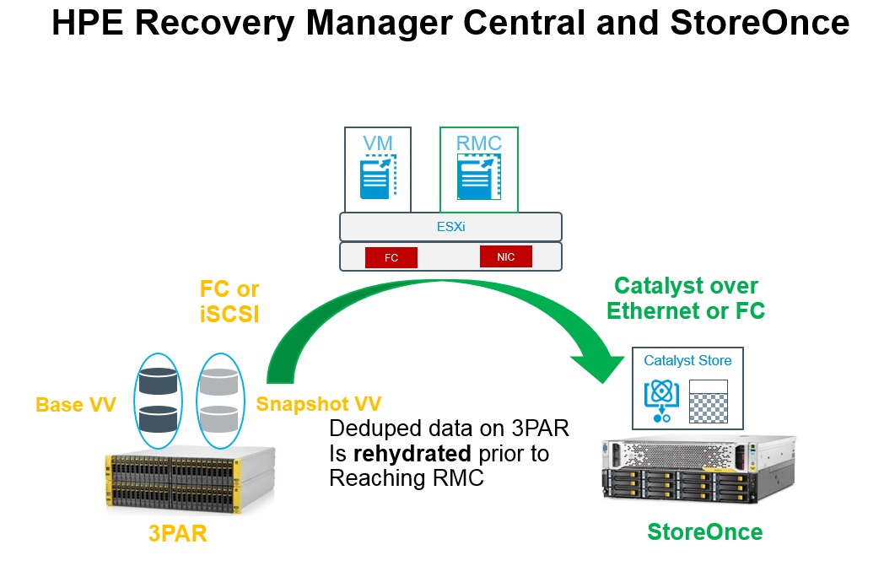

Figure 62. HPE Recovery Manger Central and HPE StoreOnce

* The connectivity between HPE 3PAR StoreServ and HPE RMC for data traffic is over iSCSI.
* The connectivity between HPE StoreOnce and HPE RMC is over CoEthernet (Catalyst OverEthernet)

The connectivity between HPE RMC, HPE 3PAR StoreServ, and HPE StoreOnce for management traffic is over IP.

Figure 63 illustrates the connectivity between various components.

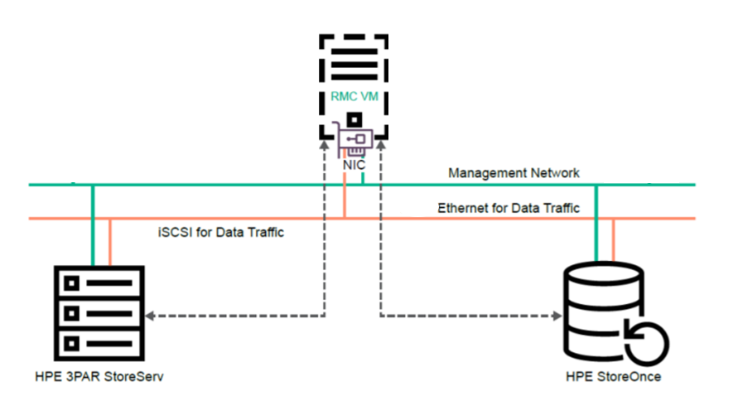

Figure 63. Connectivity

Refer to [HPE RMC User guide](https://support.hpe.com/hpsc/doc/public/display?docId=emr_na-a00042435en_us) for detailed instructions on setup and configuration of HPE RMC and HPE StoreOnce. When RMC is installed, it can be configured with the Backup Appliance Persona. The Backup persona allows the RMC to manage snapshots and Express Protect Backups. During installation, RMC configuration should specify Data Protection of RMC Core. The initial configuration of backups can be set up using the Protection Wizard. The Protection Wizard assists with creation of a Recovery Set.

Create a Recovery Set as shown in Figure 64 and select to protect your DockerBackup volume. Once you have created your Recovery Set, the next step is to create Protection Jobs. The Auto Protection Job simplifies the initial configuration of policies. The Auto Protection Job will automatically configure the storage, define default backup policies and protection policies and will schedule snapshots or express protect jobs with the created policies.

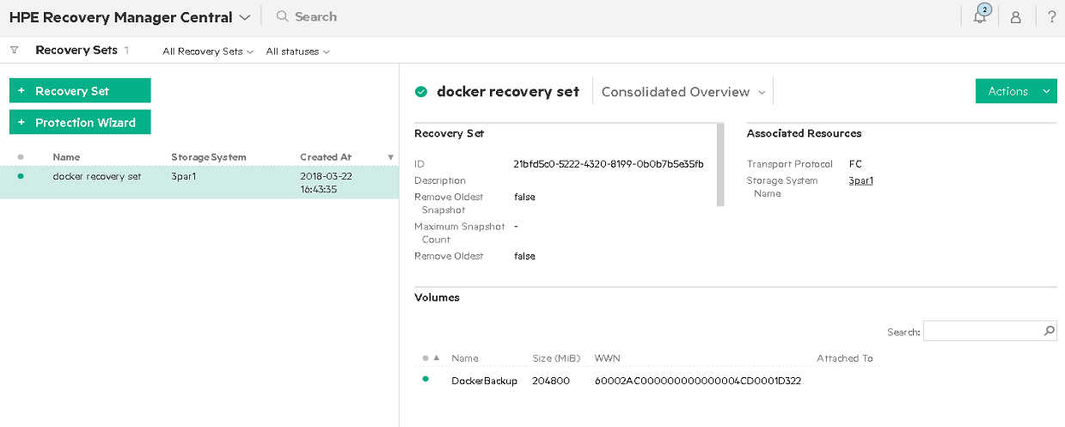

Figure 64. Recovery Set Overview

RMC uses the Express Protect feature, as shown in Figure 65, to enable the backup of the snapshot data from the HPE 3PAR array to the HPE StoreOnce system for deduplication and long-term retention.

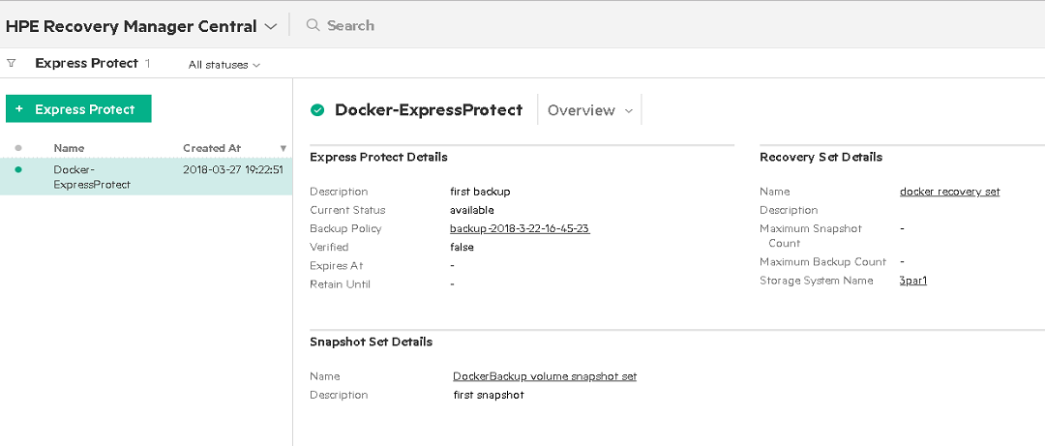

Figure 65. Express Protect

The Express Restore feature restores either snapshots or base volumes.

RMC leverages HPE 3PAR StoreServ SnapDiff technology to create an application-consistent snapshot. Only changed blocks are sent to the HPE StoreOnce system, which minimizes network traffic and saves disk space on the backup system.

### Restoring the volume

If a Docker persistent storage volume needs to be restored from backup, the HPE 3PAR volume can be restored either from a snapshot saved on the HPE 3PAR or from a backup on HPE StoreOnce. Stop any applications using the Docker volume. Use the vSphere Web UI to unmount the datastore from the vSphere cluster. Use RMC to detach the HPE 3PAR virtual volumes prior to restoring the backup. The volume can be restored from a Recovery Set restore point as shown in Figure 66. The Express Protect restore point will restore the volume from the HPE StoreOnce system. A Snapshot Set restore point will restore an HPE 3PAR StoreServ snapshot.

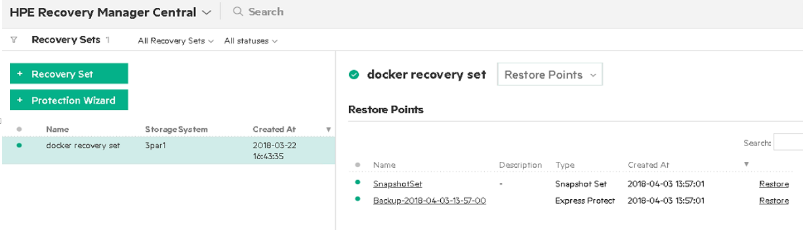

Figure 66. Restore points

Once the HPE 3PAR virtual volume is restored, the volume must be reattached to the vSphere cluster from RMC. After the volume is reattached, the datastore must be mounted. Applications can then access the restored docker volume.

## Integrate UCP and DTR backup with HPE RMC and HPE StoreOnce

You can take advantage of HPE Recovery Manager Central and HPE StoreOnce to provide scheduled snapshots and backup protection for the data generated by the backup procedure for Docker UCP and DTR.

1. Create a datastore from the Backup virtual volume you created and present it to all hosts in the vSphere cluster. This backup datastore is used for storing copies of Docker persistent volumes as well as backups of DTR and UCP.
2. The Ansible server is used to create backup and restore files for DTR and UCP on the local hard drive. The backup files should be copied to the DockerBackup datastore which can be automatically configured for snapshots and offsite backup.
3. Edit the Ansible server configuration from vCenter. Add a new hard disk and specify the location as the Docker Backup datastore as shown in Figure 67.

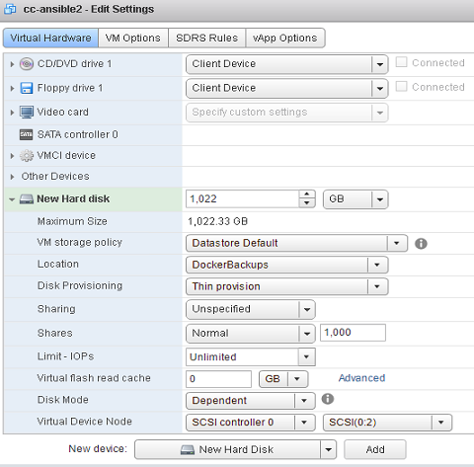

Figure 67. Add new hard disk

1. After the hard disk is added, it is visible from the Linux operating system. From the Ansible server:

# ls /dev/sd*

1. The newly added storage should appear as /dev/sdb. Now, make a filesystem, ignoring any warnings:

# mkfs -t ext4 /dev/sdb

1. Create a mount point for the new disk:

# mkdir /dockerbackup

1. Edit the /etc/fstab file and add the following line:

/dev/sdb /dockerbackup ext4 defaults 0  0

1. After saving the change, mount the new volume using:

#mount -a

Each time you backup Docker UCP and DTR using the backup.sh script, you should copy the generated files from the /root/backups folder to /dockerbackup. You may wish to add a command to the backup script to automate this process.

The virtual volume used to host the DockerBackup datastore can be scheduled for snapshot and backup protection with HPE Recovery Manager Central and HPE StoreOnce as described in the section Backup and restore Docker persistent volumes. Data backed up to HPE StoreOnce can be restored to the HPE 3PAR StoreServ and attached to the Ansible host for recovery.

# Solution lifecycle management

Lifecycle management with respect to this solution refers to the maintenance and management of software and hardware of various components that make up the solution stack. Lifecycle management is required to keep the solution up-to-date and ensure that the latest versions of the software are running to provide optimal performance, security and to fix any existing defects within the product.

In this section, we will cover life cycle management of the different components that are used in this solution. The lifecycle of the following stacks need to be maintained and managed:

* Monitoring Tools (Splunk or Prometheus and Grafana)
* Docker Enterprise Edition Environment
* Virtual Machine Operating systems
* HPE Synergy environment

The general practice and recommendation is to follow a bottom-up approach for updating all components of the environment and making sure the dependencies are met. In our solution, we would start with HPE Synergy and end with the monitoring environment. If all components are not being updated at the same time, the same approach can be followed – updating only the components that require updates while adhering to the interdependencies of each component that is being updated.

## HPE Synergy

HPE Synergy Composer powered by HPE OneView provides fast, reliable, and simplified firmware and driver management across many HPE Synergy components. HPE OneView manages firmware to reduce manual interactions and errors, in addition to minimizing downtime. Firmware updates of management appliances and shared infrastructure are non-disruptive to the production workload.

More information is available in the Best Practices for HPE Synergy Firmware and Driver Updates guide at <https://support.hpe.com/hpsc/doc/public/display?docId=c05212310>.

## vSphere Docker Volume Service Plug-in

vSphere Docker Volume service plug-in is part of an open source project by VMware that enables running stateful containers by providing persistent Docker volumes leveraging existing storage technology from VMware. There are two parts to the plug-in, namely, client software and server software (see Table 32). Every version of the plug-in that is released includes both pieces of software and it is imperative that the version number installed on the client side and server side are the same.

When updating the Docker Volume service plug-in, ensure the ESXi version you are running is supported and that the client software is compatible with the operating system.

Table 32. vSphere Docker Volume service components

| Order | Component | Dependency (compatibility) | Download/Documentation |
| --- | --- | --- | --- |
| 1. | Server Software | 1. VMware ESXi  2. Docker EE | [vSphere Docker Volume Service on GitHub](http://vmware.github.io/vsphere-storage-for-docker/documentation/index.html) |
| 2. | Client Software | 1. VM Operating System  2. Docker EE |

## Red Hat Enterprise Linux operating system

This solution is built using Red Hat Enterprise Linux (see Table 33) as the base operating system. When upgrading the operating system on the VMs, first verify that the OS version is compatible with Docker EE by looking at the Docker OS compatibility matrix.

Table 33. Operating system

| Order | Component | Dependency (compatibility) | Download/Documentation |
| --- | --- | --- | --- |
| 1. | Red Hat Enterprise Linux | 1. Docker EE  2. vDVS client software plugin | [RHEL](https://access.redhat.com/articles/11258) |

## Docker EE Environment

Each release of Docker Enterprise Edition contains three technology components – UCP, DTR and the Docker Daemon or Engine. It is imperative that the components belonging to the same version are deployed or upgraded together – see Table 34.

A banner will be displayed on the UI, as shown in Figure 68, when an update is available for UCP or DTR. You can start the upgrade process by clicking on the banner.

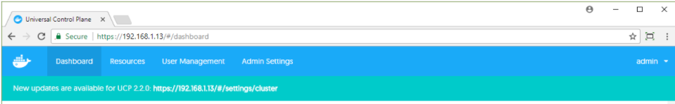

Figure 68. Docker update notification

Table 34. Docker EE components

| Order | Component | Dependency (compatibility) | Download/Documentation |
| --- | --- | --- | --- |
| 1. | Docker Daemon/Engine | 1. VM Operating System  2. vDVS plugin  3. Prometheus and Grafana | [Docker Lifecycle Maintenance](https://success.docker.com/Policies/Maintenance_Lifecycle)  [Docker Compatibility Matrix](https://success.docker.com/Policies/Compatibility_Matrix) |
| 2. | Universal Control Plane |
| 3. | Docker Trusted Registry |

## Monitoring Tools

To learn more about upgrading Splunk, see the relevant documentation at [How to upgrade Splunk Enterprise](http://docs.splunk.com/Documentation/Splunk/7.0.3/Installation/HowtoupgradeSplunk).

The Sysdig agent runs as a container and the latest version is pulled from the Docker hub on first installation. Re-run the install_sysdig.yml playbook to update to the newest version if required.

Prometheus and Grafana monitoring tools (see Table 35) run as containers within the Docker environment. Newer versions of these tools can be deployed by pulling the Docker images from Docker Hub. Verify that the version of Prometheus that is being used is compatible with the version of Docker EE.

Table 35. Monitoring tools: Prometheus and Grafana

|  |  |  |  |
| --- | --- | --- | --- |
| Order | Component | Dependency (compatibility) | Download/Documentation |
| 1. | Prometheus | 1. Grafana  2. Docker EE | 1. Prometheus Images on Docker Hub  2. [Upgrading Grafana](http://docs.grafana.org/installation/upgrading/) |
| 2. | Grafana | 1. Prometheus  2. Docker EE |

# Summary

This document has described how to architect and deploy an HPE Enterprise Containers as a Service with Docker EE solution, using Ansible playbooks to quickly install and deploy a production-ready container environment. This deployment includes a highly available container cluster with backup services and persistent data support. This solution is ideal for customers looking to run containers on VMs to take advantage of the resource efficient usage of virtual machines for Docker containers, and having the ability to run legacy and new container applications side-by-side. Customers deploying Docker containers on a large scale, on Linux and Microsoft Windows, should consider HPE Synergy as the deployment infrastructure.

# Appendix A: Software Licenses

Licenses are required for the following software components:

* VMware
* Red Hat Linux
* Microsoft Windows Server
* Docker EE
* Splunk (optional software)

Sysdig (optional software)

# Appendix B: Using customer supplied certificates for UCP and DTR

Table 36 lists the variables used when configuring customer supplied certificates for UCP and DTR.

Table 36. Customer certs variables

|  |  |  |
| --- | --- | --- |
| Variable | File | Description |
| ucp_certs_dir | group_vars/all/vars | If ucp_certs_dir is not defined, UCP is installed with self-signed certificates and DTR is installed with the --ucp-insecure-tls switch  If ucp_certs_dir is defined, this is a folder on the Ansible machine that must contain 3 files:  ca.pem, the root CA certificate in PEM format  cert.pem, the server certificate optionally followed by intermediate CAs  key.pem, the private key that comes with the cert.pem certificates |
| dtr_certs_dir | group_vars/all/vars | If dtr_certs_dir is not defined, DTR is installed with self-signed certificates  If dtr_certs_dir is defined, this is a folder on the Ansible machine that must contain 3 files:  ca.pem, the root CA certificate in PEM format  cert.pem, the server certificate optionally followed by intermediate CAs  key.pem, the private key that comes with the cert.pem certificates |

Note

The installation will fail if the ca.pem, cert.pem and key.pem files cannot be found in the folders designated by dtr_certs_dir and ucp_certs_dir or if they don't constitute valid certificates.

The certificates should specify the names of the FQDNs of the load balancer and the FQDNs of the VMs themselves. This applies to both the UCP server certificate and the DTR server certificate.

## Generating and testing certificates

In the example described here we have a root CA named Example root CA and an intermediate CA named Intermediate CA valid 3 years. The intermediate CA signs the server certificates for UCP and DTR.

Below is the start of the output displayed by running the openssl x509 utility against the ca.pem file (the root CA certificate).

[root@ansible ucp_certs]# openssl x509 -text -noout -in ca.pem|head -14  
Certificate:  
    Data:  
        Version: 3 (0x2)  
        Serial Number:  
            0d:07:ca:ea:00:37:77:6e:25:e0:18:3e:0e:db:80:0f:11:cb:1b:3f  
    Signature Algorithm: sha256WithRSAEncryption  
        Issuer: CN=Example Root CA  
        Validity  
            Not Before: Apr 24 20:12:01 2018 GMT  
            Not After : Apr 21 20:12:30 2028 GMT  
        Subject: CN=Example Root CA  
        Subject Public Key Info:  
            Public Key Algorithm: rsaEncryption  
                Public-Key: (4096 bit)

Here is an excerpt from the example ca.pem file:

-----BEGIN CERTIFICATE-----  
MIIFJTCCAw2gAwIBAgIUDQfK6gA3d24l4Bg+DtuADxHLGz8wDQYJKoZIhvcNAQEL  
BQAwGjEYMBYGA1UEAxMPRXhhbXBsZSBSb290IENBMB4XDTE4MDQyNDIwMTIwMVoX  
...  
...  
uXzYbCtU6Jt9B3fayAeWWswQv+jQSzuuA3re0M1x838iIZWDx93f4yLJWLJl7xsY  
btvKBmqKDCsAqsQLFLnNj/JyYq4e9a6Xxcyn9FXNpzuEsfjfNGHn+csY+w3f987T  
MNviy376xZbyAc1CV5kgmnZzjU5bDkgT8Q==  
-----END CERTIFICATE-----

The cert.pem file should contain the server certificate itself, followed by your intermediate CA's certificate. The following example shows how to extract the intermediate CA certificate from cert.pem and to save it to a file named intca.pem. Using the openssl x509 utility, you can display the content of the intca.pem file in human readable form. This certificate was signed by the example CA above (Issuer = 'Example Root CA').

[root@ansible ucp_certs]# openssl x509 -text -noout -in intca.pem|head -14  
Certificate:  
    Data:  
        Version: 3 (0x2)  
        Serial Number:  
            6b:1e:0c:86:20:cf:f0:88:d2:52:0d:5d:b9:56:fa:91:87:a0:49:18  
    Signature Algorithm: sha256WithRSAEncryption  
        Issuer: CN=Example Root CA  
        Validity  
            Not Before: Apr 24 20:12:09 2018 GMT  
            Not After : Apr 23 20:12:39 2021 GMT  
        Subject: CN=Intermediate CA valid 3 years  
        Subject Public Key Info:  
            Public Key Algorithm: rsaEncryption  
                Public-Key: (4096 bit)

Here is an excerpt from the incta.pem file showing the example Intermediate CA certificate:

-----BEGIN CERTIFICATE-----  
MIIFcjCCA1qgAwIBAgIUax4MhiDP8IjSUg1duVb6kYegSRgwDQYJKoZIhvcNAQEL  
BQAwGjEYMBYGA1UEAxMPRXhhbXBsZSBSb290IENBMB4XDTE4MDQyNDIwMTIwOVoX  
...  
...  
o2tL5nwR7ROiAr/kk9MIRzWrLNbc4cYth7jEjspU9dBqsXgsTozzWlwqI9ybZwvL  
Ni1JnZandVlyQdoOaB2M/1DNFfKvwW3JeArKvDA9j95n/BWFTjoZ+YOz9pYit6T7  
1GCGu3be  
-----END CERTIFICATE-----

The openssl x509 utility will only decrypt the first certificate found in cert.pem, so you don't need to extract the server certificate from cert.pem. In this example, the server certificate is signed by the intermediate CA above. Note the Subject Alternate Names: hpe-ucp.cloudra.local is the FQDN of the UCP load balancer, and the other names are those of the UCP instances (hpe-ucp01.cloudra.local, hpe-ucp02.clodura.local, hpe-ucp03.cloudra.local).

[root@ansible ucp_certs]# openssl x509 -text -noout -in server.pem  
Certificate:  
    Data:  
        Version: 3 (0x2)  
        Serial Number:  
            25:d9:f8:1d:9b:1d:23:f1:21:56:54:f2:43:cc:4f:0e:73:22:be:ec  
    Signature Algorithm: sha256WithRSAEncryption  
        Issuer: CN=Intermediate CA valid 3 years  
        Validity  
            Not Before: Apr 24 20:17:30 2018 GMT  
            Not After : Apr 24 20:18:00 2019 GMT  
        Subject: O=HPE, OU=CloudRA Team, CN=hpe-ucp.cloudra.local  
        Subject Public Key Info:  
            Public Key Algorithm: rsaEncryption  
                Public-Key: (2048 bit)  
                CA Issuers - URI:http://localhost:8200/v1/intca  
      ( portions removed )  
   
            X509v3 Subject Alternative Name:  
                DNS:hpe-ucp.cloudra.local, DNS:hpe-ucp01.cloudra.local, DNS:hpe-ucp02.cloudra.local, DNS:hpe-ucp03.cloudra.local

The following excerpts from cert.pem show the first certificate which is the server certificate itself and the second certificate which is the intermediate CA's certificate.

-----BEGIN CERTIFICATE-----  
MIIFGTCCAwGgAwIBAgIUJdn4HZsdI/EhVlTyQ8xPDnMivuwwDQYJKoZIhvcNAQEL  
BQAwKDEmMCQGA1UEAxMdSW50ZXJtZWRpYXRlIENBIHZhbGlkIDMgeWVhcnMwHhcN  
...  
...  
s0R4I3Qnc50oNISng5l7wW1d4RMMwmXQhG1H5QKAUjHfJXH4bNtIzKxw/zGTVr4Z  
llYKbEwJcgAvvfkn+w==  
-----END CERTIFICATE-----

-----BEGIN CERTIFICATE-----  
MIIFcjCCA1qgAwIBAgIUax4MhiDP8IjSUg1duVb6kYegSRgwDQYJKoZIhvcNAQEL  
BQAwGjEYMBYGA1UEAxMPRXhhbXBsZSBSb290IENBMB4XDTE4MDQyNDIwMTIwOVoX  
...  
...  
Ni1JnZandVlyQdoOaB2M/1DNFfKvwW3JeArKvDA9j95n/BWFTjoZ+YOz9pYit6T7  
1GCGu3be  
-----END CERTIFICATE-----

Finally, here is an excerpt from key.pem, the private key that goes with the server certificate.

-----BEGIN RSA PRIVATE KEY-----  
MIIEpQIBAAKCAQEA5rmmb52ufE80a3cXhY2HSRZNazb7/fipXY1rZ+U5+rJv9BN5  
d/X3NTroSE8/PvoS/maGkHCnURGNqbu/G2umKN/tm/eSpDY861YnGWxj+bc0gtiU  
...  
...  
A0SGidSMk3hFX1Iaftgx4EUGbrzZO7I8M5RO64U1aMFNFyj4XghJ2mZTdNelwNBw  
pr/fYulyi5lYPalQHYH3OyvNqQQ3arEbTbZp8hEyY0gxtZRXmmaoqOY=  
-----END RSA PRIVATE KEY-----

## Verify your certificates

The playbooks do not verify the validity of the certificate files you supply so you should verify them manually before you start your deployment.

### Verify that the private and the server cert match

On the Ansible box, run the following commands:

ckcert=$(openssl x509 -noout -modulus -in cert.pem | openssl md5)  
ckkey=$(openssl rsa -noout -modulus -in key.pem| openssl md5)  
if [ "$ckkey" == "$ckcert" ] ; then echo "Private key and Certificate match" ; else echo "STOP! Private Key and Certificate don't match" ; fi

### Verify that the server certificate was signed by the CA

Extract all but the first certificate from cert.pem ( i.e. extract the certs for the intermediate CA authorities) into the file int.pem

sed -e '1,/-----END CERTIFICATE-----/d' cert.pem >intca.pem

Combine intca.pem and ca.pem to form cachain.pem:

cat intca.pem ca.pem > cachain.pem

Finally, verify that cert.pem was signed by the CA or by an intermediate CA:

openssl verify -verbose -CAfile cachain.pem  cert.pem

A successful check will generate output similar to:

[root@ansible ucp_certs]# cat intca.pem ca.pem > cachain.pem  
[root@ansible ucp_certs]# openssl verify -verbose -CAfile cachain.pem  cert.pem  
cert.pem: OK

An unsuccessful check will generate output similar to:

[root@ansible ucp_certs]# openssl verify -verbose -CAfile cachain.pem  certsignedbyanotherca.pem  
certsignedbyanotherca.pem: O = HPE, OU = CloudRA Team, CN = hpe-ucp.cloudra.local  
error 20 at 0 depth lookup:unable to get local issuer certificate

# Appendix C: Enabling SSL between the universal forwarders and the Splunk indexers using your certificates

The procedure for enabling SSL between the universal forwarders and the Splunk indexers using your certificates is described below. In summary, the following steps are required:

1. Set the variable splunk_ssl to yes in group_vars/all/vars
2. Put your root CA certificate and your server certificate files in /root/Docker-Synergy/files/splunk/linux/SPLUNK_HOME/etc/mycerts

Uncomment the [sslConfig] stanza in the file /files/splunk/linux/SPLUNK_HOME/etc/system/local/server.conf

## Limitations

SSL only works with Linux worker nodes. The Universal Forwarders verify that the indexers they connect to have a certificate signed by the configured root CA and that the Common Name in the certificate presented by the indexer matches its FQDN as listed by the variable splunk_architecture_forward_servers.

## Prerequisites

Configure your indexers to use SSL on port 9998. The following is an example inputs.conf file located in $SPLUNK_HOME/etc/system/local that enables SSL on port 9998 and configures the certificate file for use by the indexer itself, in this instance /opt/splunk/etc/mycerts/indexer.pem.

[splunktcp-ssl://9998]  
disabled=0  
connection_host = ip  
  
[SSL]  
serverCert=/opt/splunk/etc/mycerts/indexer.pem  
#requireClientCert = true  
#sslAltNameToCheck = forwarder,forwarder.cloudra.local  
  
[tcp://1514]  
connection_host = dns  
sourcetype = ucp

For more information, see the documentation at <https://docs.splunk.com/Documentation/Splunk/7.1.2/Security/ConfigureSplunkforwardingtousesignedcertificates>. In addition, you can see how to create your own certificates and the content of the file designated with serverCert at <http://docs.splunk.com/Documentation/Splunk/7.1.2/Security/Howtoself-signcertificates>.

In this instance, the folder mycerts was created under /opt/splunk/etc and the file indexer.pem was copied to this folder.

Indexers are configured with the Root CA cert used to sign all certificates. This can be achieved by editing the file server.conf in $SPLUNK_HOME/etc/system/local on your indexer(s). The following code block shows the relevant portion of this file where sssRootCaPath is pointing to the root CA certificate.

[sslConfig]  
sslRootCAPath = /opt/splunk/etc/mycerts/ca.pem

Note

In order to be able to download and install additional applications, you may want to append the file $SPLUNK_HOME/auth/appsCA.pem to your ca.pem file. If you don't do this, the Splunk UI will make this suggestion when you attempt to Find more apps.

Splunk should be restarted on the indexers if you had to make these changes (see the Splunk documentation for more information).

## Before you deploy

Generate the forwarder certificate and name it forwarder.pem. Make sure that you copy the root CA certificate to ca.pem

1. Copy both the ca.pem and the forwarder.pem files to files/splunk/linux/SPLUNK_HOME/etc/mycerts/ (overwriting any existing files).
2. Edit the file server.conf in the folder files/splunk/linux/SPLUNK_HOME/etc/system/local and uncomment the last two lines as suggested in the file itself. Your file should look like this:

#  
# uncomment the section below if you want to enable SSL  
#  
[sslConfig]  
sslRootCAPath = /opt/splunkforwarder/etc/mycerts/ca.pem

1. Set splunk_ssl to yes in the file group_vars/all/vars, uncommenting the line if required. Make sure that the splunk_architecture_forward_servers list specifies all your indexers together with the port that was configured to accept SSL:

monitoring_stack: splunk  
splunk_ssl: yes  
splunk_architecture_forward_servers:  
- indexer1.cloudra.local:9998  
- indexer2.cloudra.local:9998

## Hybrid environment Linux / Windows

Currently, you cannot deploy your own certificates for use by the Universal Forwarders deployed on Windows machines. If you want to have your Linux machines in a hybrid deployment to use SSL, proceed as follows.

1. Comment out the splunk_architecture_forward_servers variable (and its values) from group_vars/all/vars

monitoring_stack: splunk  
splunk_ssl: yes  
#splunk_architecture_forward_servers:  
#  - hpe2-ansible.cloudra.local:9998

1. Create a file named vms.yml in the folder group_vars and specify the list of forward servers to use by the Linux servers. This list is typically the same as the one used for Windows servers but specifies a TCP port that enables SSL.

splunk_architecture_forward_servers:  
- hpe2-ansible.cloudra.local:9998

1. Edit the group_vars/win_worker.yml file and specify the list of forward servers to be used by the Windows servers. This list is typically the same as the one used for Linux servers but specifies a TCP port that does not enable SSL.

splunk_architecture_forward_servers:  
- hpe2-ansible.cloudra.local:9997

# Appendix D: How to check that certs were deployed correctly

The following commands should return the CA certificates used by UCP / DTR. This certificates is the same as the one pointed to by the --cacert switch.

# curl --cacert <ucp_certs_dir>/ca.pem https://<your ucp fqdn>/ca   
# curl --cacert <dtr_certs_dir>/ca.pem https://<your dtr fqdn>/ca

Output 1: certificates successfully deployed (content will depend on your own CA certificate)

-----BEGIN CERTIFICATE-----  
MIIDyTCCArGgAwIBAgIUUeo+H6xGSB7/9gqq9T2SUwJPLggwDQYJKoZIhvcNAQEL  
BQAwbDELMAkGA1UEBhMCRlIxFTATBgNVBAcTDFRoZSBJbnRlcm5ldDETMBEGA1UE  
ChMKQ2hyaXN0b3BoZTEUMBIGA1UECxMLQ0EgU2VydmljZXMxGzAZBgNVBAMTEkNo  
...  
XkJ8WcsHocJO8J9J3RaWsM2BQc7wRntJc0kA7ooTH13OtQTP1jFcQp5xNdI4J3Mz  
j9BAYERjkGqu7v9tfOem99oVGUal20pu4r73eWUm1mL948xuw6PgiRSLZrXhn/RS  
uvFVnS/vPYJozOXIZA==  
-----END CERTIFICATE-----

If the deployment was not successful, curl will output something like Output 2.

Output 2: certificates were not successfully deployed

curl: (60) Peer's Certificate issuer is not recognized.  
More details here: http://curl.haxx.se/docs/sslcerts.html   
...

### Enable certs for browser (Windows 2016 example)

Choose Manage computer certificates in the control panel as shown in Figure 69.

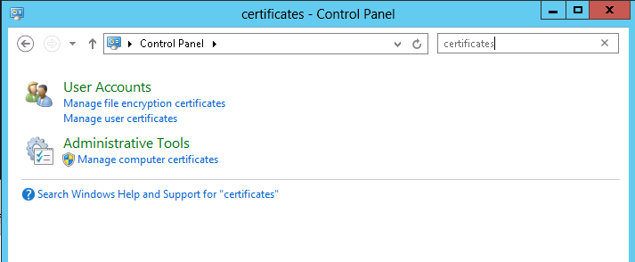

Figure 69. Manage computer certificates

Import the ca.pem for UCP into the Trusted Root Certification Authorities, as shown in Figure 70.

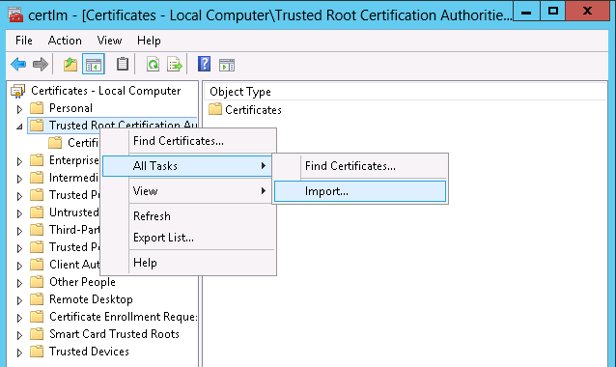

Figure 70. Import the ca.pem

It should now show up in the list of certificates. You may need to restart your browser to see the green, secure lock symbol as shown in Figure 71.



Figure 71. Secure HTTPS

# Resources and additional links

HPE Reference Architectures, [hpe.com/info/ra](http://www.hpe.com/info/ra)

HPE Synergy, [hpe.com/synergy](http://hpe.com/synergy)

HPE Servers, [hpe.com/servers](http://www.hpe.com/servers)

HPE Storage, [hpe.com/storage](http://www.hpe.com/storage)

HPE Networking, [hpe.com/networking](http://www.hpe.com/networking)

HPE Technology Consulting Services, [hpe.com/us/en/services/consulting.html](http://www.hpe.com/us/en/services/consulting.html)

Docker Reference Architectures, <https://success.docker.com/architectures>

Splunk Validate Architectures, <https://www.splunk.com/pdfs/white-papers/splunk-validated-architectures.pdf>

Sysdig Resources, <https://sysdig.com/resources/>

To help us improve our documents, please provide feedback at [hpe.com/contact/feedback](http://www.hpe.com/contact/feedback).